Makaton signs for this week (22.09.2025)
fruit

Video link
https://www.youtube.com/watch?v=PhD4ITXnJRw
vegetables
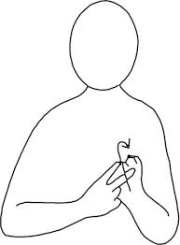
Video link
(Same as above)

