Makaton signs for this week (13.10.2025)
worried
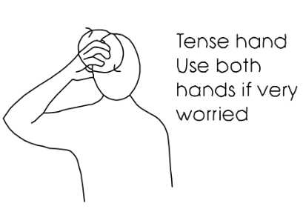
Video link
https://www.youtube.com/watch?v=bbVCDH4OKp0
scared/frightened
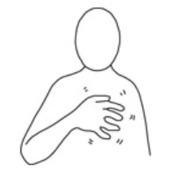
Video link
https://www.youtube.com/watch?v=pKmEhUAo534

