Makaton signs for this week (01.09.2025)
walk
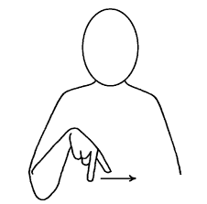
Video link
https://www.youtube.com/watch?v=-8Goitw8avw
run
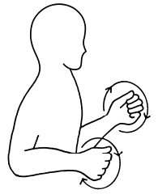
Video link
https://www.youtube.com/watch?v=TEveXmrNiow

