Makaton signs for this week (20.10.2025)
same
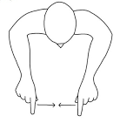
Video link
https://www.youtube.com/watch?v=rVkPoReJevY
different
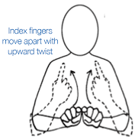
Video link
(same as above)

