Makaton signs for this week (03.11.2025)
Yes
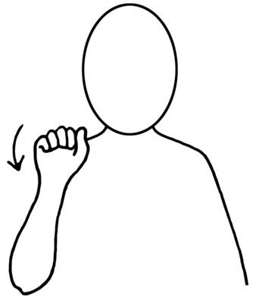
Video link
https://www.youtube.com/watch?v=iDbevFwBelk
No
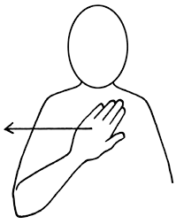
Video link
https://www.youtube.com/watch?v=NjCdnC-lNKw

