Makaton signs for this week (29.09.2025)
sing
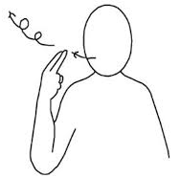
Video link
https://www.youtube.com/watch?v=n0x0IMw_JrA
dance
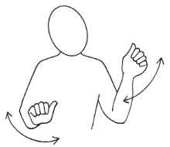
Video link
https://www.youtube.com/watch?v=O3TxcNKOhcA

