Makaton signs for this week (08.09.2025 link is for both signs)
to cut with scissors/scissors
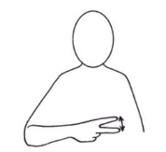
Video link
https://www.youtube.com/watch?v=YMH5H5qkW5Q
to cut with a knife/knife
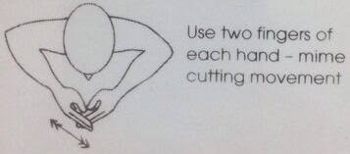
Video link
as above

