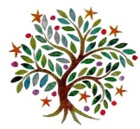
Year 4 - Autumn 1 LKS2

 | 9:00 -9:20 | 9:20 – 10:20 | 10:20 – 10:35 | 10:35 – 11:00 | 11:00 – 12:00 | 12:00 – 13:00 | 13:00 – 13:20 | 13:20 – 14:00 |  |  | 14:00 – 15:00 |  |  | 15:00 -15:20
Monday | Assembly   | Maths  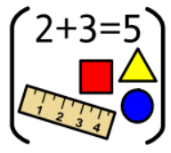 | B | Spelling   | English   | L | Mastering Number   | PE   |  |  | History/ Geography   |  |  | STAR  
Tuesday | Assembly | Maths | R | Spelling | English | U | Mastering Number | Guided Reading   |  |  | Science   |  |  | STAR
Wednesday | Mastering Number | Maths | E | Spelling | English | N | Guided Reading |  | Art/ DT   |  |  |  | Assembly
Thursday | Mastering Number | Maths | A | Handwriting   | English | C | Guided Reading |  | Computing   |  |  | PE
Friday | Assembly | English | K | Handwriting | Music   | H | Maths |  |  | RE   |  |  | Artis    30mins
PSHE/MFL blocked

