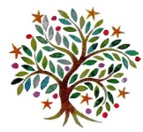
Year 3 - Autumn 1 LKS2

 | 9:00 -9:20 | 9:20 – 10:20 | 10:20 – 10:35 | 10:35 – 11:00 | 11:00 – 12:00 | 12:00 – 13:00 | 13:00 – 13:20 | 13:20 – 14:00 |  | 14:00 – 15:10 |  |  | 15:10 -15:20
Monday | Assembly   | Maths  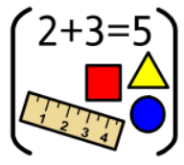 | B | Spelling   | English   | L | Mastering Number   | Guided Reading   |  | Computing   |  |  | STAR  
Tuesday | Assembly | Maths | R | Spelling | English | U | Mastering Number | RE   |  | PE   |  |  | STAR
Wednesday | Assembly | Maths | E | Spelling | English | N | Mastering Number | Guided Reading |  | Science   |  |  | STAR
Thursday | Mastering Number | Maths | A | Handwriting   | English | C | Guided reading |  | Art/DT   |  |  | History/Geography  
Friday | Assembly | Maths | K | Artis    30mins | English | H | Music  (PPA)   |  |  |  | PE  (PPA)
PSHE/MFL
 blocked

