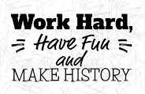

Science (Human body and senses)
Create a senses table of things you like and dislike.
I like the smell of……….
I do not like the smell of…


English
Write a letter to your teacher to tell them about a favourite toy you have been given. What is it? When did you get it? Why was it a favourite?
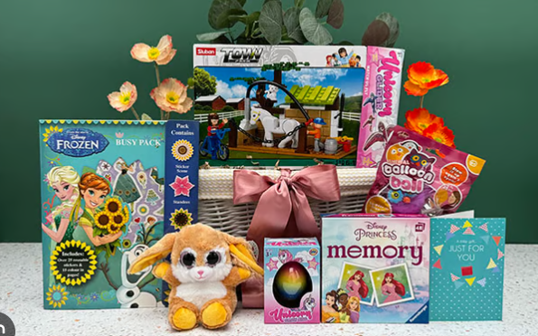
Weekly homework
Year 1
Numbots - 20 minutes a week
Reading – Bring your book bag in on Thursday
Year 2
TTRS – 20 minutes a week
Spelling shed (if Read Write Inc is completed)
Reading – Bring your book bag in on Thursday. Book returned home on Friday.
History
Talk to your family about one of your favourite memories. Bring in a photo or draw a picture of the memory to share with the class.
Design Technology 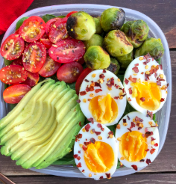
Create and cook a healthy meal. Write the menu or recipe. You could take some photos to share with us.

How am I making history?
Homework Year 1 and 2
Autumn 1
Maths
- Learn the days of the week and the months of the year.
Monday Tuesday Wednesday Thursday Friday
Saturday Sunday
- Find out the birthdays of people in your family and then order then from the beginning of the year to the end. You could make a timeline.

