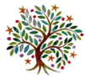
Autumn 1
Year 1 & 2
Dear Parents and carers,
Welcome back to a brand-new year at SAB. During the Autumn Term, our theme is ’How do I make history?’ Here is an idea of some of things we will be learning in Year 1 and 2 in our new topic.
What will we be learning?
We have lots of fun learning coming up this half-term.
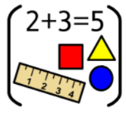
Maths: Place value
Addition and subtraction

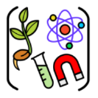
Science: We will be learning to identify, name, draw and label basic parts of the human body and say which part of the body is associated with each sense


English:
We will be writing retelling stories and writing narratives.
Grammar: Use suffixes Yr1 and 2 -s and -es & -er and -est Yr2
Using co-ordination Yr1 ‘and’ & Yr2 ‘so, or and, but’
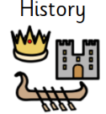
History: This term we will be investigating the past within living memory by exploring personal chronology and using photographs to ask and answer questions about the past.

RE: We will be exploring how our worldview can be seen through the choices we make.

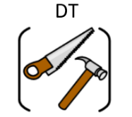
Design Technology – Cooking and Nutrition: Balanced diet – we will be discovering the
importance of a balanced diet and creating a tasty, balanced wrap to meet a design brief.

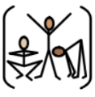
PE: We will be working on locomotion skills and Health and Well-being.
Year 1PT PE days will be Tuesday and Friday
Year 1/2M PE days will be Tuesday and Thursday
Year 2 PE days will be Monday and Wednesday.

 Computing: We will be reviewing our School User Agreement and working on a Project Evolve unit all about self-image and identity

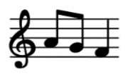
Music: Singing- nursery rhymes, songs with simple melodies and choruses, and a focus on pop and classical music.

Parent Drop-ins

Subject | Date & Time | Activity
History | 1.10.26  2:45pm | History research: Finding about childhood in the past
DT | TBC | Evaluating wraps children have created and made
Dates for your diary
Parent Meeting | 9.9.26  3:30pm | Curriculum Meeting: information about organisation, curriculum, homework and expectations  Hall

