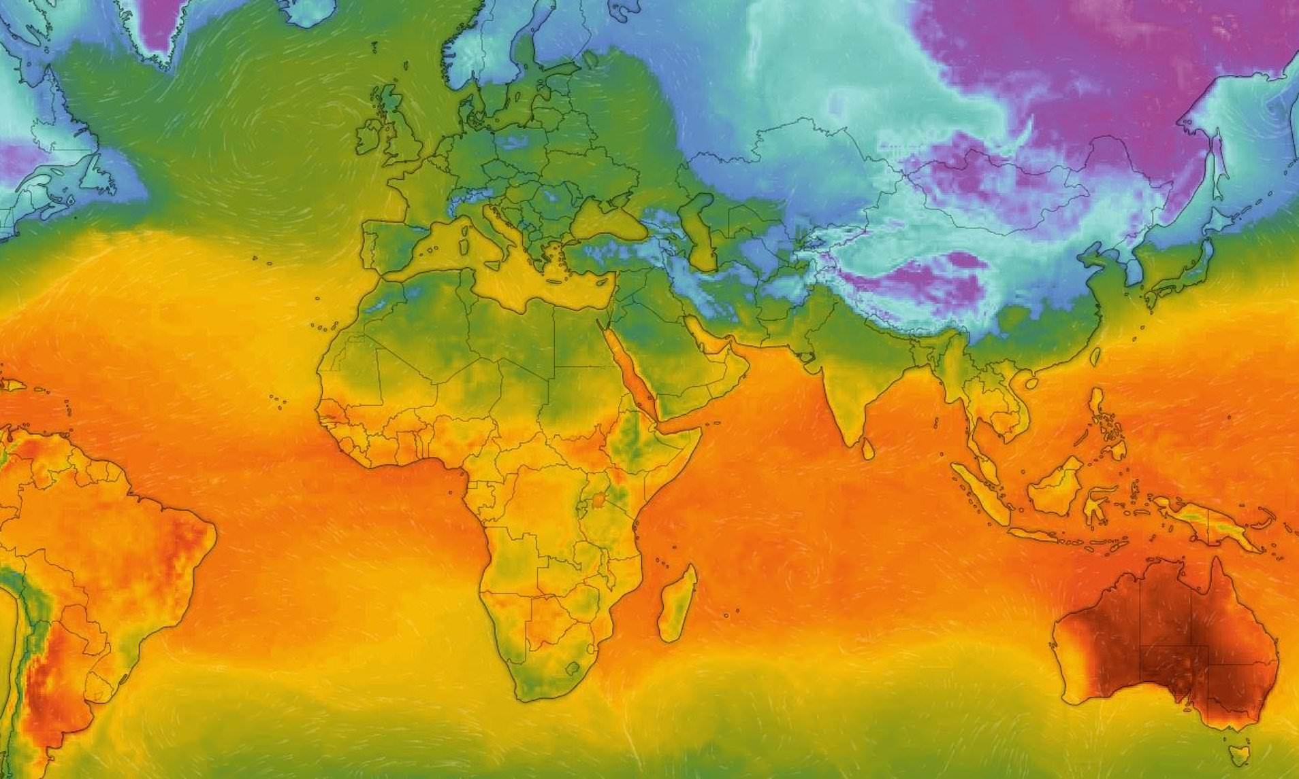
Weekly homework
Maths-Year 1
Numbots - 20 minutes a week

Maths-Year 2
TTRS – 20 minutes a week
Spelling shed
Reading every day - Bring your book bag in on Thursday.
Read, Write, Inc: Practice phonics videos using the QR code videos.

Science:
Create a life cycle of an animal of your choice. You could label the stages or write a short explanation.

Geography:
Choose a country that you or a family member would like to live in. Research and write facts about the weather/climate.

Science:

Select an animal that lives in a hot or cold country. Research the animal and create a fact file or draw your animal and label it.
P.E.
Create an aerobics circuit or learn a dance.
Take pictures to share with your teacher.

Spring 2 – Would you prefer to live in a hot or cold country?
Art:
Study an artist (Matisse or Rothko). Look at pictures of their artwork and recreate a piece.


