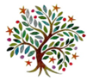
Spring 2
Year 5 & 6
Dear Parents and carers,
Welcome back for the Autumn Term; here is an idea of what we will be learning in Year 5 and 6 in our new topic: ‘Do all actions have consequences?’
What will we be learning?
We have lots of fun learning coming up this half-term:

Maths:
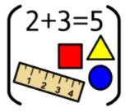
- Area & Perimeter - Shape
- Angles
- Statistics
Year 6 will be using LBQ to support their learning this half term.

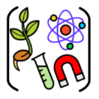
Science: We will be focusing on learning about body health.

English: We will focusing on the book ‘The Promise’ by Nicola Davies. We will be writing an extended narrative, as well as a non-fiction piece based on learning about deserts

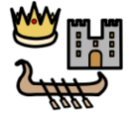
Geography: We will finding out about deserts and how these are being impacted by humans.
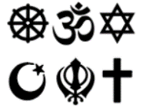
RE: In RE we will be focusing on salvation and Jesus’ resurrection still impacts Christians today.

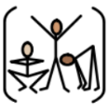
Art: We are going to creating 3d shadow art this half term, focusing on artists such as Tim Nobel and Sue Webster.

PE: We will be practising our dance skills and developing our skills basketball skills. Year 5/6 T have PE on Thursday and Friday. Year 5/6P have PE on Wednesday and
Friday. Year 5/6WP have PE on Wednesday and Thursday.

Computing: We will be looking at databases.

