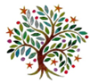
Spring 2
Year 3 & 4
Dear Parents and carers,
Welcome back. We hope you had a lovely, restful half term. Here is an idea of what we will be learning in Year 3 and 4 in our new topics over the next 5 weeks. Our Lens this half term is: ‘Actions & Consequences’. Our Big Question this half term is: ‘Do all actions have consequences?’, where we will look at ‘Do rainforest really matter?’ in geography and ‘Plants and classification’ in science.
What will we be learning?
We have lots of great learning opportunities coming up this half-term:

Maths:
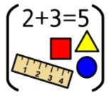
- mutlipliaction
- Division
- Fractions & decimals

English: We will be reading a fantastic book called The Great Kapok Tree by Lynne Cherry, to help develop our writing skills as well as explore rainforests. As well, we will be looking at performance poetry using There’s a Rang Tan in My Bedroom.

Geography: We will be exploring Rainforests. Within our lessons, we will be locating where in the world they are, who lives in them and how they are changing. We will focus our study on the Amazon rainforest as well as looking at our local woodland.

RE: We will explore Who or what is god? though the beliefs of people with different worldviews.

Art: This half term we will be looking at 3D sculpture, and then creating our own sculptures. We will be looking at the work of Alexander Calder and Thomas Heatherwick.
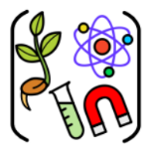
Science: This half term, we will be looking at classifying plants and animals using Venn diagram, Carroll diagrams. We will spend time looking at vertebrates, invertebrates and plants.

PE: Children will be doing Dance with Mr Whittle on a Monday – for all classes. With class teachers, children will be looking at basketball. Remember children are to come to school in PE kit on PE days.

Computing: This half term, children will be coding or altering the appearance of text and images.
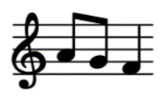
Music: Year 3 and 4 will be singing each Monday morning. They will also begin to look at composing music. Year 3/4
Parent Drop-ins

Subject | Date | Activity
Reading | Thursday 5th March | Come and share a book and a biscuit with your child for World Book Day.
Art | Thursday 19th March | Whole School Art Exhibition

Dates to remember:
- Wednesday 25th February 2026 – Year 3 ad Year 3/4 – trip to Herbert Museum and Art Gallery
- Friday 27th February 2026 – Year 4 – trip to Herbert Museum and Art Gallery
- Thursday 5th March 2026 – World Book Day

