









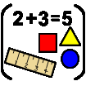
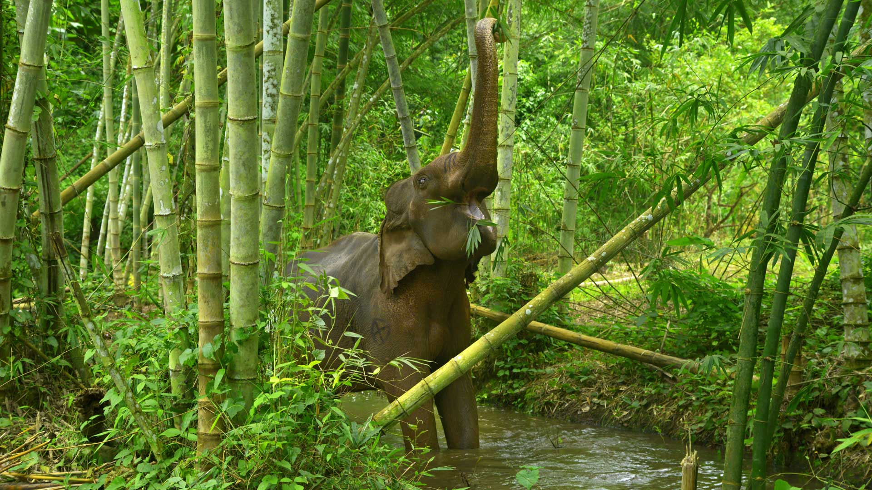
Sustainability
Rainforests and Jungles
Why should we love our planet?
Key vocab in this topic is:

Habitat
Shelter
Climate
Camouflage
Map
Solid
Liquid
Gas
Change
Humidity
Environment
Endangered
Extinct

Maths: count beyond 20 recognising the counting pattern, explore the composition of numbers to 10, explore doubles and odd & even numbers. Name and describe 3D shapes, use a greater range of time vocabulary.

In Understanding the World we will be comparing woods/forests/jungles around the world, looking at maps of the world to identify woods/forest/jungles, learning how to look after our forests and the species that live there. Exploring changes in state through humidity.

English Opportunities:
Retell and adapt stories as a class. Learn new vocabulary and use it in our own play.
Tell stories using small world toys and puppets and write sentences about our play.

In Expressive Arts and Design we will be planning and making animal models, drawing and painting jungle pictures and using different materials to create spring pictures.
In this topic we will explore and answer the questions…
Are all woods the same?
Where are all the forests?
What lives in all the trees?
Why are there so many trees in the world?
Texts that go with this topic are:
Traditional Tale- Little Red Hen by Paul Galdone
We’re Roaming in the Rainforest by Laurie Krebs
Slowly, Slowly, Slowly Said the Sloth by Eric Carle
Monkey Puzzle by Julia Donaldson
Secrets of the Rainforest by Carron Brown

In the rest of the curriculum we will be doing:

Physical Development – working hard on a tripod grip and adding more detail to pictures.
PE – demonstrating coordination with ball skills.
Phonics – reading 4/5 sound words and 3/4 sound nonsense words.
RE unit – What times are special and why?
PSHE unit – Healthy Me
Celebrations – Shrove Tuesday, Easter
Season – spring, exploring the changes in the natural world.
Value - forgiveness
Music – matching the pitch and melody in call and response songs.
EYFS - Reception

