






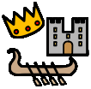


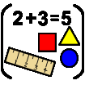
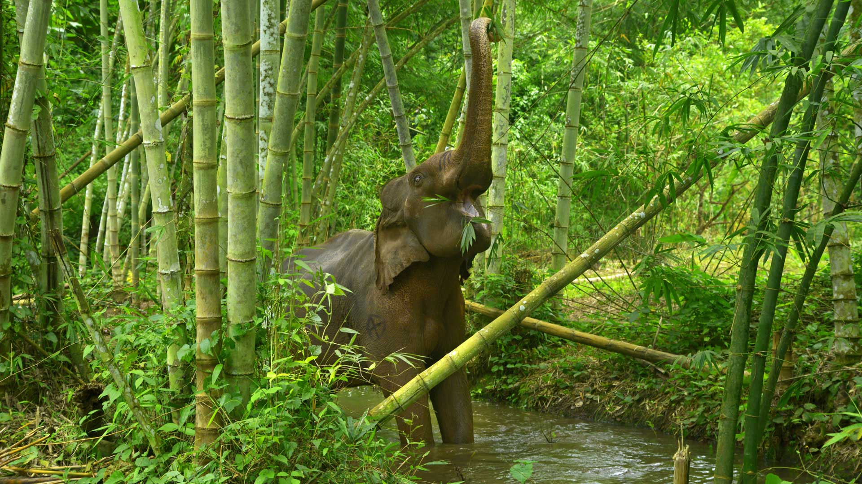
Sustainability
Rainforests and Jungles
Why should we love our planet?
In the rest of the curriculum we will be doing:
Personal, Social and Emotional Development – Beginning to solve our own conflicts and talk about our feelings.
Physical Development – trace familiar letters
PE – moving like different animals.
Phonics – fill in missing words in rhymes and exploring letter sounds.
Celebrations – Shrove Tuesday, Easter
Season – spring, exploring the changes in the natural world.
RE and Value - forgiveness
Music – copy the pitch of a tune an adult has sung. Exploring the sounds of instruments.
Key vocab in this topic is:

Rainforest
Jungle
Habitat
Tree
Plant
Flower
Bush
Hot
World
Destroyed
Endangered
Extinct

In Understanding the World we will explore natural materials from a forest, look at woods/forest/jungles from different countries and talk about what we notice, plant seeds and watch them grow, learn about how to look after woods and the animals that live there.
Maths: counting accurately objects to 5, linking the numeral to amounts, showing finger numbers to 5, reciting numbers to 10 and making marks and symbols to represent numbers. Naming and describing shapes, extending repeating patterns and sequencing events.

In Expressive Arts and Design we will be making pictures and models of animals.
English Opportunities:
Copy repetitive phrases from a story in their play.
Recognising print with pictures around the classroom and in books.
Answer questions.

Texts that go with this topic are:
Traditional Tale- Little Red Hen by Paul Galdone
We’re Roaming in the Rainforest by Laurie Krebs
Slowly, Slowly, Slowly Said the Sloth by Eric Carle
Monkey Puzzle by Julia Donaldson
Secrets of the Rainforest by Carron Brown
In this topic we will explore and answer the questions
Are all woods the same?
Where are all the forests?
What lives in all the trees?
EYFS - Nursery

