






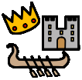


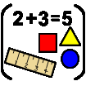
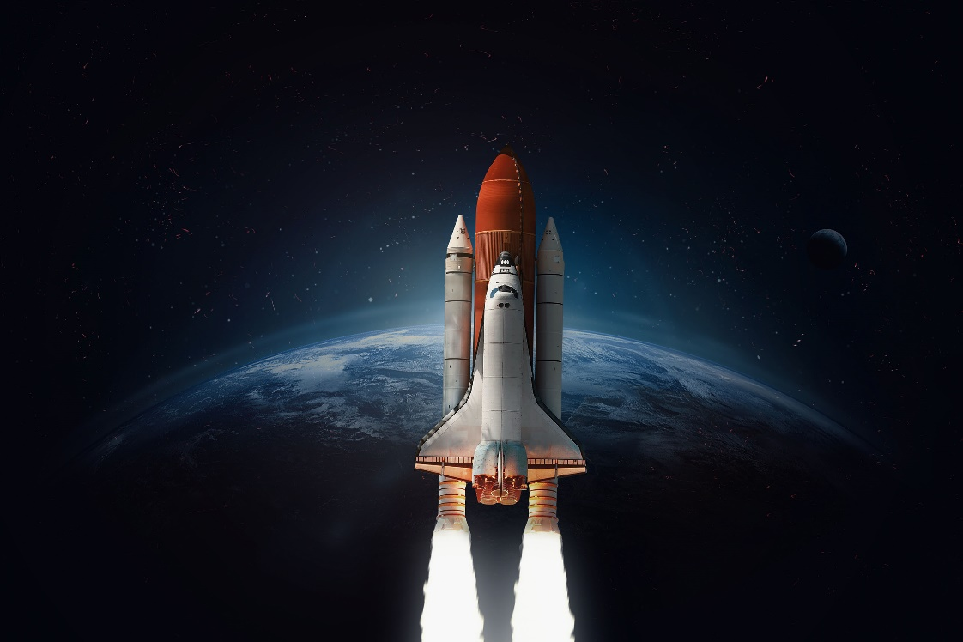
Space
Do all actions have consequences?
Texts that go with this topic are:
Traditional Tale- The 3 Little Pigs by Mara Alperin
Goodnight Spaceman by Michelle Robinson
QPootle by Nick Butterworth
The Way Back Home by Oliver Jeffers
Aliens in Undrepant Save the World by Claire Freedman
Little Explorers Outer Space by Ruth Martin
English Opportunities:
Retell stories about space. Learn new vocabulary and use it in role-play.
Tell stories using small world toys and puppets.

In the rest of the curriculum we will be doing:
Physical Development – forming letters and drawing pictures with greater control.
PE – Movement – refining skills of crawling and rolling.
Phonics – learning special friends’ sounds and reading some words containing them.
RE unit – What places are special and why?
PSHE unit – Dreams and Goals
Celebrations – Chinese New Year
Season – Winter, exploring the changes in the natural world.
Value - courage
Music – matching the pitch and melody in call and response songs.
In Expressive Arts and Design we will be learning some new paint techniques, collaborating to create some large planets, designing and making rockets.
In Understanding the World we will be comparing habitats, exploring forces such as gravity and learning about light and shadows. We will learn about the occupation of an astronaut and about some famous ones.
Be
Key vocab in this topic is:

Habitat
Shelter
Climate
Camouflage
Gravity
Force
Transparent
Opaque
Astronaut
Oxygen
Planets

In this topic we will explore and answer the questions
Where is space?
What is space?
What can I see in space?
Maths: continuing to subitise with random arrangements, recognising patterns which show ‘1 more’, continuing to explore the composition of small numbers recognising the missing ‘parts’, comparing mass and talking about capacity.

EYFS - Reception

Actions and Consequences

