






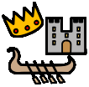


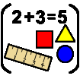
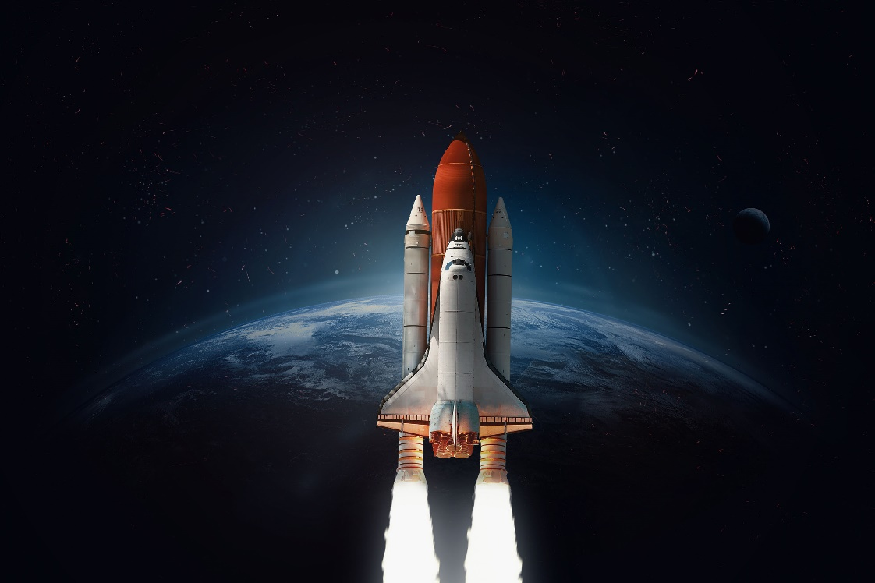
Actions and Consequences
Space
Do all actions have consequences?
In Understanding the World we will explore a new occupation – being an astronaut! We will explore the properties of materials and explore some new processes such as floating and sinking and light and shadow.
Be
In the rest of the curriculum we will be doing:
Personal, Social and Emotional Development – Playing with friends more independently.
Physical Development – beginning to use one-handed tools and making lines on white boards.
PE – Movement songs, listening to instructions.
Phonics – joining in with rhymes and continue to discriminate between sounds.
Celebrations – Chinese New Year
Season – Winter, exploring the changes in the natural world.
RE and Value - courage
Music – listening to different music and talking about how it makes us feel.
Key vocab in this topic is:

Push
Pull
Shape
Model
Solid
Flat

In Expressive Arts and Design we will be making snowflakes, making models of spaceships and using dough to make aliens.
English Opportunities:
Joining in with some actions and words to help an adult to retell a story.
Recognising print with pictures in role-play and around the classroom.

Texts that go with this topic are:
Traditional Tale- The 3 Little Pigs by Mara Alperin
Goodnight Spaceman by Michelle Robinson
QPootle by Nick Butterworth
The Way Back Home by Oliver Jeffers
Toys in Space by Mini Grey
Little Explorers Outer Space by Ruth Martin
In this topic we will explore and answer the questions
Where is space?
What is space?
What can I see in space?
Maths: making comparisons between small groups of objects (up to 3), reciting numbers beyond 5, making comparisons between objects length and height and playing games to understand positional language.

EYFS - Nursery

