- i) Draw a rectilinear shape on squared paper with a perimeter of 50cm.
- How many other rectilinear shapes can you draw with a perimeter of 50cm? (Mild: 1 more. Medium: 2 more. Spicy: 3 more)
- Liam has two rectangular tiles like this.

5cm

11cm

He makes this L shape.
- What is the perimeter of Liam’s L shape?
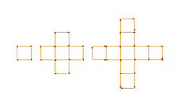
- Draw a different rectilinear shape with the same perimeter.
C
- Look at these rectilinear shapes.
- Calculate the perimeters of A, B and C.
B
- Make the fourth shape in the pattern.
A
- What is its perimeter?
- Spicy: Work out what the fifth shape’s perimeter will be without making it.

Spicy challenge:
