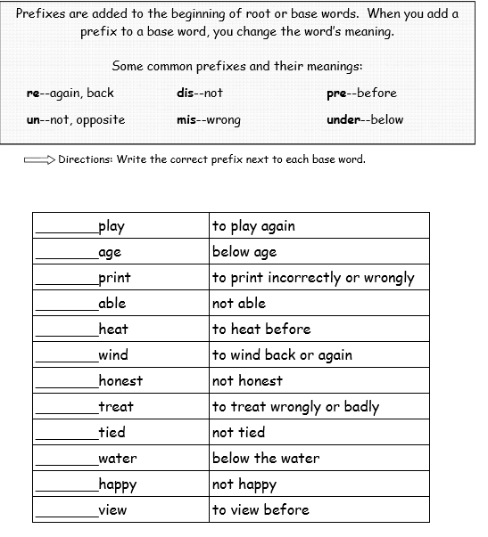
LO: Know what prefixes are and be able to use them
Try doing a 10 minute challenge – just like we do in class! Set yourself a timer for ten minutes and write a story that includes as many words with prefixes as you can! Underline them in a coloured pen, or write them in a different colour if you like!

Self- Assessment:

