LO: Solve word problems about place value
Everybody have a go at the medium – if it is too easy, try spicy. You can mix and match too if you like, as long as you have done at least 4 sections.

Spicy Challenge
Medium Challenge

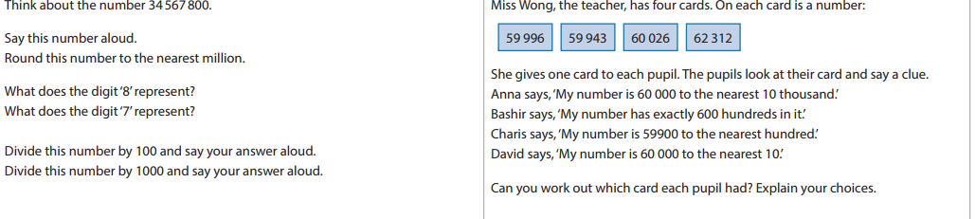
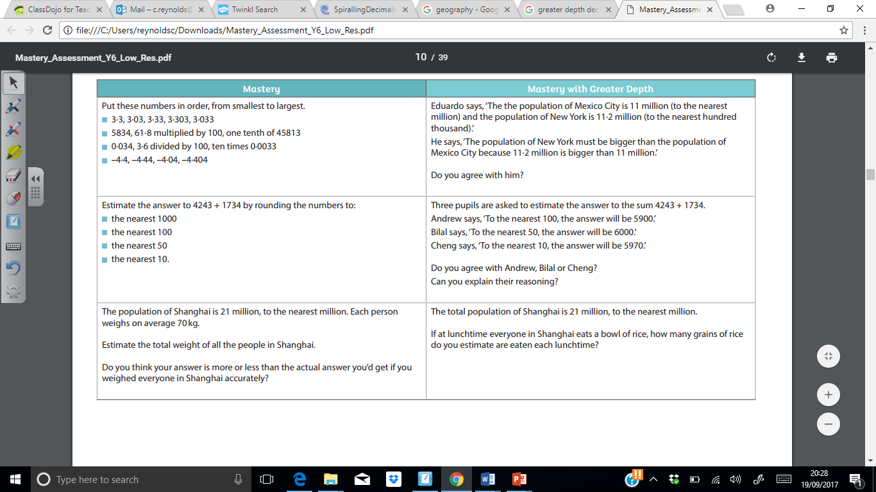
Now write a little comment about how you found that task overall…Be honest! If you needed a little help from an adult or friend, just say! Equally, if you just steamed through it and found it easy peasy – say so and I’ll aim for something harder next time! I want to know what you are capable of. I have tried to make them trickier this week, so please don’t worry if you struggled a bit!

Self – Assessment:

