Year 1 Autumn 1

Harvest celebration in church, Autumn walk to the Brickcroft
Welcome back to school and to Year 1! We hope you have had an amazing holiday and are ready to settle back into school for some fantastic learning and fun with friends. Below you will find an outline of our learning for this half term. We always have a Science topic and then a mix of other subjects rotating over the year. This will help you with project ideas for later on this half term. Please ask if you are not sure about anything as we go through the year. Here’s to a great year!

Geography:  KQ: What is it like here?  - Where in the world are we?  - What can we see in the classroom?  - Where can we find our school grounds?  - What are the different places in school?  - How do we feel about our playground?  - Can we make our playground even better?  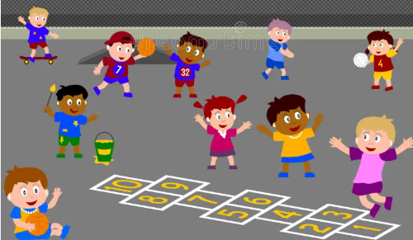 |  | Science: Forces and Space: Seasonal changes  KQ: How do the seasons change?  - How does the weather change across the 4 seasons?  - What events and activities take place in different seasons?  - How do trees change across the 4 seasons?  - How does daylight change across the 4 seasons?  - What changes can we see across the 4 seasons?  - How do you plan and carry out a weather report?  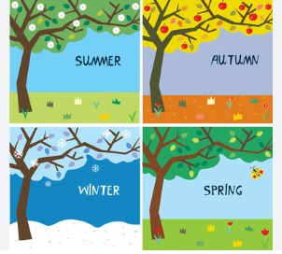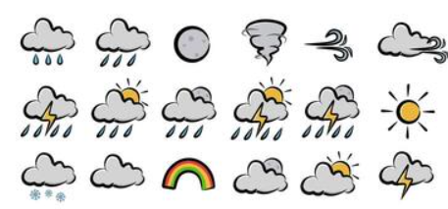
Key Vocabulary - deciduous tree, evergreen tree, season, weather, aerial view, sea, land, city, features, place , locate, belief,
believe, create, creator, creation, idea, natural, proof, proud

History:  KQ: | RE:  KQ: How did the world begin?  • What do I believe?  • What is creation?  • What might some Christian and Jewish People think about creation?  • What do some Hindu people believe about creation?  • What do creation stories suggest to some people about God?  • Where did the world come from? |  | PSHE: My healthy self- How can we look after our emotions?  - What emotions can we recognise?  - When and why do people show different emotions?  - How cam emotions change?  - What helps us feel calm or excited?  - What might make us fell worried, annoyed or upset?  - What can we do when our emotions get tricky?
Computing:  - Multi media- creative computing  PE:  - Ball skills  - Fundamental movement skills | Music:  - Keep the pulse – my favourite things  Art: Drawing – exploring line and shape |  | Drama  - Recap activities, drama techniques e.g. mirroring, miming

