Year 1 Spring 2nd half term
Welcome back – hope everyone had a great break and did some exciting things! (Don’t forget to tell me all about it in your holiday passports!) Our learning for this half term is outlined below; we have Celebration assembly coming up, our Easer celebrations, make an Easter bonnet to join our parade, Easter shop, Easter egg bingo and our Easter service in church at the end of the half term. More details on all of these to follow via parent mail.
History: How have toys changed?  - What is your favourite toy?  - Did your grandparents play with the same toys as you?  - What were toys like in the past?  - What is similar /different about toys now and in the past?  - How have teddy bears changed over time?  - How have toys changed?  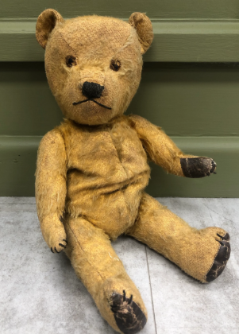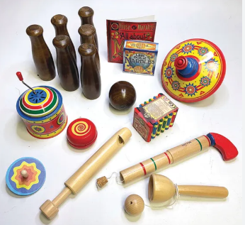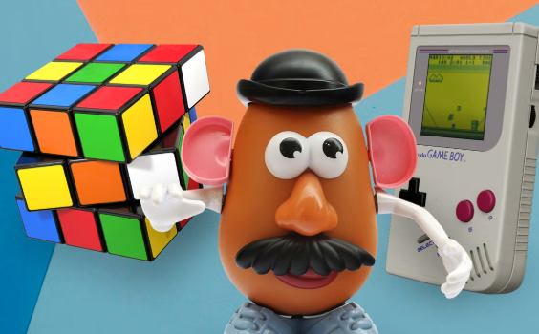 |  | Science: Animals – Comparing animals  - How can you identify and group animals?  - How can you describe animals?  - How can we compare animals?  - Which animals are carnivores, herbivores or omnivores?  - Which animals make suitable pets?  - Who was Jane Goodall  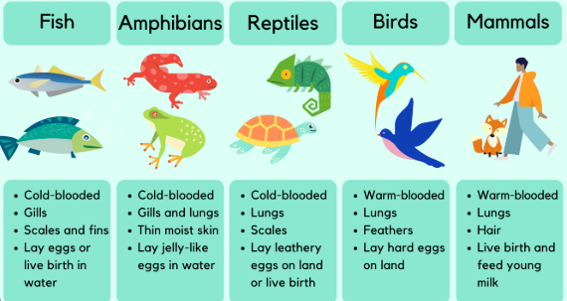
Key Vocabulary
artefact different memory past present similar
carnivore herbivore omnivore compare diet
blend chopping board evaluate healthy ingredients recipe

DT: Food: Fruit and vegetable smoothies  KQ: Can you prepare fruit and vegetables to make a smoothie?  - What fruits and vegetables do you know?  - How do you know it is a fruit?  - How do you know it is a vegetable?  - What words can you use to describe them, how they:  - feel?  - taste?  - smell?  - What is a smoothie?  - How do you prepare fruit and vegetables ready for use?  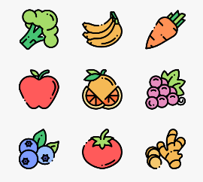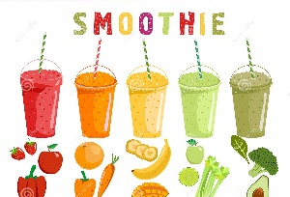 | RE: Why should we care for the world?  - Why do some people believe we should care for the world?  - What do some Muslim people believe about caring for the world?  - What other reasons are there for caring about the world?  - Why should we care for the world?   |  | PSHE: Safety and the changing body  - What do I do if I get lost?  - How do I make an emergency phone call?  - How do I keep safe at home?  - Who can help me keep safe?  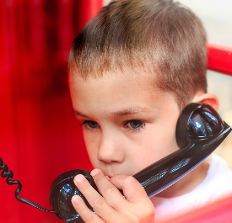  
Computing:  - Technology all around us  PE :  - Games – target games  - Games – invasion games | Music:  Art:  - Sculpture and 3D – paper play

