Year 1 Summer 1st half term
Welcome back; hope everyone had a great break and managed to enjoy some sunshine! This half term as well as our normal fantastic learning we have our class assembly, a trip to Southport to compare human and physical features, Arts week, sports day… busy, busy as always !!More details to follow on all of these as we go through the term.
Geography - KQ: What is it like in Shanghai?  - What can we see in our local area?  - Can we map our local area?  - Where in the world is China?  - What can you see in China?  - What is Shanghai like?  - How is Shanghai different from our local area?  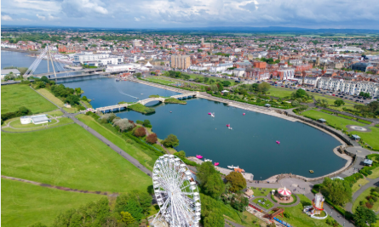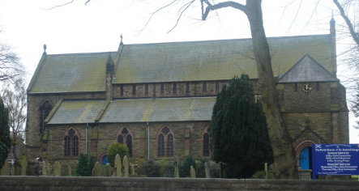 |  | Science: Plants -introduction to plants  - What is a plant?  - What are the names of parts of a flowering plant?  - Which plants are wild, which are garden plants?  - Which trees are evergreen, which are deciduous?  - Where do new plants come from?  - Which plant parts can you eat?  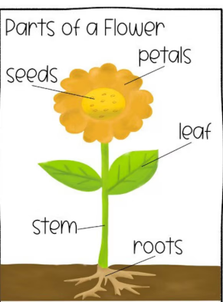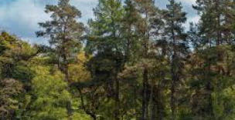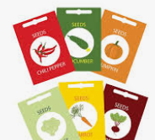
Key Vocabulary
Continent, different, human feature, physical feature, flower, garden plants, leaf, observe, seed, wild plants, design, fabric, needle, stitch, thread, scripture, creator, creation, Torah, Brahman, Proof
Blend, primary colour, print, secondary colour, shade., care, democracy, different, fair, responsibility, similar, unique, vote

DT Textiles: Simple stitches  - What is fabric?  - What stitches can you make?  - What design will your bunting be?  - How will you stitch your design?  - What was your finished bunting like?   | RE: Why should we care for others?  . What can we learn about caring for other though stories?  · Why do people care for others?  · How might Muslim people show it is important to care for others?  · Is giving always the same?  · Why might some humanists choose to care for others?  · What inspires some people to care for others? |  | PSHE: Citizenship  Rules: Why are rules important?  Caring for others: How are animal needs different and how do we care for them?  The needs of others: Why are babies and young children’s needs different?  Similar or different: How are we the same/different to others?  Belonging: What groups do people belong to?  Democratic decisions: How does democracy work?
Computing: Physical computing and programming  PE :  - Athletics  Tennis | Music – Superheroes - pitch  Art: Painting and mixed media  - Colour splash |  | Arts week - 100 years theme

