Year 1 Spring 1st half term

Happy New Year and welcome back! This half term we are exploring our senses and what is it like in the UK. We continue to experience the seasons and will be going on a Winter walk to the Brickcroft. Parents evenings are later on this term please remember to have fun with your children completing a project, it can be topics we are learning about last half term/this half term or a hobby, club the children belong to. We also have our Valentines shop and disco at the end of the half term. Thank you for all your support with reading and homework, it really does make a difference.
Geography: What is it like here?  - Where is the UK?  - What are the names of the 4 seasons?  - What are the names of simple compass directions?  - What is the weather like today?  - Is the weather the same everywhere in the UK?  - How do people prepare for the weather?  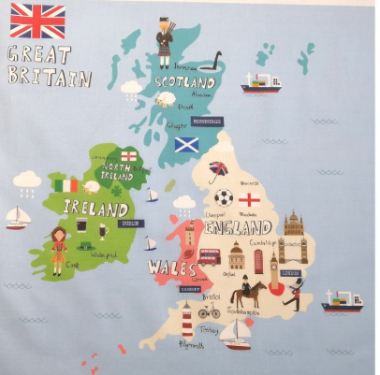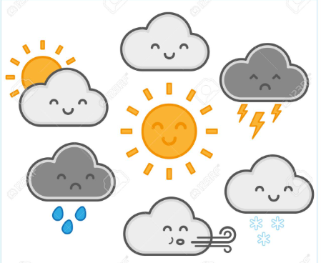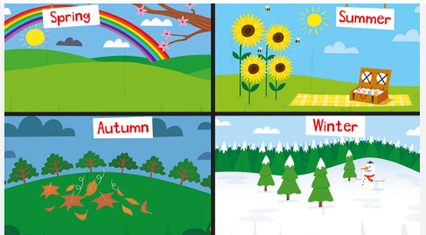 |  | Science: Animals – Sensitive bodies  - What are the names of different parts of the human body?  - Which body part is used for each sense?  - What body parts do we use for touch and taste?  - Which body parts do we use for smell and sight?  - Which body part do we use for hearing?  - How do we use our senses in everyday life?  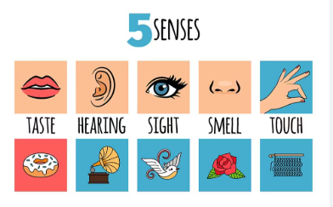
DT: Structures: Stable structures  KQ: Can you make a pencil pot meeting a design criteria?  - Can you follow design criteria to meet the needs of a user?  - How do you make a stable structure?  - How does weight help to stabilise?  - Can you design a stable pencil pot?  - How can you improve your pencil pot?  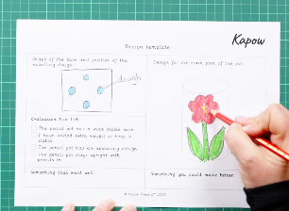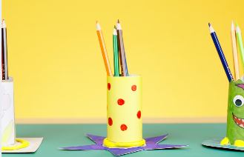 | RE:  Why should we care for the world?  - Who owns the world?  - Who can care for the world?  - Why do some people believe we should care for the world?  - What do some Muslim people believe about caring for the world?  - What other reasons are there for caring about the world?  - Why should we care for the world?  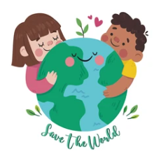 |  | PSHE: SCARF – Keeping safe  KQ: How Our Feelings Can Keep Us Safe?  How many different feelings can people have?  Do different feelings make your body feel different?  What can you do if you have ‘not so good’ feelings?  How can you help if someone else has ‘not so good’ feelings?  Keeping Healthy  What do people need to keep healthy?  How do you keep yourself healthy?  Why do we need different things to be healthy?  Medicine Safety  How do medicines help?  Are medicines always helpful?  Where do medicines need to be kept? Why?
Computing:  - Technology around us  PE:  - Gymnastics  - Dance - Pirates | Music:  - Music vocabulary. Theme - under the sea  Art:

