Year 1 Autumn 2nd half term

Welcome back and hope everybody had a lovely holiday, don’t forget to share your holiday news in your holiday passports. This half term we will be celebrating Remembrance Day in our usual way and we have all the exciting Christmas events to look forward to, starting with the Year 1 and Reception Nativity Play. We also have our Celebration assembly in church, more details on all of this to follow as we go through the term.
History: KQ: How am I making history?  - What is my history?  - How can I find out about myself?  - How are special events remembered?  - What was it like for children in the past?  - What have I learnt about childhood in the past?  - How am I making history?  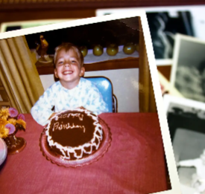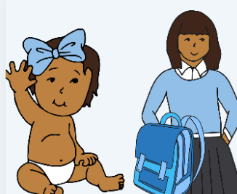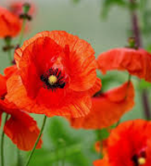 |  | Science: KQ: What are the properties of everyday materials?  - What are the names of different materials?  - What materials can I find around school?  - What are the properties of different materials?  - Is it absorbent?  - Is it waterproof?  - Is it tough?  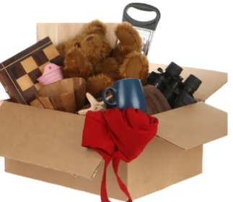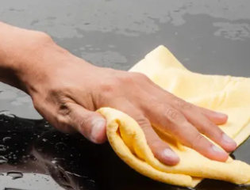
DT: Mechanisms Moving story books  KQ: How do you create a moving picture book?  - How can you make pictures move?  - Can you design a moving picture book?  - Can you construct a moving picture book?  - How successful was my moving picture book?  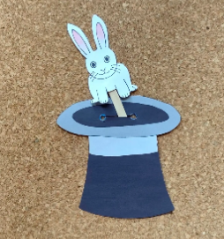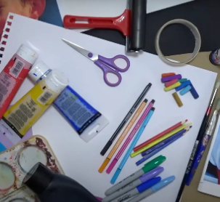 | RE:  KQ; What do some people believe God looks like?  • How might ideas about God be represented?  • What do some Muslim people believe about God?  • What so some Hindu people believe God looks like?  • What do some Christian people believe God looks like?  • Do people all share the same beliefs about what God looks like?  • Why do people have different names for God?  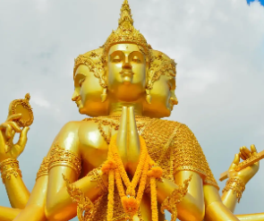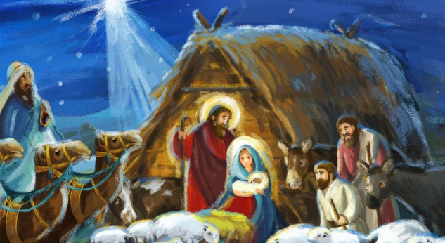 |  | PSHE: Recognising, Valuing difference  How are people different?  How are people similar?  What is good about people being different?  Developing tolerance  What is fair?  What is unfair?  Do things seem unfair even when they’re not?  Why do some people see something as unfair and other people see it as fair?  
Computing:  - Creative computing – digital painting  PE:  - Gymnastics  - Dance | Music:  Art: drawing – make your mark |  | Drama

