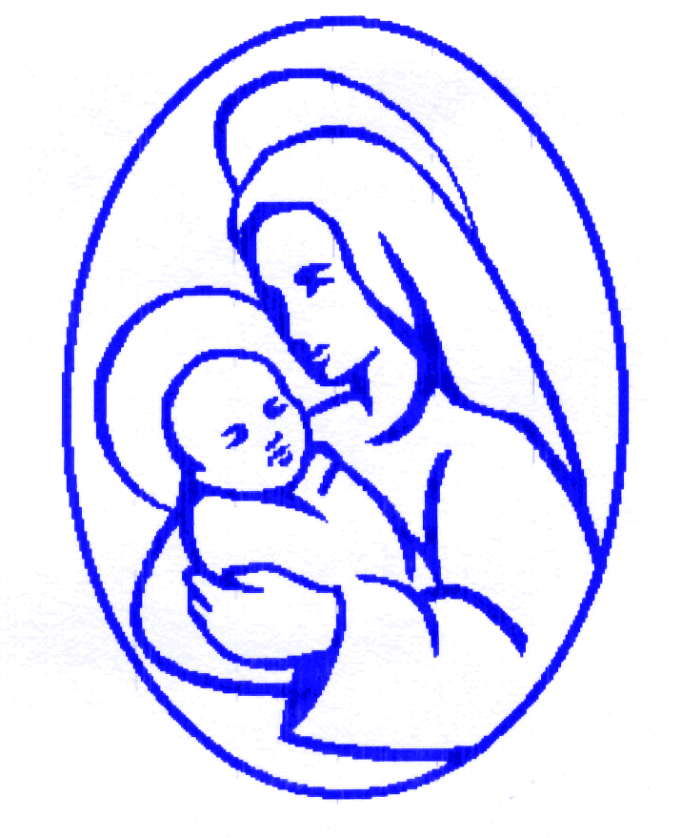

‘Love one another as Jesus loved us’ (John 13 v 34-35)

Art and Design at St Mary’s CE Primary School

Art and Design Curriculum Rationale
At St Mary’s CE we are artists, designers and craft makers! We want the children at our school to love Art and Design. We want our children to aim high, be ambitious and grow up wanting to be illustrators, graphic designers, curators or printmakers. Our vision at St Mary’s CE Primary School is to encourage and nurture the growth of every individual and their uniqueness, so that all flourish and become all that they can be and all that God made them to be.

The Art and Design curriculum has been carefully designed and sequenced so that our children develop their Art and Design capital. We want our children to remember their Art and Design lessons in our school and embrace the Art and Design opportunities they are presented with! Previously, children in Year 6 have been set a challenge of studying and creating street art, using shading techniques, perspective and scale and effectively enhancing visual impact. This builds on prior learning in Year 5 where pupils explore mark making to show depth, emotion and movement. Bringing Art and Design alive is important at St Mary’s CE Primary School.

Curriculum Intent
The Art and Design curriculum is ambitious and allows our children to become independent and resilient – like all curriculum areas.
We want to equip our pupils with all the statutory requirements of the Art and Design National Curriculum and also prepare them for the opportunities, responsibilities and experiences in the next stage of their education and beyond. We do this by ensuring all children:

● Produce creative work
● Explore their own ideas
● Record their experiences
● Become proficient at drawing, painting, sculpting
● Become proficient at general art, craft and design techniques
● Evaluate and analyse creative works using artistic language
● Know about great artists, craft makers and designers
● Understand historical and cultural developments of art forms

At St Mary’s Primary School, we believe that developing art and design skills provides a valuable educational, social and cultural experience for our pupils. We want to expand their personal horizons, instil in them a love of learning and to foster inquisitive minds, resilience, self-motivation and respect for all.

At St Mary’s we are committed to teaching Art and Design to every child. By learning about different artists and cultures, we give our children a new perspective on the world, encourage them to understand their own culture and history, and that of other countries.

Children leave St Mary’s, with confidence in sharing their artistic skills, as well as understanding and respect for other cultures, and customs. At St Mary’s we believe that through
through our Art and Design curriculum, we provide enjoyment and prepare our children for the next steps in their education and for the future beyond.

Implementation
Learning in Art and Design at St. Mary’s is delivered through the Kapow scheme of work. The Kapow Art scheme of work is designed with four strands that run throughout.
These strands are:
- Making skills
- Formal elements (line, shape, tone, texture, pattern, colour)
- Knowledge of artists
- Evaluating
These strands are revisited in every unit. In the art and design skills and formal elements of art units, pupils have the opportunity to learn and practise skills discretely. The knowledge and skills from these units are then applied throughout the other units in the scheme. Key skills are revisited again and again with increasing complexity in a spiral curriculum model. This allows pupils to revise and build on their previous learning.

The Curriculum overview document (Appendix 1) shows which units cover each of the National Curriculum attainment targets as well as each of the strands.

The Progression of skills document (Appendix 2) shows the skills that are taught within each year group and how these skills develop to ensure that attainment targets are securely met by the end of each key stage.

Kapow Primary’s Art and Design curriculum develops pupil’s knowledge and understanding of key artists and art movements through the ‘Every picture tells a story’ units and links to artists through practical work. The units fully scaffold and support essential and age appropriate sequenced learning. Creativity and independent outcomes are robustly embedded into the units, supporting pupils in learning how to make their own creative choices and decisions, so that their outcome, whilst being knowledge rich, are unique to the pupil and personal.

Lessons are practical in nature and encourage exploratory and experimental learning. Art books are used in Key Stage 1 and 2 by pupils to document their ideas.
Differentiated guidance is available for every lesson to ensure that lessons can be accessed an enjoyed by all pupils and opportunities to stretch pupil’s learning are available when required.

Knowledge organisers for each unit support pupils in building a foundation of factual knowledge by encouraging recall of key facts and vocabulary.

As part of the scheme pupil videos created by subject specialists help pupils to see art techniques modelled by experts.

Within each unit taught there are multiple teacher videos to develop subject knowledge and support CPD. This is to ensure that all teachers feel supported to deliver lessons of a high standard that ensure pupil progression.

In Key Stages 1 and 2 Art and Design is timetabled for at least one hour per week, across three half terms . In Reception (EYFS) weekly art activities are provided through continuous provision and planned for via focussed tasks.

Art equipment and paper is stored centrally in the Shared Resource Area, Reception has their own supply of paint and additional resources required for continuous provision.

Impact
Children will:
- Produce creative work, exploring and recording their ideas and experiences
- Be proficient in drawing, painting, sculpture and other art, craft and design techniques.
- Evaluate and analyse creative works using subject specific language.
- Know about great artists and the historical and cultural development of their art.
- Meet the end of key stage expectations outlined in the National curriculum for art and design.

The impact of the Art curriculum is constantly monitored through both formative and summative assessment opportunities. Each lesson in the scheme includes guidance to support teachers assessing pupils against learning objectives. Summative outcomes are recorded on FFT.

After the implementation of the Art and Design scheme, pupils should leave primary school equipped with a range of techniques and the confidence and creativity to form a strong foundation for their Art and design learning at Key Stage 3 and beyond

At St Mary’s CE Primary School,
we are
ARTISTS!

Art and Design programmes of study:

Key Stages 1 and 2

Purpose of study
Art, craft and design embody some of the highest forms of human creativity. A high-quality art and design education should engage, inspire and challenge pupils, equipping them with the knowledge and skills to experiment, invent and create their own works of art, craft and design. As pupils progress, they should be able to think critically and develop a more rigorous understanding of art and design. They should also know how art and design both reflect and shape our history, and contribute to the culture, creativity and wealth of our nation.

Aims
The national curriculum for art and design aims to ensure that all pupils:
- produce creative work, exploring their ideas and recording their experiences
- become proficient in drawing, painting, sculpture and other art, craft and design techniques
- evaluate and analyse creative works using the language of art, craft and design
- know about great artists, craft makers and designers, and understand the historical and cultural development of their art forms.

Attainment targets
By the end of each key stage, pupils are expected to know, apply and understand the matters, skills and processes specified in the relevant programme of study.
Schools are not required by law to teach the example content in [square brackets].

Subject content – Key stage 1
Through a variety of creative and practical activities, pupils should be taught the knowledge, understanding and skills needed to engage in an iterative process of designing and making. They should work in a range of relevant contexts [for example, the home and school, gardens and playgrounds, the local community, industry and the wider environment].

Pupils should be taught:

to use a range of materials creatively to design and make products

to use drawing, painting and sculpture to develop and share their ideas, experiences and imagination

to develop a wide range of art and design techniques in using colour, pattern, texture, line, shape, form and space

about the work of a range of artists, craft makers and designers, describing the differences and similarities between different practices and disciplines, and making links to their own work.

Subject content – Key stage 2
Pupils should be taught to develop their techniques, including their control and their use of materials, with creativity, experimentation and an increasing awareness of different kinds of art, craft and design.

Pupils should be taught:
- to create sketch books to record their observations and use them to review and revisit ideas
- to improve their mastery of art and design techniques, including drawing, painting and sculpture with a range of materials [for example, pencil, charcoal, paint, clay]
- about great artists, architects and designers in history.

