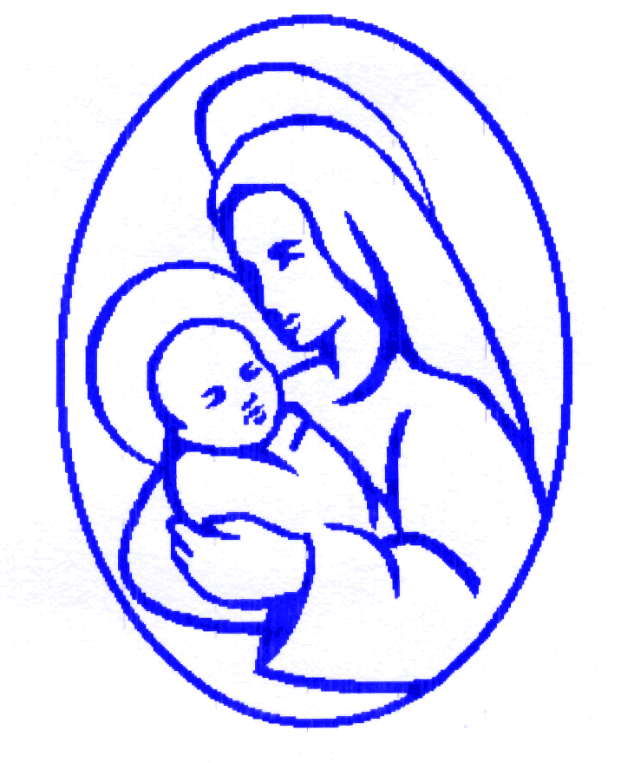

 | Autumn 1
RECEPTION | Genre:
 | Week 1 | Week 2 | Week 3 | Week 4 | Week 5 | Week 6 | Week 7
 | Stories familiar to children  For example:  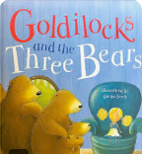 | The Troll / Three Billy Goats Gruff  Rules  Roles  Simple positional language  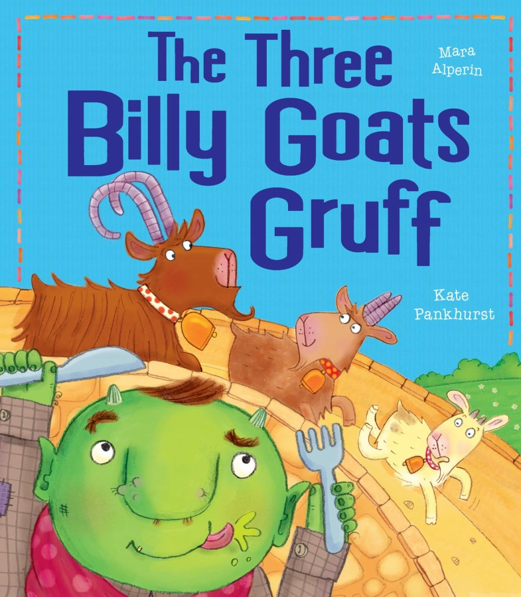 | Funny Bones  Who lives in my house?  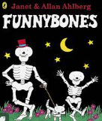 | My Body  All about me & my body  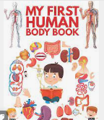 | Supertato  How do I grow?  Write about vegetables and growth.  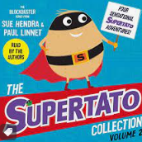 | Pirates Love Underpants  Towns, cities, seaside -writing about differences and similarities.  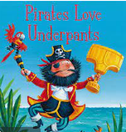 | Who sank the boat?  Science writing – floating and sinking  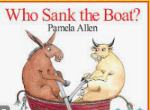
 | Autumn 2
RECEPTION | Genre:
 | Week 1 | Week 2 | Week 3 | Week 4 | Week 5 | Week 6 | Week 7
 | 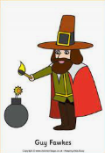  Guy Fawkes | Whatever Next  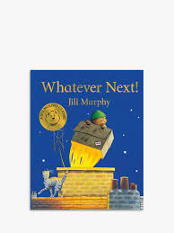 | Rama & Sita - Diwali  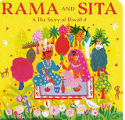 | 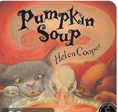  Pumpkin Soup | Maisie Goes to London  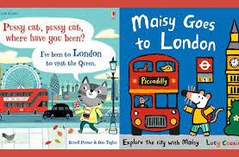 | 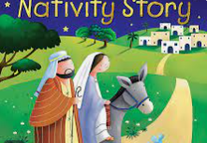  Nativity Story | A letter to Father Christmas  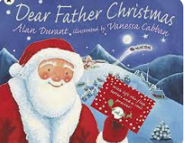
RECEPTION | Spring 1
 | Genre:
 | Week 1 | Week 2 | Week 3 | Week 4 | Week 5 | Week 6
 | One Snowy Night  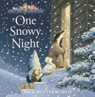 | Gruffalo’s Child  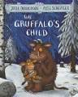  Non Fiction- Penguins | Day monkey Night Monkey  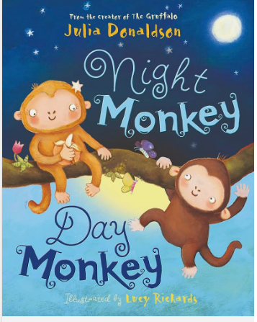 | The Three Little Pigs  Chinese New Year Non Fiction Texts  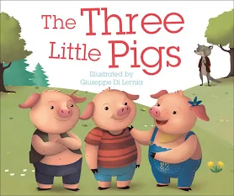 | Peace at Last  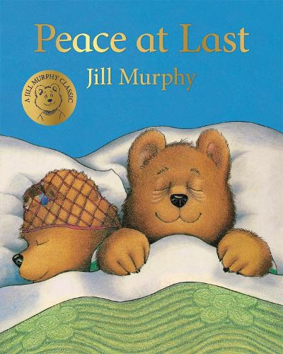 | TheLittle Red Hen  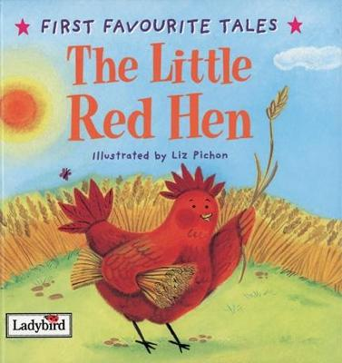
RECEPTION | Spring 2
 | Genre:
 | Week 1 | Week 2 | Week 3 | Week 4 | Week 5 | Week 6
 | Flower Garden  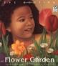 | A Tiny Seed  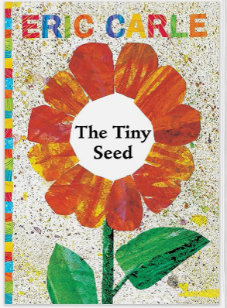 | Jasper’s Beanstalk  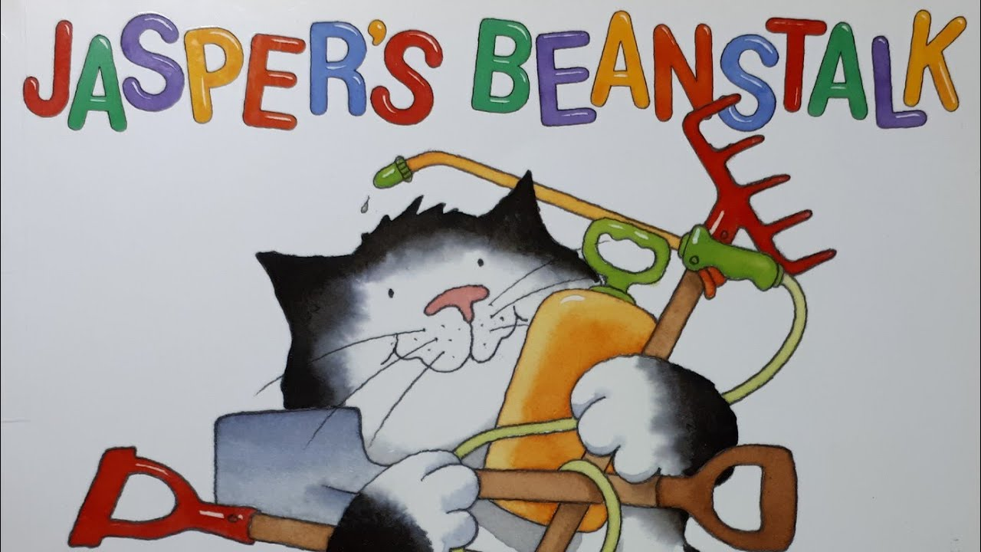 | The Enormous Turnip  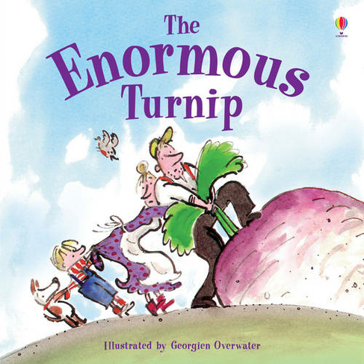 | The Leaf Thief  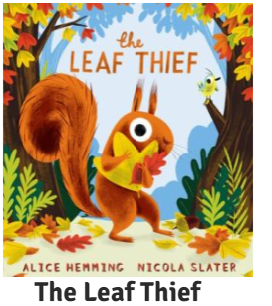 | The Very First Easter  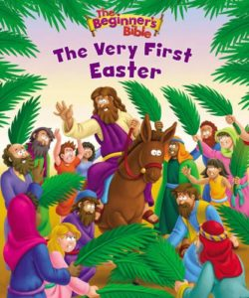
RECEPTION | Summer 1
 | Genre:
 | Week 1 | Week 2 | Week 3 | Week 4 | Week 5 | Week 6 | Week 7
 | Minibeast Encylopeadia  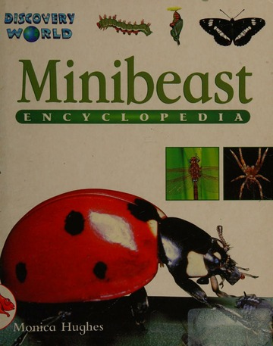 | The Very Hungry Caterpillar  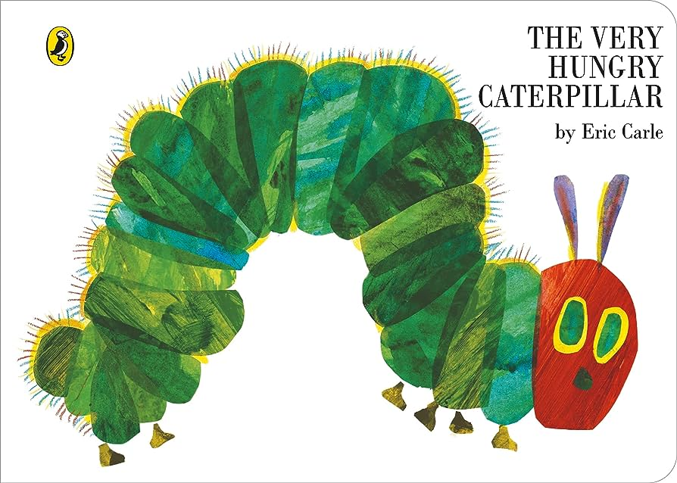 | The Frog life cycle  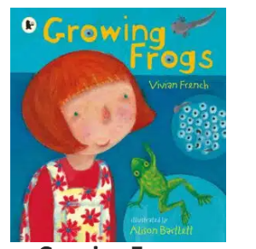 | What the Ladybird heard  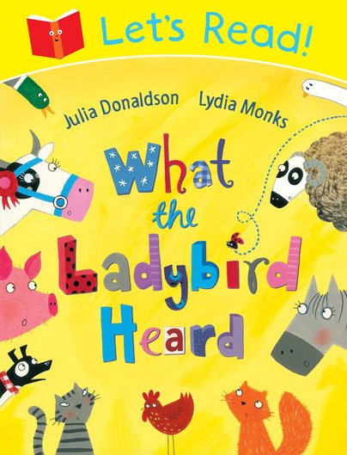 | Commotion in the Ocean  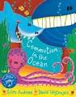 | Harry Saves the Ocean  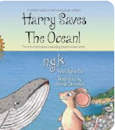 | What is a habitat?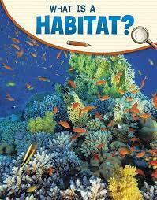
RECEPTION | Summer 2
 | Genre:
 | Week 1 | Week 2 | Week 3 | Week 4 | Week 5 | Week 6 | Week 7
 | Book of Seasons  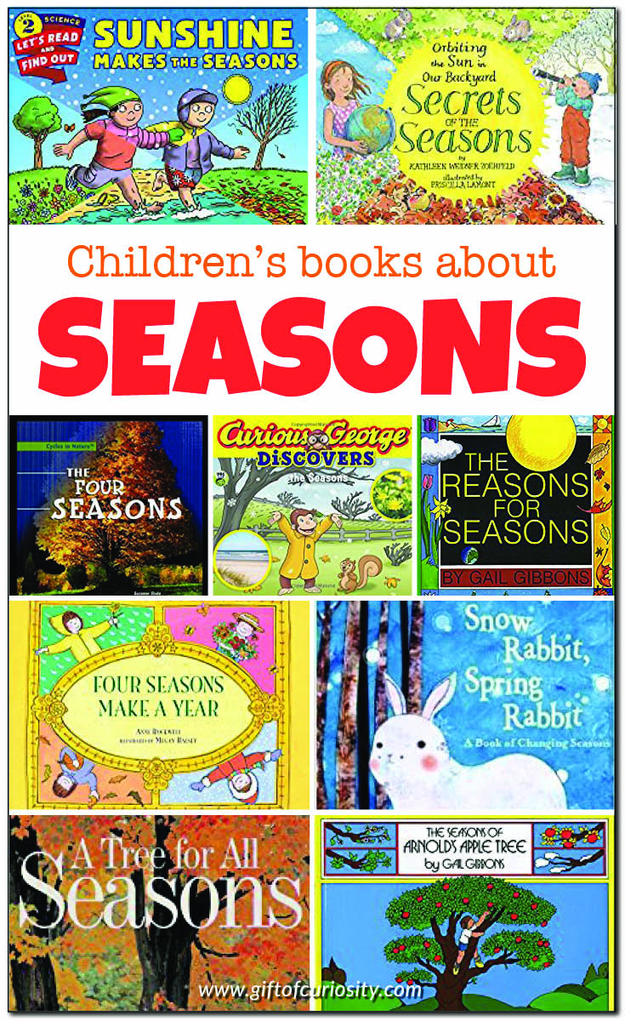 | Dear Zoo  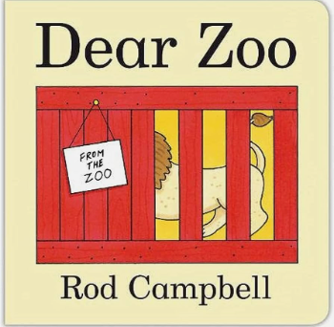 | The Queen’s Hat  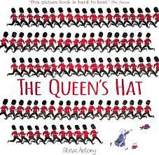 | Look what I found at the seaside  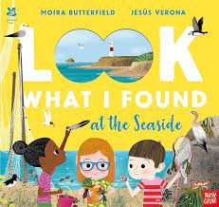 | Loony Little  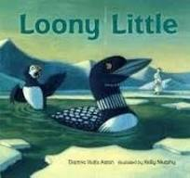 | Going to India  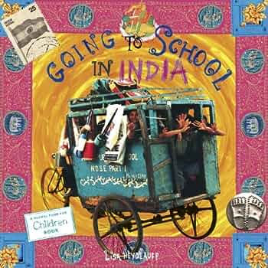 | Rocky and Blanche  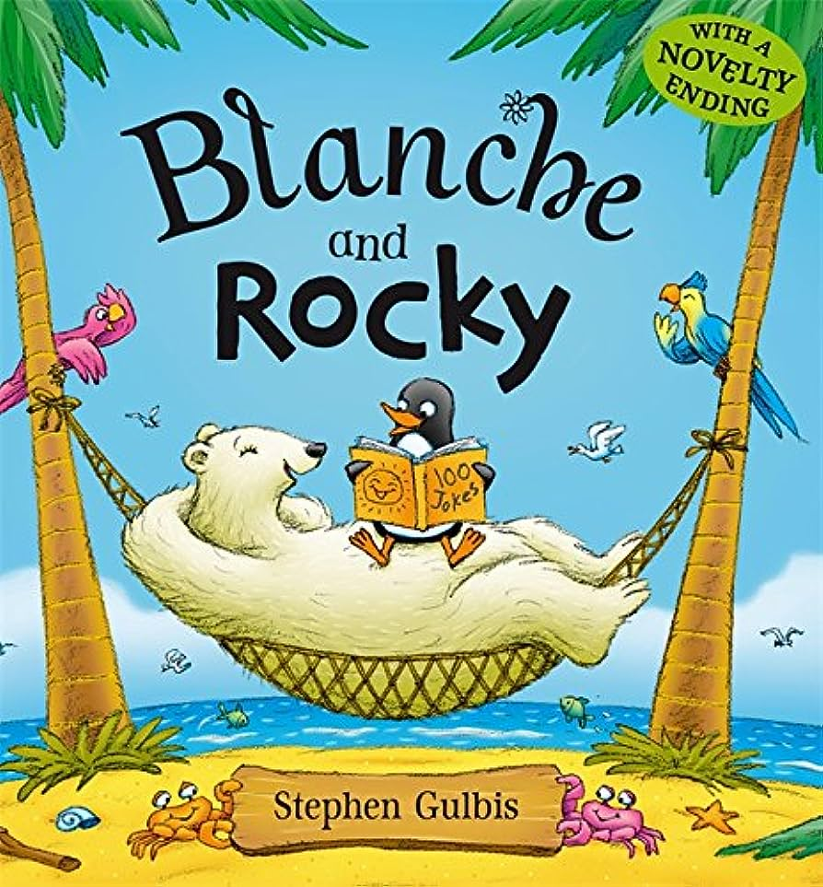

‘Love one another as Jesus loved us’ (John 13 v 34-35)

 | Autumn 1
Year 1 | Genre:
 | Week 1 | Week 2 | Week 3 | Week 4 | Week 5 | Week 6 | Week 7
 | Basics  Key skills: writing their name, letter formation, alphabet, what is a letter / grapheme / word / sentence?  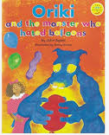 | Poetry -  Poems with Pattern & Rhyme (Leaf Poems)  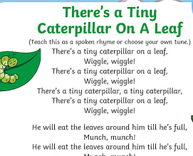 | Poetry -  Poems about the Senses  (My 5 Senses)  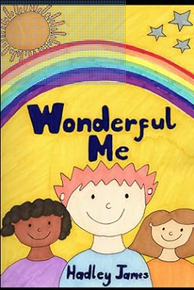 | Our Local Area  N-F writing -Lists, captions  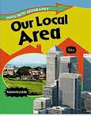 | Our Local Area  N-F writing -Lists, captions  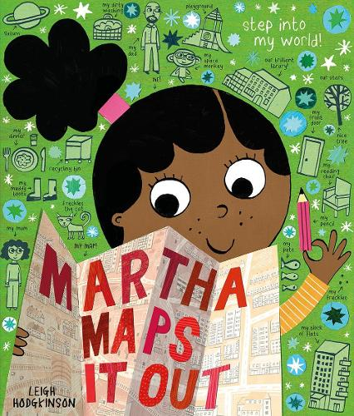 | Stories with familiar setting –  Anna’s Amazing Coloured Glasses  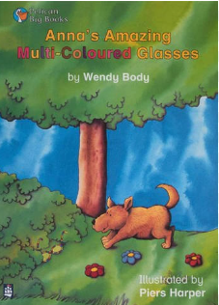 | Stories with familiar setting –  Gruffalo  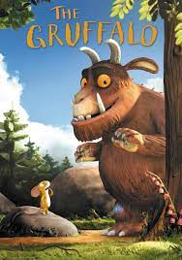
 | Autumn 2
Year 1 | Genre:
 | Week 1 | Week 2 | Week 3 | Week 4 | Week 5 | Week 6 | Week 7
 | Descriptive writing  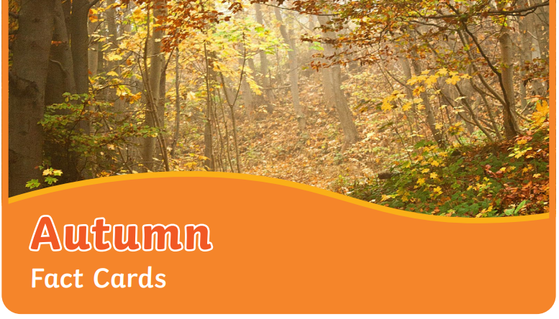  What will you see in autumn? | Stories with repeating Patterns- Retell  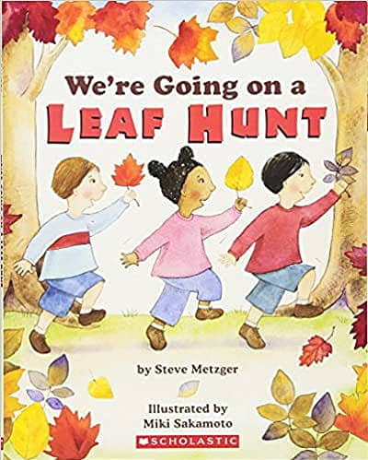 | Stories with repeating Patterns  Retell  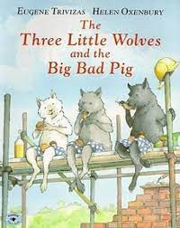 | Stories with repeating Patterns  Retell  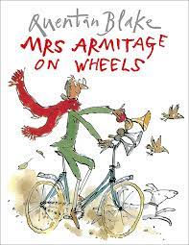 | Information texts:  What is the Christian Christmas Festival?  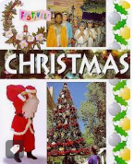 | Characters  The Grinch  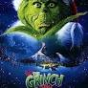  Explore the character of the Grinch  Write own character description | Letters  The Grinch  Formal Letter- asking the Grinch to please not try and take Christmas away again and invite to Christmas lunch
 | Spring 1
Year 1 | Genre:
 | Week 1 | Week 2 | Week 3 | Week 4 | Week 5 | Week 6
 | Letters  Dear Snowman  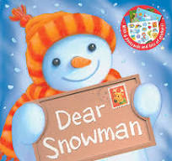 | Information Leaflet  Seren’s Seasons  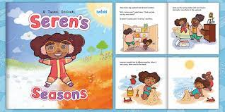 | Information - fact fIle  The Boy Who Lost His Bumble  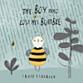  Cycle of the effects of the seasons on the bumble bee | Traditional Tales  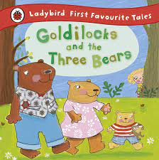 | Traditional Tales  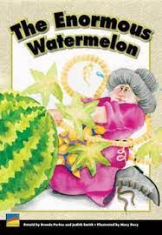 | Traditional Tales  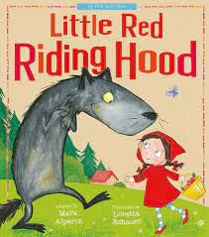
 | Spring 2
Year 1 | Genre:
 | Week 1 | Week 2 | Week 3 | Week 4 | Week 5
 | Labels, Lists and Signs  The Big Book of Blooms  Plants  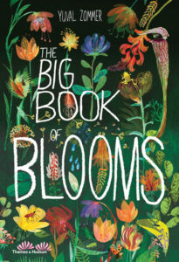 | Information Text - create a toy Fact File  Use dictated sentences with known /taught words/phonics/phrases.  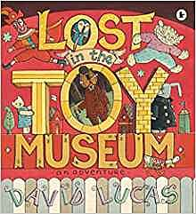 | Narrative  Sequencing a story and writing from dictated simple sentences (use of known words/phonemes already taught  (see Twinkl story sequencing activity)  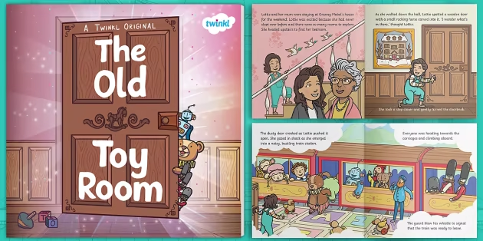 | Poetry  -song poems -  plants and living things (performance poetry)  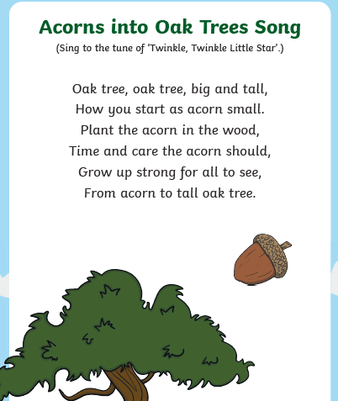  Pupils learn some simple plant songs to perform and try to write simple lines of song - repetition. | Poetry  -acrostic poetry  Simple acrostic poetry - toys.  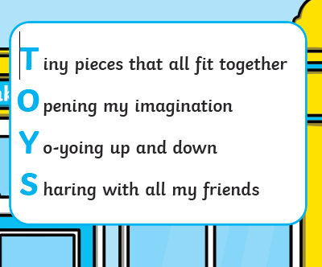  Learn a simple acrostic poem about toys/a toy. Adapt, change and write own with given words already taught.
 | Summer 1
Year 1 | Genre:
 | Week 1 | Week 2 | Week 3 | Week 4 | Week 5 | Week 6 | Week 7
 | Recount –  Holiday News  Don’t forget the bacon!  Recount a trip to the shops on holiday..  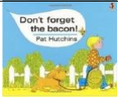  https://www.youtube.com/watch?v=6GY-oy5laAA | Instructions  How to Make a Jam Sandwich  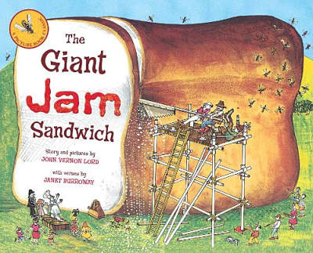 | Instructions  How to make a fruit salad  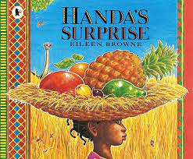 | Stories from different cultures  Recount | Non Fiction Report  Lifecycle of a penguin  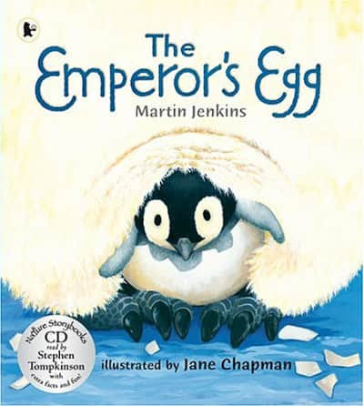 | Fantasy Stories  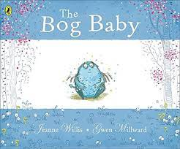 | Information text  Marvellous body  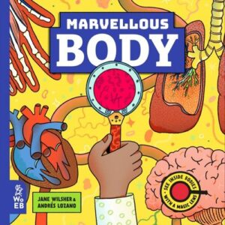
 | Summer 2
Year 1 | Genre:
 | Week 1 | Week 2 | Week 3 | Week 4 | Week 5 | Week 6 | Week 7
 | Descriptive Writing  (recount)  On my holidays I…  Simple recount based on teacher holiday experience as model text.  Sentence structure and formation.  Oral frames for rehearsal. | Descriptive Writing  A Postcard From ….  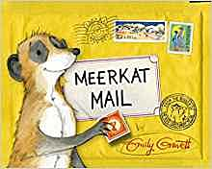 | Fantasy Stories  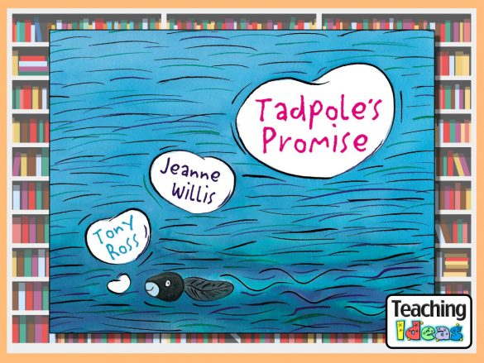  Write a different ending | Fantasy Stories  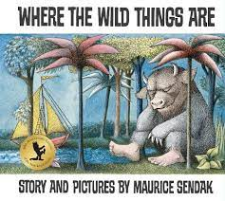 | Non Fiction Report  Little People, Big Dreams - Emeline Pankhurst  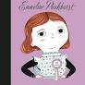 | Letters  A letter to say thank you..  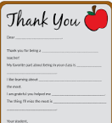  Model letters to thank staff around the school… | Letters  A letter to myself in Year 2..  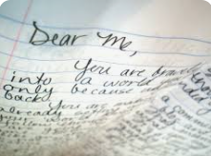

Year 2

 | Autumn 1
Genre:
Year 2 | Week 1 | Week 2 | Week 3 | Week 4 | Week 5 | Week 6 | Week 7
 | Recounts from the summer.  Basic standards  Writing standard english  Oral rehearsal | Re-tell: Vlad and the Great Fire of London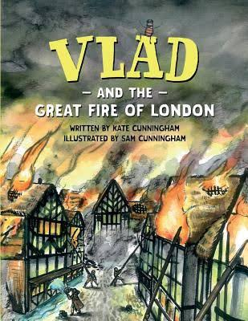 | Re-tell: Vlad and the Great Fire of London | Poetry: Tell Me a Dragon  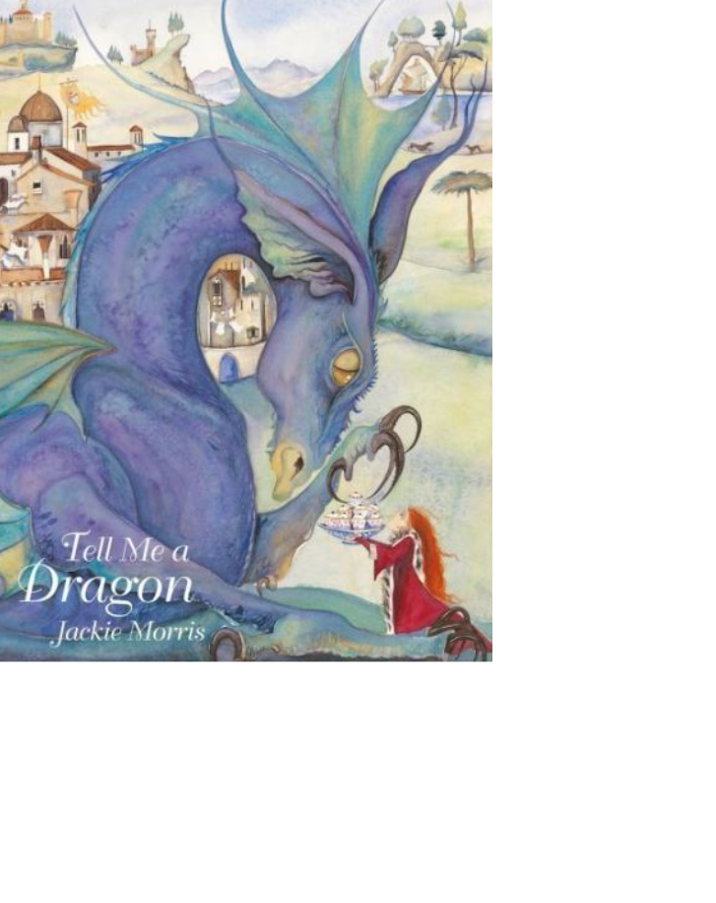 | Poetry: Tell Me a Dragon | Reports: Tell Me a Dragon | Reports: Tell Me a Dragon
 | Autumn 2
Year 2 | Genre:
 | Week 1 | Week 2 | Week 3 | Week 4 | Week 5 | Week 6 | Week 7
 | Instructions: The Disgusting Sandwich  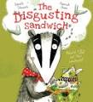 | Instructions: The Disgusting Sandwich | Instructions: How to Catch a Dragon  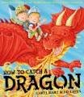 | Instructions: How to Catch a Dragon | Narrative comparison: The Dragon Machine and The Tin Forest  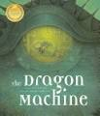  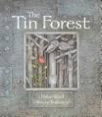 | Narrative comparison: The Dragon Machine and The Tin Forest | A letter to Father Christmas  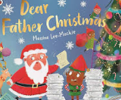
 | Spring 1
Year 2 | Genre:
 | Week 1 | Week 2 | Week 3 | Week 4 | Week 5 | Week 6
 | Recount: Dougal’s Deep-Sea Diary  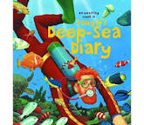 | Recount: Dougal’s Deep-Sea Diary | Postcard/Letter: Dougal’s Deep-Sea Diary | Postcard/Letter: Dougal’s Deep-Sea Diary | Character Description: The Barnabus Project  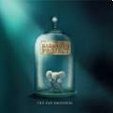 | Character Description:  The Barnabus Project
 | Spring 2
Year 2 | Genre:
 | Week 1 | Week 2 | Week 3 | Week 4 | Week 5
 | Setting Description: Katie Morag Delivers the Mail  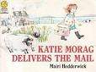 | Setting Description: Katie Morag Delivers the Mail | Re-tell: Katie Morag and the Two Grandmothers  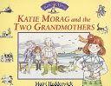 | Re-tell: Katie Morag and the Two Grandmothers | The Lighthouse Keeper’s Lunch  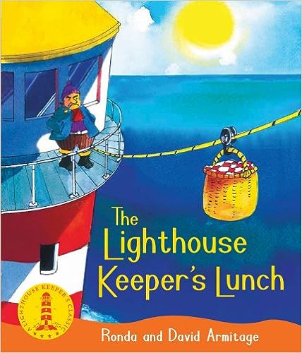
 | Summer 1
Year 2 | Genre:
 | Week 1 | Week 2 | Week 3 | Week 4 | Week 5 | Week 6 | Week 7
 | Toys in Space  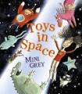 | Toys in Space | Man on the Moon  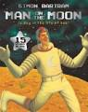 | Man on the Moon | Letter: Dear Miss  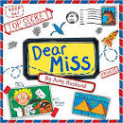 | Letter: Dear Miss | Assessment  Week
 | Summer 2
Year 2 | Genre:
 | Week 1 | Week 2 | Week 3 | Week 4 | Week 5 | Week 6 | Week 7
 | Significant Author Poetry: Please Mrs. Butler  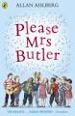 | Significant Author Poetry: Please Mrs. Butler | Humorous Poetry: Michael Rosen  Chocolate Cake  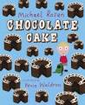 | Humorous Poetry: Michael Rosen  Chocolate Cake | Classic Poetry: The Owl and the Pussy Cat  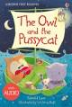 | Classic Poetry: The Owl and the Pussy Cat | All about me:  Fact Files and letters for my new class teacher.  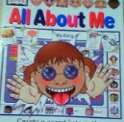

Year 3

Year 3 | Autumn 1
Genre:
 | Week 1 | Week 2 | Week 3 | Week 4 | Week 5 | Week 6 |  | Week 7
 | Recounts from the summer.  Basic standards  Writing standard english  Oral rehearsal  Writing with descriptive detail. | Fables  The Hare and  The Tortoise  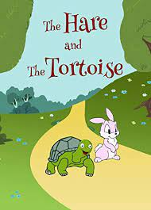 | Fables  The Hare and  The Tortoise | Narrative  Stone Age Boy  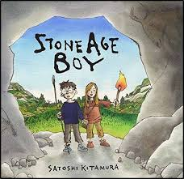 | Narrative  Stone Age Boy | Dialogue and Plays  Jack and Jill  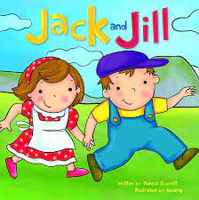 |  | Dialogue and Plays  Jack and Jill
Year 3 | Autumn 2
 | Genre:
 | Week 1 | Week 2 | Week 3 | Week 4 | Week 5 | Week 6 |  | Week 7
 | Myths  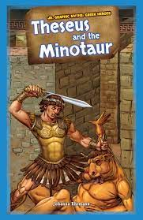 | Myths | Myths  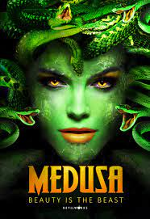 | Myths | Myths  Non-Chronological Reports  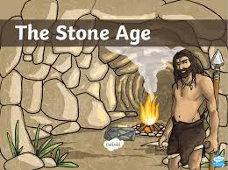 | Myths  Non-Chronological Reports |  | Character Development:  The Christmas Miracle of Jonathan Toomey  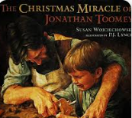
Year 3 | Spring 1
Genre
 | Week 1 | Week 2 | Week 3 | Week 4 | Week 5 | Week 6
 | Mystery Stories  The 25th December  Incident  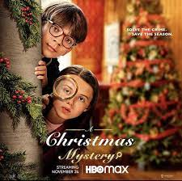 | Mystery Stories  The 25th December  Incident | Mystery Stories  The Mystery of the Bookcase  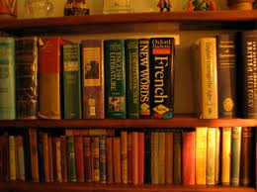 | Mystery Stories  The Mystery of the Bookcase | Shape Poems  Calligrams  Pyramid poems  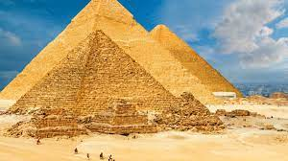 | Shape Poems  Calligrams  Shape poems - raindrops and love hearts  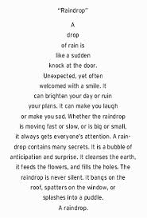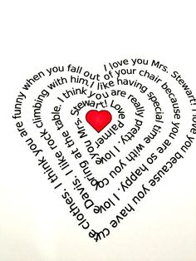
Year 3 | Spring 2
 | Genre:
 | Week 1 | Week 2 | Week 3 | Week 4 | Week 5 | Week 6
 | Instructions  George’s Marvellous Medicine  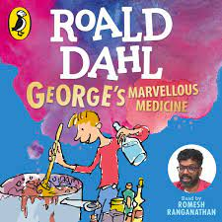 | Instructions  George’s Marvellous Medicine | Procedural  Beware of Boys  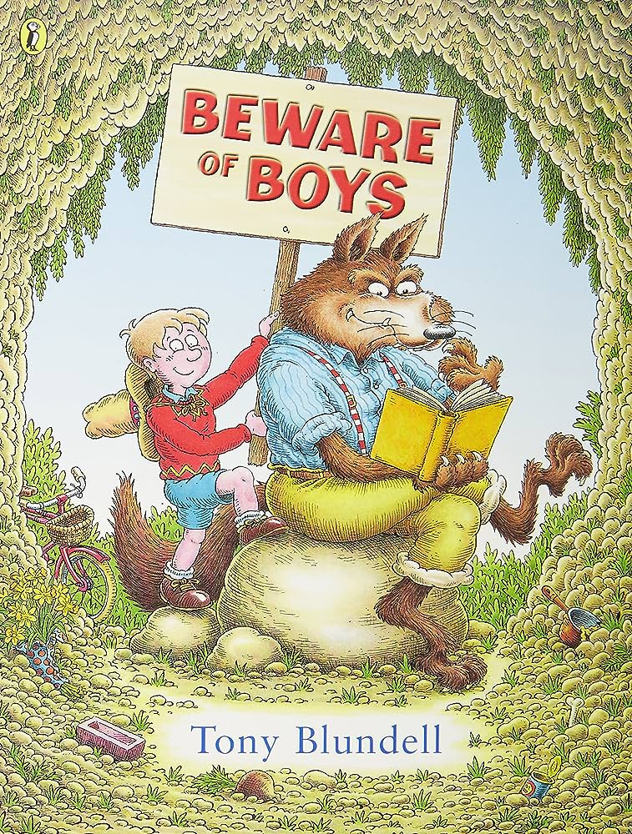 | Procedural  Beware of Boys | Diary Entry  Tadeo Jones - Ancient Egypt Tomb Raider  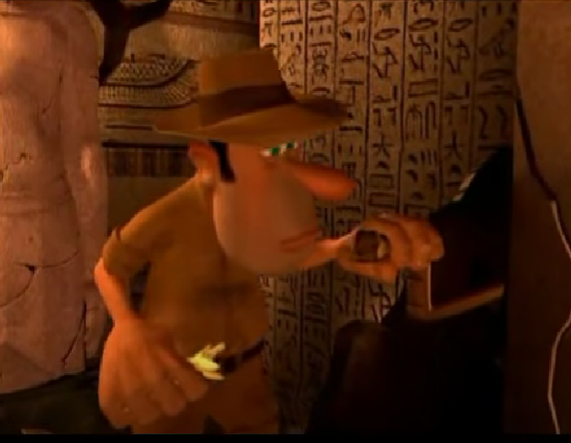 | Diary Entry  Tadeo Jones - Ancient Egypt Tomb Raider
Year 3 | Summer 1
 | Genre:
 | Week 1 | Week 2 | Week 3 | Week 4 | Week 5 | Week 6 |  | Week 7
 | Information Text  Mythical Monsters - information text  (Pie Corbett)  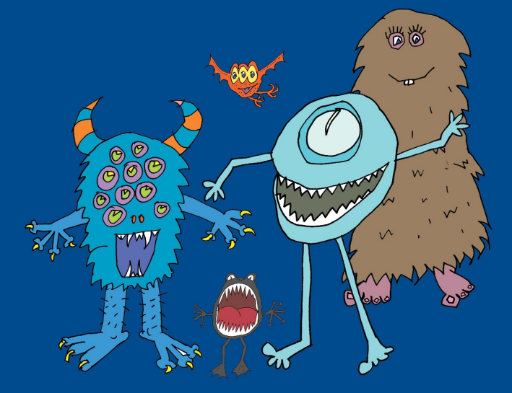 | Information Text  Mythical Monsters - information text  (Pie Corbett) | Persuasive Text  Write a Holiday Advert - Fictional Seaside town  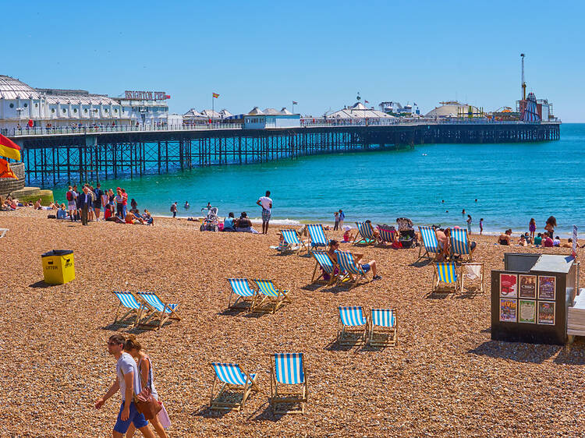 | Persuasive Text  Write a Holiday Advert - Fictional Seaside town | Poetry  Language Poem  In the Land of the Bumbley Boo  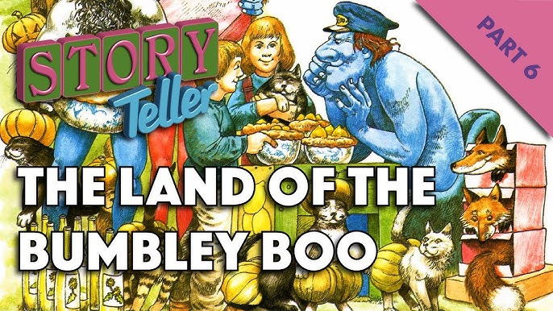 | Character Description  The Twits  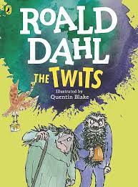 |  | Assessment  Character Description  The Twits
Year 3 | Summer 2
 | Genre:
 | Week 1 | Week 2 | Week 3 | Week 4 | Week 5 | Week 6 |  | Week 7
 | Letters  Letter to an inspirational person   | Letters  Letter to an inspirational person | Performance Poem  Gran can you rap?  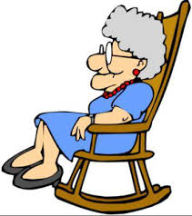 | Performance Poem  Please Mrs. Butler  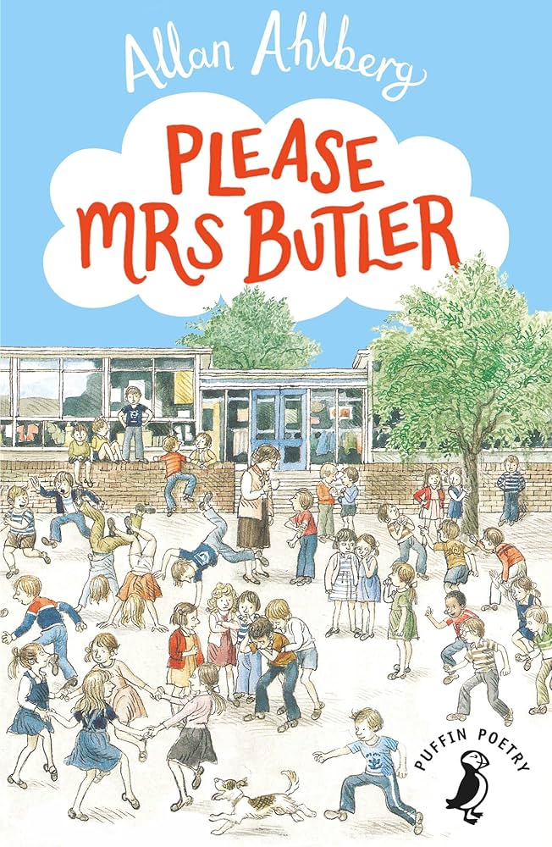 | Information Text on Rivers  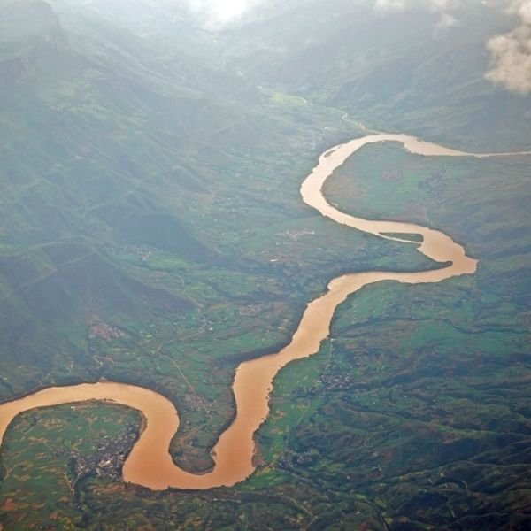 | Information Text on Rivers |  | Letter to Year 2 pupils: how to survive Year 3

YEAR 4
 | Autumn 1
Genre:
 | Week 1 | Week 2 | Week 3 | Week 4 | Week 5 | Week 6 |  | Week 7
 | Recounts from the summer.  Basic standards  Writing standard english  Oral rehearsal  Writing with descriptive detail.  Introducing fronted adverbials. | Stories with historical settings  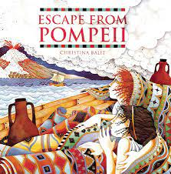 | Stories with historical settings | Stories with historical settings - Defeat the monster (Gladiator story)  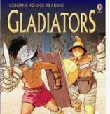 | Stories with historical settings - Defeat the monster (Gladiator story) | Recounts (Trip recount)  Trip to museum  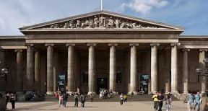 |  | Assessment
YEAR 4 | Autumn 2
 | Genre:
 | Week 1 | Week 2 | Week 3 | Week 4 | Week 5 | Week 6 |  | Week 7
 | Diary entry  Diary of a Roman soldier  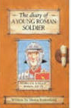 | Diary entry  Diary of a Roman soldier | Debate recount  -Shaw Market and where to locate it.  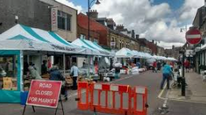 | Debate recount  -Shaw Market and where to locate it. | Information text  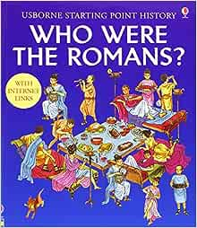 | Information text |  | Recount -  Pantomime Trip  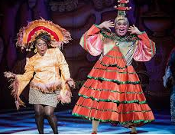
YEAR 4 | Spring 1
Genre
 | Week 1 | Week 2 | Week 3 | Week 4 | Week 5 | Week 6
 | Stories from other cultures  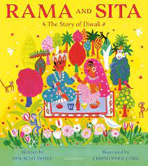 | Stories from other cultures | Stories from other cultures | Stories from other cultures | Persuasive letter - Letter to headteacher  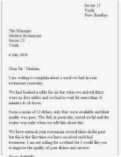 | Persuasive letter - Letter to headteacher
YEAR 4 | Spring 2
 | Genre:
 | Week 1 | Week 2 | Week 3 | Week 4 | Week 5 | Week 6
 | Persuasive writing - advertisements The Mighty Multifunctional Mobile Phone  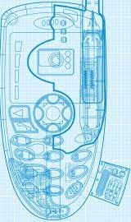 | Persuasive writing - advertisements The Mighty Multifunctional Mobile Phone | Stories set in imaginary worlds  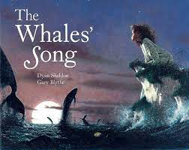 | Stories set in imaginary worlds | Stories set in imaginary worlds  The Flying Blanket  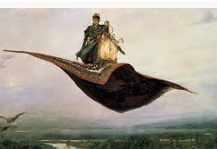 | Stories set in imaginary worlds  The Flying Blanket
YEAR 4 | Summer 1
 | Genre:
 | Week 1 | Week 2 | Week 3 | Week 4 | Week 5 | Week 6 |  | Week 7
 | Stories with Issues & Dilemmas  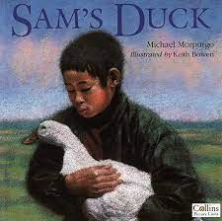 | Stories with Issues & Dilemmas | Stories with Issues & Dilemmas  The Stolen Cap  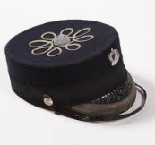 | Stories with Issues & Dilemmas  The Stolen Cap | Poetry: Exploring Form, List poems  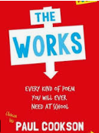 | Poetry: Exploring Form, List poems |  | Assessment
YEAR 4 | Summer 2
 | Genre:
 | Week 1 | Week 2 | Week 3 | Week 4 | Week 5 | Week 6 |  | Week 7
 | Explanation Texts  The Snoozatron  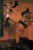 | Explanation Texts  The Snoozatron | Poetry: Creating Images | Poetry: Creating Images | Playscripts  Charlie and the Chocolate Factory  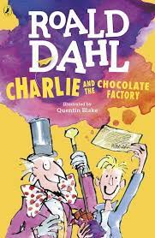 | Playscripts  Charlie and the Chocolate Factory |  | Recount:Key events in my school year -memories.  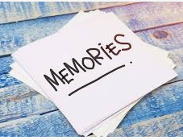

YEAR 5
 | Autumn 1
Genre:
 | Week 1 | Week 2 | Week 3 | Week 4 | Week 5 | Week 6 |  | Week 7
 | Recounts - The Best Holiday… Ever  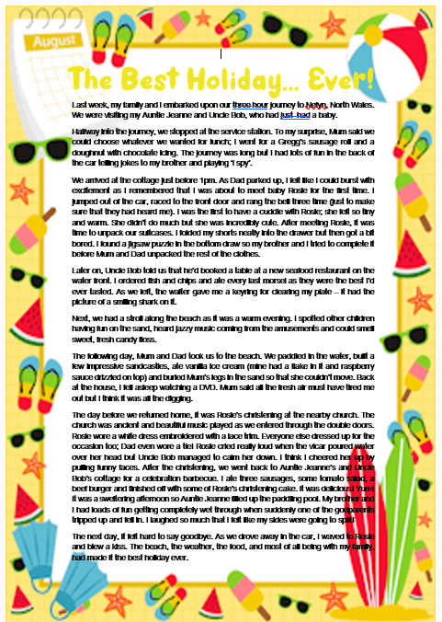 | Non-chronological reports - The Explorer  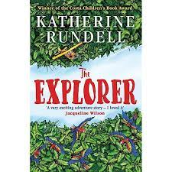 | Non-chronological reports - The Explorer | Diary entry - The Explorer | Diary entry - The Explorer | Newspaper report - Devastation in Pompeii  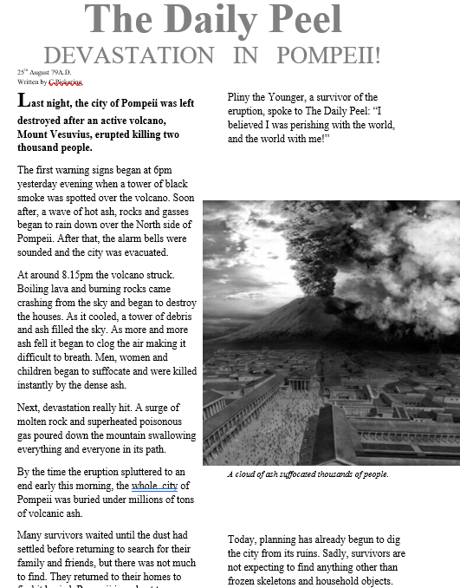 |  | Newspaper report - Devastation in Pompeii
YEAR 5 | Autumn 2
 | Genre:
 | Week 1 | Week 2 | Week 3 | Week 4 | Week 5 | Week 6 |  | Week 7
 | Character descriptions - Street Child  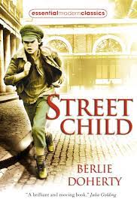 | Character descriptions - Street Child | Setting descriptions - The Nowhere Emporium  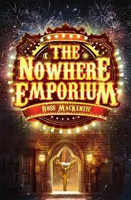 | Setting descriptions - The Nowhere Emporium | Narrative writing - The Little Match Girl - Hans Christian Andersen  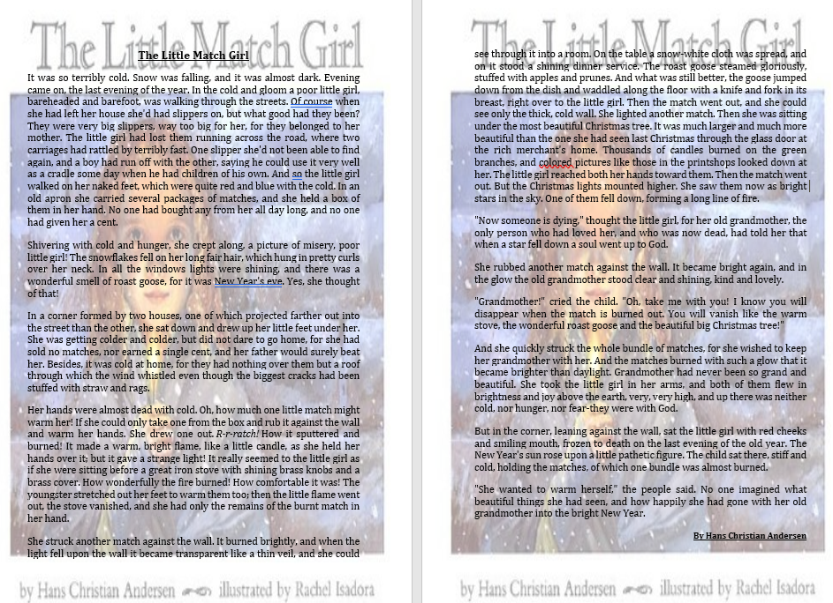 | Narrative writing - The Little Match Girl - Hans Christian Andersen |  | Assessment
YEAR 5 | Spring 1
Genre
 | Week 1 | Week 2 | Week 3 | Week 4 | Week 5 | Week 6
 | Letter -  The Alchemists Letter (Literacy Shed)  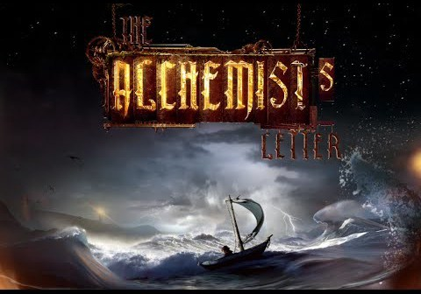 | Letter -  The Alchemists Letter (Literacy Shed) | Playscripts - Mr William Shakespeare’s plays by Marcia Williams  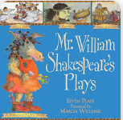 | Playscripts - Mr William Shakespeare’s plays by Marcia Williams | Classic Poetry  The Highwayman  Alfred Noyes  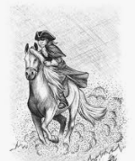 | Classic Poetry  The Highwayman  Alfred Noyes
YEAR 5 | Spring 2
 | Genre:
 | Week 1 | Week 2 | Week 3 | Week 4 | Week 5 | Week 6
 | Character Descriptions - Viking Boy  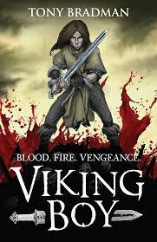 | Character Descriptions - Viking Boy | Viking saga - Thor and the giants  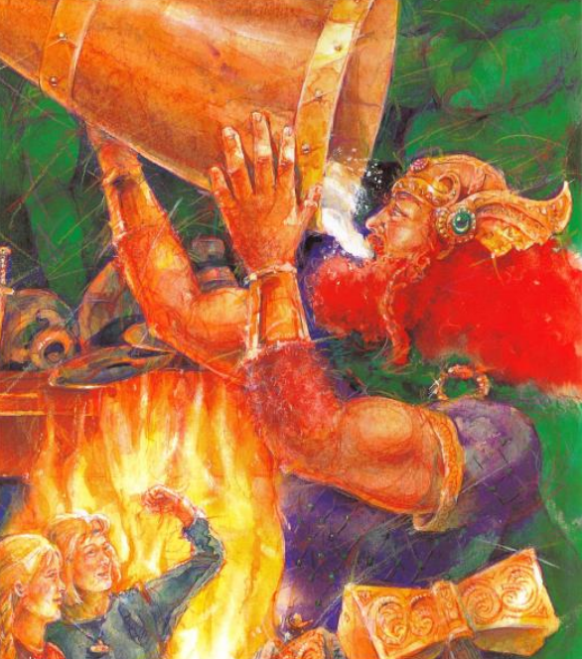 | Viking saga - Thor and the giants | Drama / Performance / Speaking and Listening - The Galaxy by Henry Wadsworth Longfellow  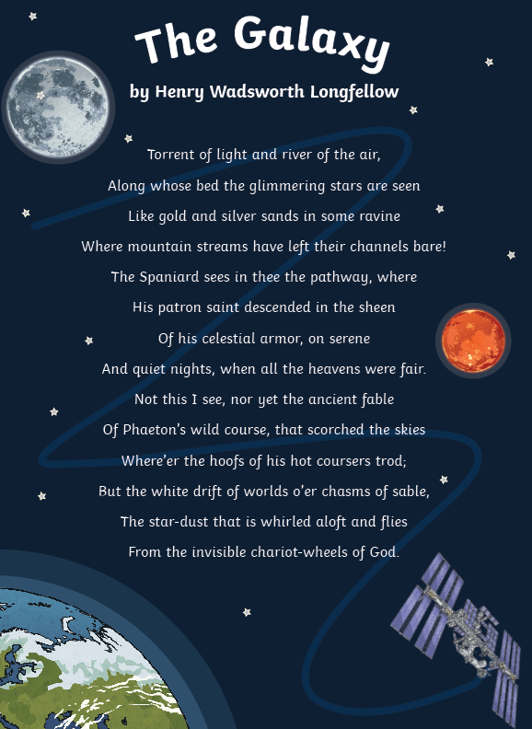 | Drama / Performance / Speaking and Listening - The Galaxy by Henry Wadsworth Longfellow
YEAR 5 | Summer 1
 | Genre:
 | Week 1 | Week 2 | Week 3 | Week 4 | Week 5 | Week 6 |  | Week 7
 | Narrative writing - Pig Heart Boy  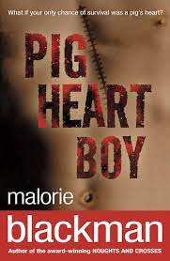 | Narrative writing - Pig Heart Boy | Letters to buddies - new Reception intake | Non-Chronologicall Reports - Pig Heart Boy | Non-Chronologicall Reports - Pig Heart Boy | Character Description  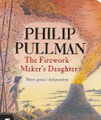 |  | Assessment
YEAR 5 | Summer 2
 | Genre:
 | Week 1 | Week 2 | Week 3 | Week 4 | Week 5 | Week 6 |  | Week 7
 | Diary entry - The Wreck of the Zanzibar  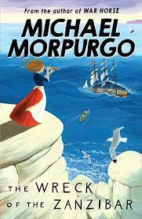 | Diary entry - The Wreck of the Zanzibar | Narrative writing -  The Wreck of the Zanzibar | Narrative writing -  The Wreck of the Zanzibar | Persuasive Writing  Stop polluting the oceans   | Persuasive Writing  Stop polluting the oceans |  | Classic poetry  From a Railway Carriage by Robert Louis Stevenson  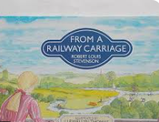

YEAR 6
 | Autumn 1
Genre:
 | Week 1 | Week 2 | Week 3 | Week 4 | Week 5 | Week 6 |  | Week 7
 | Autobiographies – Boy by Roald Dahl  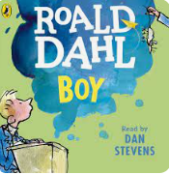 | Autobiographies – Boy by Roald Dahl | Diary – Rainforest Diary  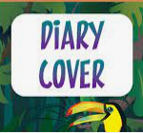 | Diary – Rainforest Diary | Character Descriptions, settings and detail: Skellig  SPIRITUALITY:  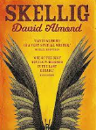  The OWs, WOWs and NOWs | Character Descriptions, settings and detail: Skellig  SPIRITUALITY:  The OWs, WOWs and NOWs |  | Assessment
YEAR 6 | Autumn 2
 | Genre:
 | Week 1 | Week 2 | Week 3 | Week 4 | Week 5 | Week 6 |  | Week 7
 | Journalistic writing: The Plight of the Orangutan  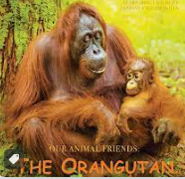  To raise awareness & of climate change | Journalistic writing: The Plight of the Orangutan  To raise awareness & of climate change | Poetry – metaphor and simile  ‘The Dreadful Menace’  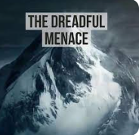 | Poetry – metaphor and simile  ‘The Dreadful Menace’ | 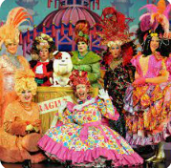  Discussion School Trips should not be banned. | Formal narrative style:  Dickens’ ‘A Christmas Carol’  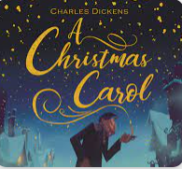 |  | Formal narrative style:  Dickens’ ‘A Christmas Carol’
YEAR 6 | Spring 1
Genre
 | Week 1 | Week 2 | Week 3 | Week 4 | Week 5 | Week 6
 | Titanic  Diary - 1st hand accounts and contrasting mood / use of formality  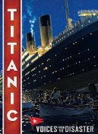 | Titanic  Diary - 1st hand accounts and contrasting mood / use of formality | Titanic-  Newspaper report-  How the disaster unfolded | Titanic-  Newspaper report-  How the disaster unfolded | Titanic -  Letters to complain  Writing to the White Star Line | Pre-sats Assessment week-  Balanced argument / letter
YEAR 6 | Spring 2
 | Genre:
 | Week 1 | Week 2 | Week 3 | Week 4 | Week 5 | Week 6 |  | Week 7
 | Non-Chronological Report -The Maya  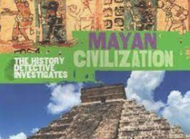 | Non-Chronological Report -The Maya | Narrative:  Continuation of a story  Fiction Flashback Story-Kidnapped by Pie Corbett.  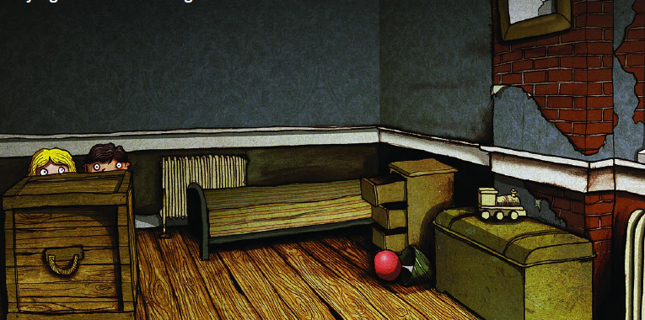 | Narrative:  Continuation of a story  Fiction Flashback Story-Kidnapped by Pie Corbett. | 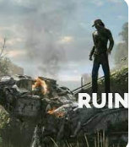  Fictional sci-fi writing: RUIN | Fictional sci-fi writing: RUIN |  | Poetry:  Range of styles to emulate -  Junk by Kirk Hendry  The Raven - Edgar Allen Poe  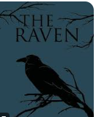
YEAR 6 | Summer 1
 | Genre:
 | Week 1 | Week 2 | Week 3 | Week 4 | Week 5 | Week 6 |  | Week 7
 | Fantasy narrative with flashback  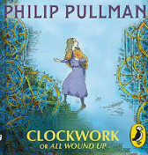 | Fantasy narrative with flashback | Explanation and instruction: how to make a clockwork child. | Explanation and instruction: how to make a clockwork child. | ASSESSMENT: plot and develop fantasy adventure with a twist | ALMA - recount and character perspectives  ….. (Literacy shed) |  | #SATS WEEK DURING THIS HALF TERM
 | Summer 2
 | Genre:
 | Week 1 | Week 2 | Week 3 | Week 4 | Week 5 | Week 6 |  | Week 7
 | Developing narrative process - longer fictional narrative based on:  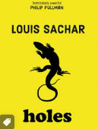 | Non-chron report:  The Yellow-spottedLizard | Recount-  Robinwood - due directly after the trip depending on date…  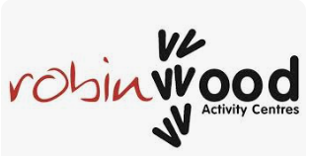 | Letter to complain about treatment of prisoners. | Report-Ancient Greek Gods  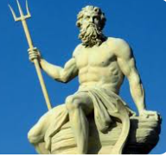 | Playscripts -  Greek Myths  Pandora’s Box  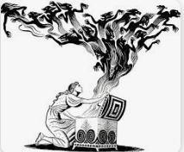 |  | Book Reviews  My book of the year is…  