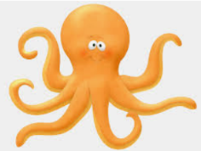
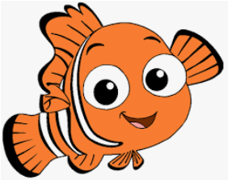
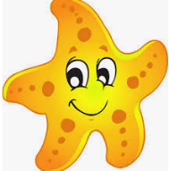
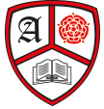
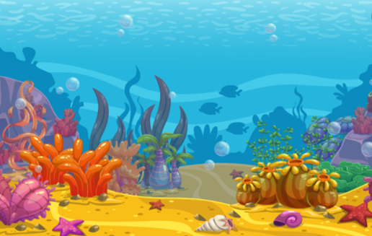
Expressive Arts and Design
- Under the sea crafts
- Easter Cards and crafts
- Mother’s Day Cards
- Spring artwork using paints and pastels
- Transient art

Maths
- Counting
- Representing, composing and comparing numbers 0-10.
- Measuring height, length and time.
- 2D and 3D Shapes
Personal Social and Emotional Development
This half term our focus will be “Respect”. We will read stories and share our own experiences of being respectful. We will also discuss our planet and explore ways in which we can respect our environment, and why this is so important.
Understanding the World
- Spring and seasonal changes
- Animal life cycles
- Easter and the Easter Story
- Mini-beasts
- Plants and growth
- Animals that live under the sea

Anderton Primary School
Spring Term 2
Reception
My big blue planet!
Communication and Language
This half term the children will be developing their vocabulary and will be encouraged to extend their spoken sentences. More opportunity will be provided for children to ask and answer questions using who, what and why. The children will also be encouraged to listen to their peers and respond appropriately to what has been said.
Reading
- Rainbow Fish by Marcus Phister
- Tiddler by Julia Donaldson
- Sharing a shell by Julia Donaldson
- The Hungry Caterpillar By Eric Carle
- Rhymes and Poems about fish
- Non-fiction books about life under the sea
- CVC words and tricky words (Phonics)

Writing
- Captions and labels
- Story writing
- Non – fiction posters
- Easter Cards and writing
- Poems about spring
Physical Development
Children will take part in two PE sessions a week on Monday and Friday. In our PE sessions we will focus on practicing the 5 fundamental movements: running, hopping, jumping, throwing and catching.
The children will continue working on their fine motor skills through daily activities and provision in the classroom.

