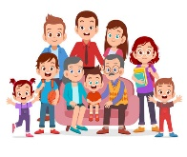
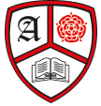
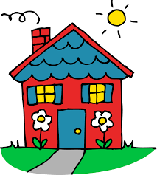
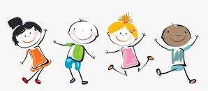
Personal Social and Emotional Development
This half term the children will focus on themselves as an individual. They will discuss their likes, dislikes, family and culture. Through group circles times we will share stories, memories and things that are special to us. We will also work on building relationships and making new friends. We will read the book “The Colour monster” and discuss our different feelings and emotions.
Understanding the World
- What do I look like?
- Body Parts
- When is my birthday?
- Where do I live?
- Who do I live with?
- My new school
- My Journey to School

Anderton Primary School
Autumn 1
Reception
This is Me!
Expressive Arts and Design
- Self Portraits
- Loose part pictures
- Junk Model Houses
- Songs and Rhymes
- Drama and Role Play

Communication and Language
This half term the children till be encouraged to listen and follow instructions throughout the day. They will be encouraged to ask and answer questions appropriately using words such as how, why and when. Children will share daily story times where they will be encouraged to listen for a short period of time and answer questions about the text.
Reading
- Name recognition
- There’s only one you
- Elmer collection
- Kippers Birthday
- Books about starting school

Writing
- Name writing
- Making marks
- Letter formation
- Birthday cards
- Labels
Maths
- Number rhymes
- Match and Sort
- Compare Amounts
- Number Recognition 0-3
- Represent, Compose and Compare 0-3
Physical Development
Children will take part in two PE sessions a week on Monday and Friday.
We will focus on developing the 5 fundamental skills.
The children will continue working on their fine motor skills through daily activities and provision in the classroom.
.

