ANDY SMITH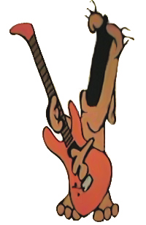 2 Old Hall Street, Macclesfield, Cheshire, SK10 2DT Tel: 07957 699423
e-mail:noisyrow@aol.com

September 2026

20 mins solo - £14 per 20 minute lesson - £84 per half term (6 weeks)
20 mins shared - £10 per 20 minute lesson - £60 per half term (6 weeks)

The terms on which the lessons are offered are as follows:
1. All lessons must be paid for in advance.
2. Reminders/invoices will be issued 2 weeks before the end of half term.
3. Any missed lessons will be charged unless by prior arrangement (school trips for example).
4. Parents wishing to terminate tuition must give half a terms notice in writing.

Regards
Andy Smith

Please complete the enrolment slip below and return it to school. I will then contact you with the lesson time and add it to the timetable. Any pupils wishing to share a lesson with a preferred partner please fill in their details and if possible pupils will be put together.
………………………………………………………………………………………………………………………………………………….I agree to the terms and conditions of the commencing peripatetic guitar tuition.
PUPIL NAME……………………………………………………………………………… CLASS……………………
TYPE OF LESSON 20 minute solo ____ 20 minute shared _____
TEL.NO …………………………………………… E-MAIL ……………………………………………………………
SIGNED …………………………………………. DATE ………………………

PREFERRED PARTNER (SHARED LESSONS) ……………………………………………………
PREFERRED PARTNER CLASS ……………………

