Name:____________________________________________
Saturn & Neptune Spelling Homework
Week 2- 21.09.26 – Test on 25.09.26
Please use the space below to practise spelling the 10 words below.
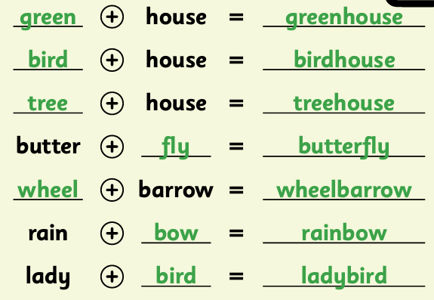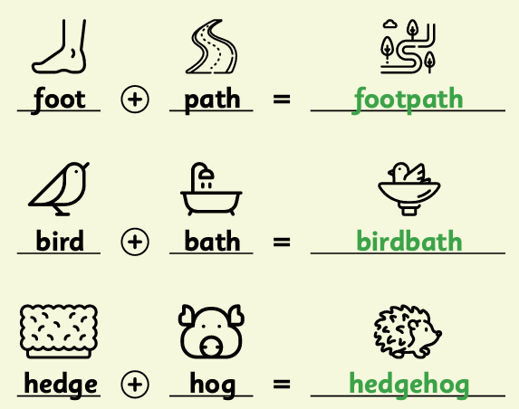

Can you work out these compound words?
