Saturn & Neptune Spelling Homework
Week 1- 14.09.26

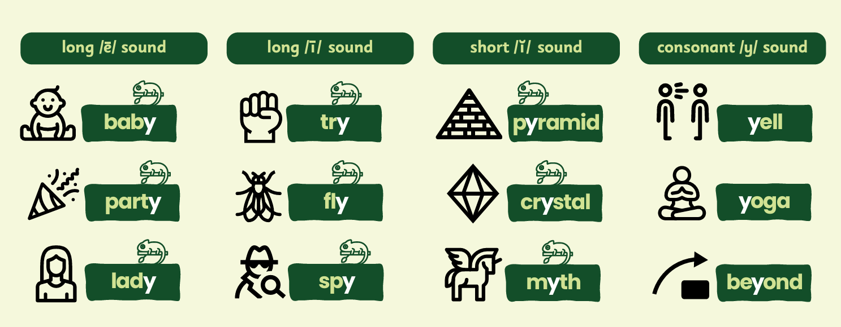
Please use the space below to practise spelling the words below.

