

Salesbury c.e. primary school homework grid
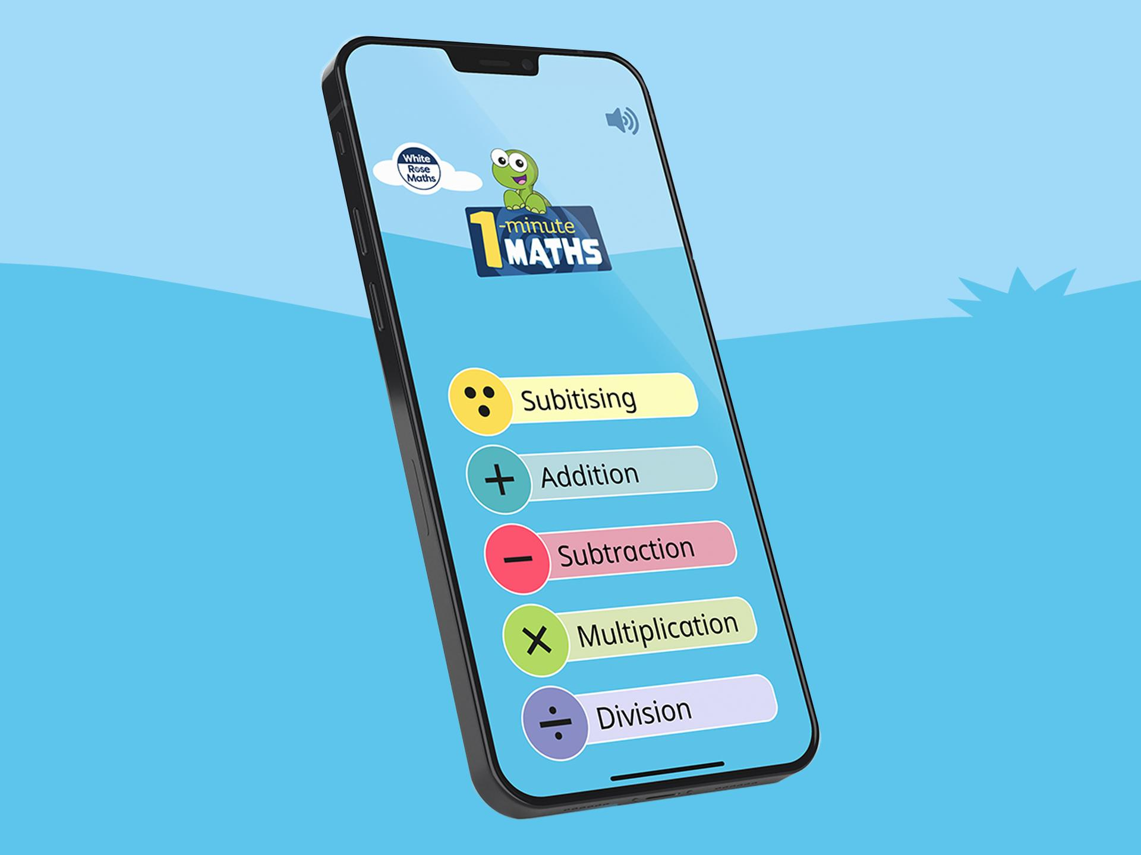
Notes for parents and carers
- Please check your child’s class page on the school website for Common Exception Words/High Frequency Words to support reading and spelling.
- Please send in your child’s homework folder every Thursday.
- Spellings and their pattern will be sent via Spell Shed, as a game and a paper-based task will be sent home every Friday.
- Please note that Reading, Spellings and Maths are the priority tasks.

How to access subscriptions: -
- TTRS, Google Classroom and Spelling Shed

YEAR 2 TERM Spring 1 2026

Reading – daily task  Aim for at least 5 minutes per day – don’t forget to put this in your reading diary and have your Game Board signed. Try to read aloud- this will improve fluency and understanding.  Please prioritise reading with your child. | Spellings & Key words – weekly task  Use Spelling Shed to practise the spellings and their pattern, in the form of a game/task online.  Complete the weekly sheet sent home on a Friday, (paper copy).  Key words taught every week in Phonics will be on your child’s class page on the school website. | Maths - weekly task  - Mission in Maths Grid – focus on the tasks:  To know the multiplication and division facts for the 2/5/10 times table. (Use TTRS and Hit the Button game)  Year 2 children need to know these facts fluently and in any order.  Please prioritise this with your child.
  Creative Task - Healthy snack – Help to make a healthy snack at home. Take a photograph/draw a picture of your creation and add this to your homework folder.  Challenge- Write a set of instructions of how you made your snack. | Google Classroom  Short tasks will be set on Google Classroom throughout the half term. | Knowledge Organiser – across the half term  - Can you read our vocabulary?  - Can you use our vocabulary in a spoken sentence?  Play games such as, ‘Matching pairs’, True or False using the vocabulary and definitions.
Subscriptions to support learning:- TTRS and Spelling Shed.

