

Salesbury c.e. primary school homework grid
Notes for parents and carers
- Please check your child’s class page on the school website for Common Exception Words/High Frequency Words to support reading and spelling.
- Please send in your child’s homework folder every Thursday.
- Spellings and their pattern will be sent via Spell Shed, as a game and a paper-based task will be sent home every Friday.
- Please note that Reading, Spellings and Maths are the priority tasks.
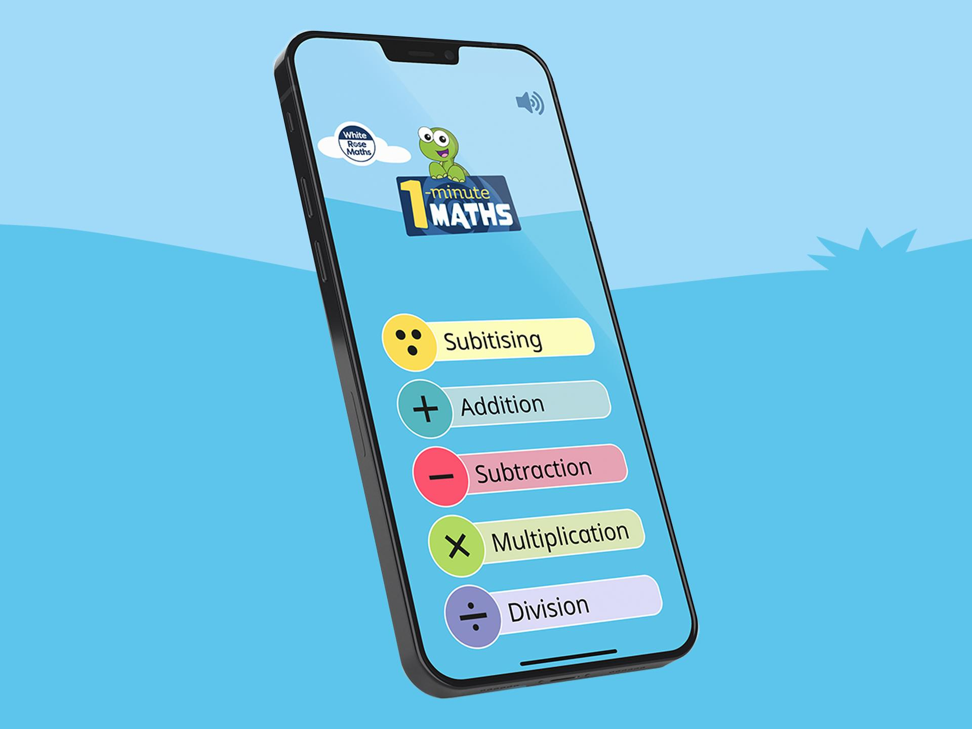
How to access subscriptions: -
- Numbots via TTRS, Google Classroom and Spelling Shed.

YEAR 1 TERM Spring 1 2026

Reading – daily task  Aim for at least 5 minutes per day – don’t forget to put this in your reading diary and have your Game Board signed. Try to read aloud- this will improve fluency and understanding.  Please prioritise reading with your child. | Spellings & Key words – weekly task  Use Spelling Shed to practise the spellings and their pattern, in the form of a game.  Complete the weekly sheet sent home on a Friday, (paper copy).  Key words taught every week in Phonics will be on your child’s class page on the school website. | Maths - weekly task  - Mission in Maths Grid – focus on the tasks:  To confidently count up and back in 2s to 24, in 5s to 60 and in 10s to 120.  (If your child can confidently recall these facts, start to learn them as table facts).  To recall all double and halves facts to 10, fluently and confidently.  Please prioritise this with your child.
  Creative Task - Healthy snack – Help to make a healthy snack at home. Take a photograph/draw a picture of your creation and add this to your homework folder.  Challenge- Write a set of instructions of how you made your snack. | Google Classroom  Short tasks will be set on Google Classroom throughout the half term. | Knowledge Organiser – across the half term  - Can you read our vocabulary?  - Can you use our vocabulary in a spoken sentence?  Play games such as, ‘Matching pairs’, True or False using the vocabulary and definitions.
Subscriptions to support learning:- Numbots via TTRS and Spelling Shed.

