
To know decimal number bonds to 1.
For example:
0.2+0.8=1

To identify prime numbers to 20.
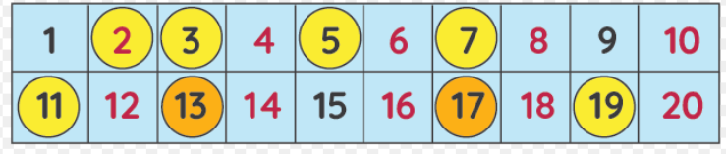

To recall square numbers up to 12.
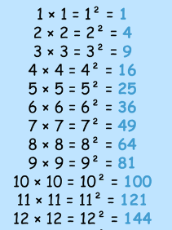
.

Congratulations, you have achieved the Planet certificate.
To find factor pairs of a number.
For example:
Factor pairs of 28: 1 and 28, 2 and 14, 4 and 7
To recall all times table and division facts up to 12 x 12.

Congratulations, you have achieved the Rocket certificate.
The gameboard encourages regular focus on key Maths skills. Certificates will be awarded for every two space missions completed.
Good luck.
Congratulations, you have achieved the Galaxy certificate.
To recognise decimal and percentage equivalents of the fractions ½, ¼, ¾,1/3, 2/3
Mission in Maths
Year 5

