
The gameboard encourages regular focus on key Maths skills. Certificates will be awarded for every two space missions completed.
Good luck.
To know the multiplication and division facts for the 8 times table, up to 12 x 8.

Count up and down in tenths.
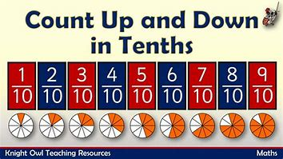
Congratulations, you have achieved the Galaxy certificate.
Congratulations, you have achieved the Planet certificate.
To know the multiplication and division facts for the 3 times table, up to 12 x 3.
To count forwards and backwards in:
2s and 20s
(Start at different numbers, not just 0. For example, count from 68 in 2s).
To count forwards and backwards in:
5s, 50s and 25s
(Start at different numbers, not just 0. For example, count from 45 in 5s).

To know the multiplication and division facts for the 4 times table, up to 12 x 4.

Year 3
Congratulations, you have achieved the Rocket certificate.
Mission in Maths

