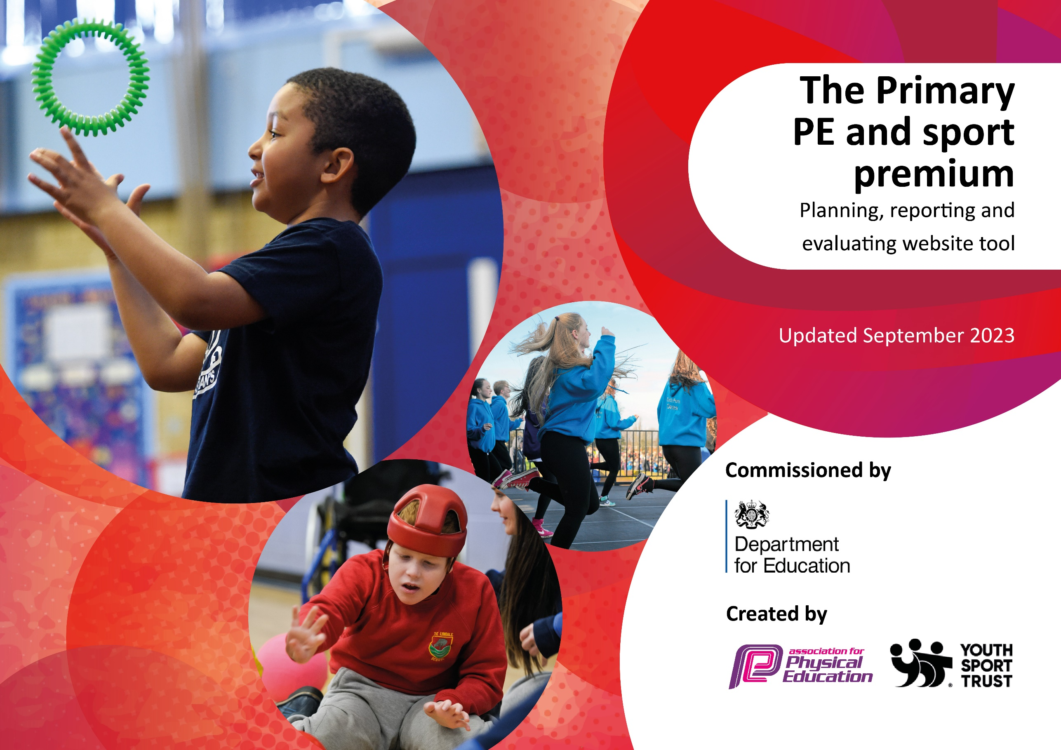

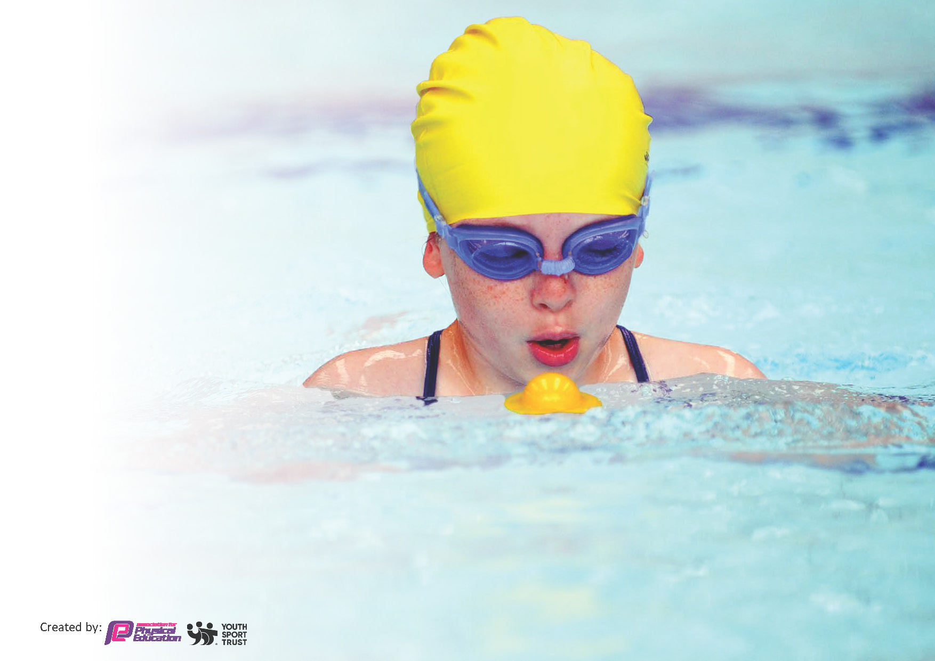
This template can be used for multiple purposes:
by:
- It enables schools to effectively plan their use of the Primary PE and sport premium
- It helps schools to meet the requirements (as set out in guidance) to publish information on their Primary PE and sport premium
- It will be an effective document to support Ofsted inspections enabling schools to evidence progress in Physical Education (PE) and evidence swimming attainment, which forms part of the PE National Curriculum. We would recommend schools consider
the Intent, Implementation and Impact of any spend, as examined within the Education Inspection Framework.

It is important that your grant is used effectively and based on school need.

Schools must use the funding to make additional and sustainable
improvements to the quality of the PE, School Sport and Physical Activity (PESSPA)
they offer. This means that you should use the Primary PE and sport premium to:

- Build capacity and capability within the school to ensure that improvements made now will benefit pupils joining the school in future years
- Develop or add to the PESSPA activities that your school already offers.

The Primary PE and sport premium should not be used to fund capital spend projects; the school’s core budget should fund these. Further detail on capital expenditure can be found in the updated Primary PE and sport premium guidance.

The Primary PE and sport premium guidance, outlines 5 key priorities that funding should be used towards. It is not

necessary that spending has to meet all the key priorities, you should select the priorities that you aim to use any funding towards.

Although completing this template is not a requirement for schools, schools are required to publish details of how they spend this funding. Schools must also outline what the impact this funding has had on pupils’ PE and sport participation and attainment and how any spending will be sustainable in the future. All funding must be spent by 31st July 2024.

The Department for Education has worked closely with the Association for Physical Education (afPE) and the Youth Sport Trust (YST) to develop this template and encourages schools to use it. This template is an effective way of meeting the reporting requirements of the Primary PE and sport premium.
Review of last year’s spend and key achievements (2025/2026)

We recommend you start by reflecting on the impact of current provision and reviewing your previous spend.

Activity/Action | Impact | Comments
Employ S4YC to work in partnership with school staff to continue to deliver high quality PE alongside effective assessment.  Offer a longer period of Swimming Sessions for children in Years 5 to increase the number of children achieving the 25m expectation within the normal curriculum lessons.  IPEP planning embedded across the school.  Enhanced after school and breakfast club provision ensures more children are engaged in physical activity. | All classes reported 100% participation in PE lessons and other physical activity.  Pupil Voice showed that the children are happy and physically active. They understand the importance of physical activity. They feel safe in PE and know they have an adult in school they can talk to if something is worrying them  We took the opportunity to send Year 4 children also for half a year. Due to the number of non-swimmers, Year 4 were split into 2 smaller groups swimming every other week. This has proved extremely beneficial to the children with children making great progress. 28 children out of 29 are now in the pool without armbands and are jumping in.  Allowed continuity between S4YC and teacher led sessions.  Ensures prior knowledge is built on and allows for progression across the school.  Ensure high-quality, engaging PE lessons are being taught.  Assessment is all in one place and children’s development and progress and be easily tracked.  Improved confidence of staff and has given them the opportunity to teach different sports.  Increase of the number of children taking part in physical activity. Encouraging healthy lifestyle. | Staff have used sessions with S4YC as CPD to ensure the continuation of high-quality PE lessons which engage ALL children and encourage participation.  Children have a good understanding of the importance of physical activity as part of a healthy lifestyle.  Children are developing fundamental skills which they can continue to build upon.  The long-term plan put in place allows for prior knowledge to be built upon and the progression of skills throughout the school.  We will continue to take the children who are now in Year 5 for another half a year to aim to get children achieving the National Curriculum expectations of swimming 25m.  Teachers like having structured planning to work from which ensures progression through each year group as well as through the school. We are starting to see the impact of this progression and the build-up of skills is evident.  This will continue into the following academic year. Pupil voice states children enjoy their clubs and enjoy taking part in physical activity. Most pupils also enjoy the competitive element to the sports.

Key priorities and Planning
This planning template will allow schools to accurately plan their spending.

Action – what are you planning to do | Who does this action impact? | Key indicator to meet | Impacts and how sustainability will be achieved? | Cost linked to the action (estimated minimum spend)
Employ S4YC to work in partnership with school staff to continue to deliver high quality PE alongside effective assessment.  To continue to compete in CDAT competitions.  Embed cross-curriculum orienteering as part of an active curriculum  Offer a longer period of Swimming Sessions for children in Years 5 to increase the number of children achieving the 25m expectation within the normal curriculum lessons.  Increase parental engagement with sports.  Aeroball TTS  Tennis Day  Slide Repair  Sports Day Stickers | Staff and children  Children and staff  Staff and Children  Children  Come and be active with me days.  Staff and children  Children  Children | Key 1 – Increased confidence, knowledge and skills of all staff in teaching PE.  Key indicator 2 -The engagement of all pupils in regular physical activity  Key indicator 3 – The profile of PE is raised across the school as a tool for whole school improvement.  Key Indicator 5 – Increased participation in competitive sport.  Key 1 – Increased confidence, knowledge and skills of all staff in teaching PE.  Key indicator 2 -The engagement of all pupils in regular physical activity  Key indicator 3 – The profile of PE is raised across the school as a tool for whole school improvement.  Key indicator 2 -The engagement of all pupils in regular physical activity  Key indicator 4. Broader experience of a range of sports and activities offered to all pupils  Key indicator 4. Broader experience of a range of sports and activities offered to all pupils  Key indicator 2 -The engagement of all pupils in regular physical activity  Key Indicator 5 – Increased participation in competitive sport. | Primary teachers more confident to deliver effective PE supporting pupils to undertake extra activities inside and outside of school  Children will be more engaged in PE and experience competition.  More pupils meeting their daily physical activity goal, more pupils encouraged to take part in PE and Sport Activities  Children’s swimming will improve and children will become more confident swimmers.  Children and parents will become more active and a healthier lifestyle will be encouraged.  More pupils meeting their daily physical activity goal, more pupils encouraged to take part in PE and Sport Activities  More pupils meeting their daily physical activity goal, more pupils encouraged to take part in PE and Sport Activities  Children engaged in physical activity and competition. | costs forS4YC support.  £13,500  £500  £630  £630  £36  £47  £250  £1219  £10

Key achievements 2025-2026
This template will be completed at the end of the academic year and will showcase the key achievements schools have made with their Primary PE and sport premium spending.

Activity/Action | Impact | Comments
Year 4 competed in the CDAT football competition.  Year 5 and 6 competed in the CDAT football competition.  Staff develop confidence in the delivery of new and current sports which results in better instruction and achievement by pupils.  Introduce cross – curricular orienteering across the school to provide CPD for staff in OAA and to help towards promoting 30 minutes daily physical activity. | Children took part in a competition, developed teamwork and leadership skills. Children exercised for a long period of time.  Children took part in a competition, developed teamwork and leadership skills. Children exercised for a long period of time.  Children experience more engaging PE lessons. Adults have grown in confidence with their delivery. Skills and misconceptions are identified earlier.  Children took part in a competition, developed teamwork and leadership skills. | Year 4 won their football competition. Regular postings on school website and in school newsletter to celebrate achievements in PE.  Year 5 and 6 won their football competition. Regular postings on school website and in school newsletter to celebrate achievements in PE.  Children enjoy their PE lessons and are able to experience a wide variety of activities and sports.  More pupils meeting their daily physical activity goal, more pupils encouraged to take part in PE and Sport Activities

Swimming Data
Meeting National Curriculum requirements for swimming and water safety.
Priority should always be given to ensuring that pupils can perform safe self-rescue even if they do not fully meet the first two requirements of the National Curriculum programme of study

Question | Stats: | Further context  Relative to local challenges
What percentage of your current Year 6 cohort can swim competently, confidently and proficiently over a distance of at least 25 metres? | 86% | High levels of SEND, poor attendance and disadvantaged children in this cohort accounts for dip in percentage meeting expected standard.
What percentage of your current Year 6 cohort can use a range of strokes effectively [for example, front crawl, backstroke, and breaststroke]? | 86% | High levels of SEND, disadvantaged and poor attendance in school with this cohort accounts for dip in percentage meeting expected standard

What percentage of your current Year 6 cohort are able to perform safe self-rescue in different water-based situations? | 86%
If your schools swimming data is below national expectation, you can choose to use the Primary PE and sport premium to provide additional top-up sessions for those pupils that did not meet National Curriculum  requirements after the completion of core lessons. Have you done this? | Yes/No
Have you provided CPD to improve the knowledge and confidence of staff to be able to teach swimming and water safety? | Yes/No | Staff have observed qualified swimming teachers deliver swimming lessons which has developed their knowledge and own skills. One staff member is ASA level 2 trained.

Signed off by: 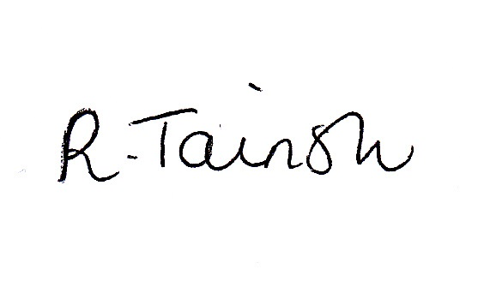

Head Teacher: | Rachel Tainsh
Subject Leader or the individual responsible for the Primary PE and sport premium: | Nathan Davies (Deputy Headteacher)  Jenna Webster (Assistant Headteacher)
Governor: | Theresa Worrall
Date: | 25.06.2026

