Year One – Spring 1 2021
Reading
Learning to read and spell more of the YR1 common exception words.
push, pull, full, house, some, where & there.

Maths – 2D and 3D shapes, Place Value and Addition & Subtraction

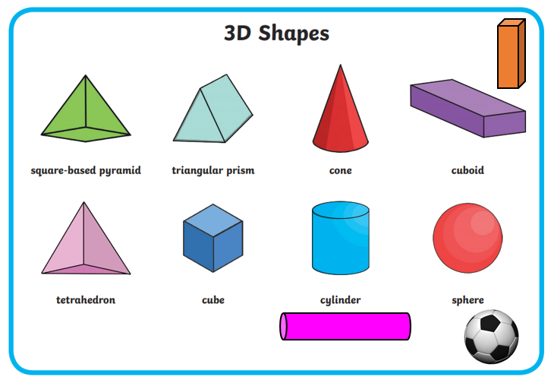
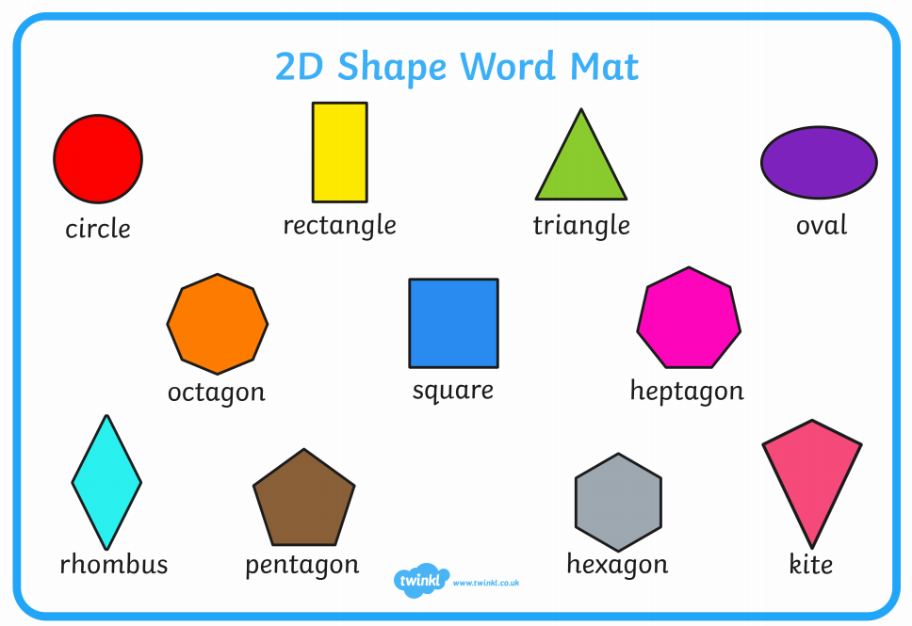
Knowledge Organiser
Vocabulary
Add, subtract, equals, capital letter, full stops, finger space, Shabbat, North Sea, Irish Sea, Bristol Channel, English Channel, 3D shape names & names of different materials.

Writing
We are continuing to have a focus on handwriting and forming our letters correctly.
All letters, except capital letters, must start with a lead in or get ready stroke.
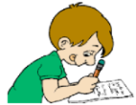
Geography To know the name of the seas surrounding the UK.

Science
Materials
and their
properties.

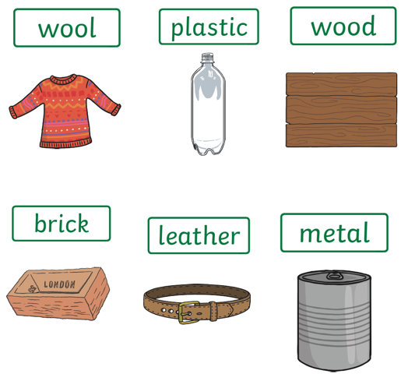
History To know about toys from the past and how they compare to modern toys.

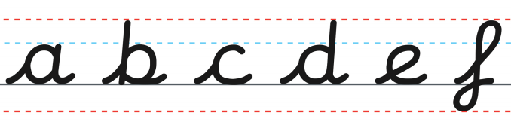
Computing
Maze Explorers.
Understanding the purpose and
how to use the direction keys.

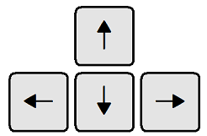

PSHE
Living in the wider world: Belonging to a community.
RE
Judaism - Shabbat



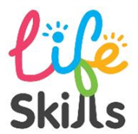
Tying own laces – especially important to reduce close contact between child/adult in school.
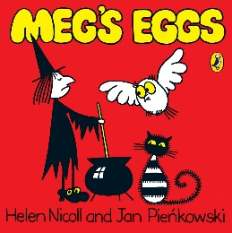
Our author is …
Helen Nicoll

