
Scholar Green Primary and Nursery School
EYFS Development Matters Statements
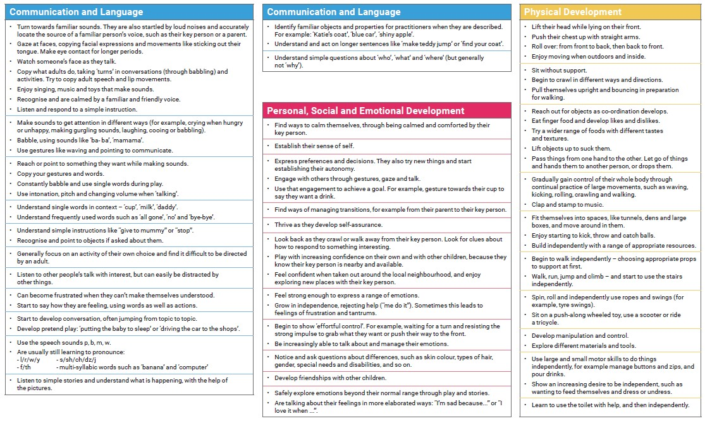
Birth to Three- Prime Areas
Scholar Green Primary and Nursery School
EYFS Development Matters Statements
Birth to Three- Specific Areas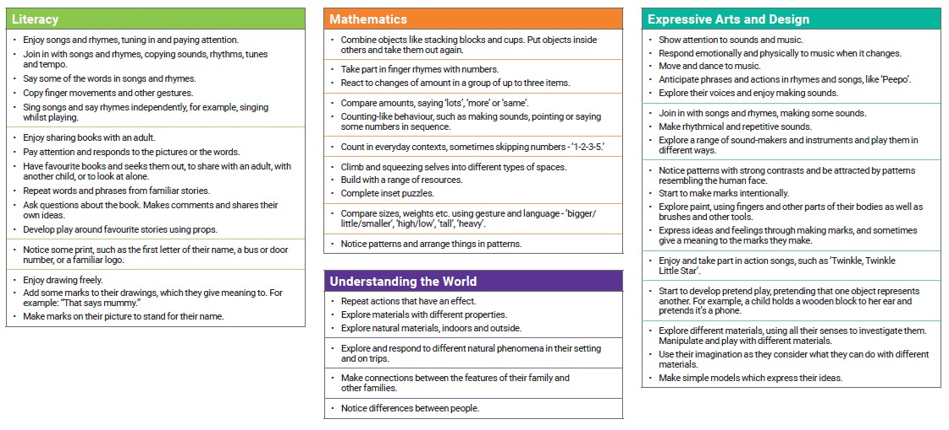

Scholar Green Primary and Nursery School
EYFS Development Matters Statements
Three and Four Year Olds- Prime Areas
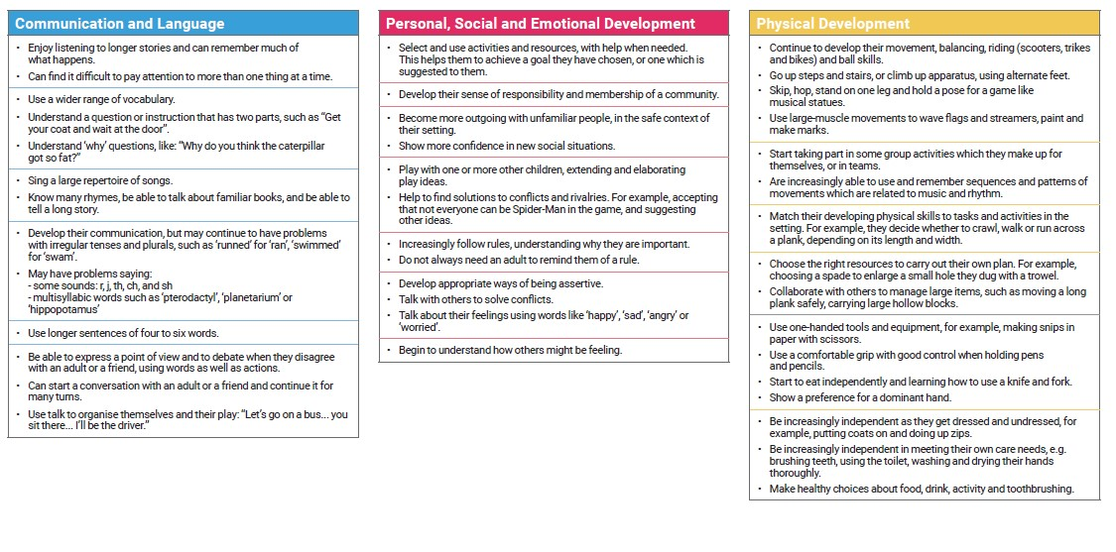

Scholar Green Primary and Nursery School
EYFS Development Matters Statements
Three and Four Year Olds- Specific Areas
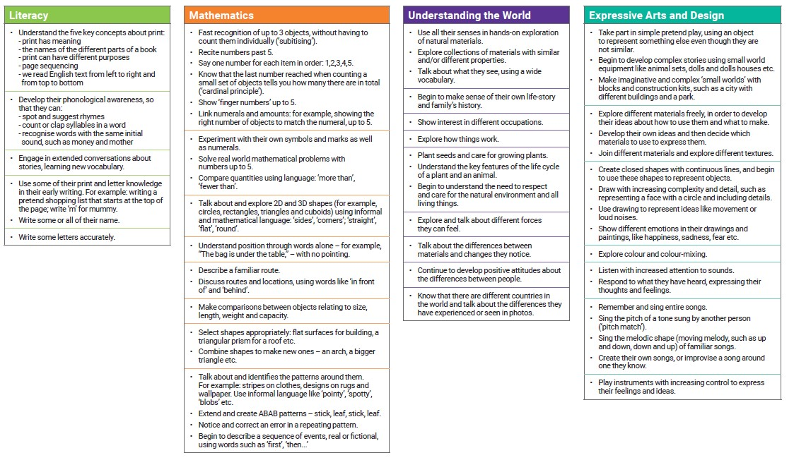
Scholar Green Primary and Nursery School
EYFS Development Matters Statements
Chidlren in Reception Class- Prime Areas
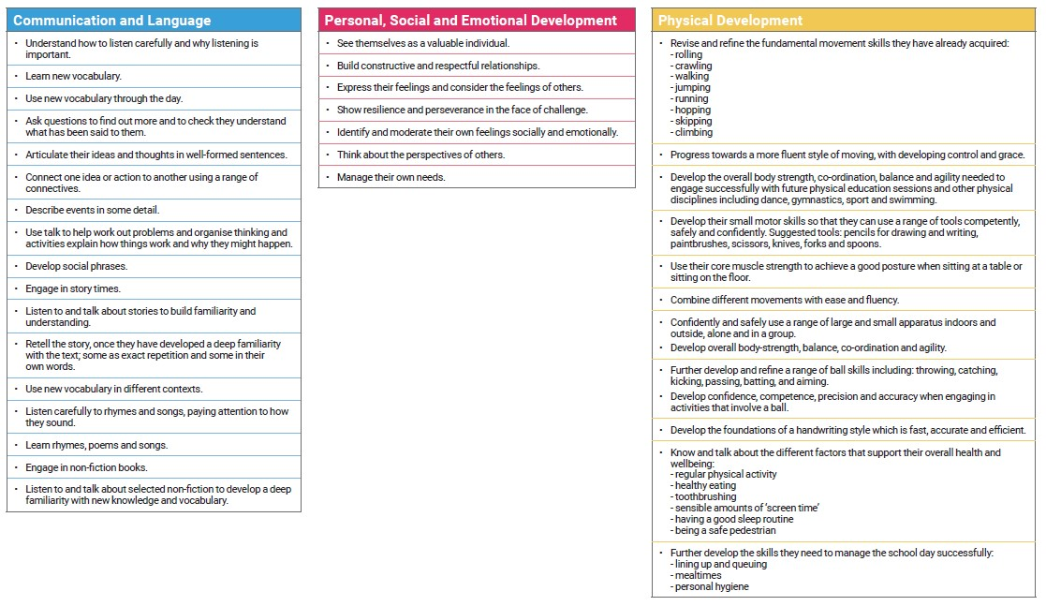
Scholar Green Primary and Nursery School
EYFS Development Matters Statements
Chidlren in Reception Class- Specific Areas
