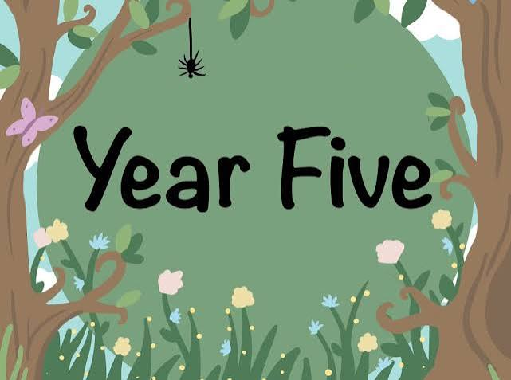


Dear Parents and Carers,
Welcome back! I hope you have all had a wonderful summer holiday and are looking forward to the exciting year ahead. I am delighted to welcome the children into Year 5, and can't wait to begin a fantastic year of learning together!
This term, our English lessons will be based around our focus author, Malorie Blackman. The children will explore a variety of fiction, non-fiction and poetry while developing their writing across a range of engaging genres. Alongside this, grammar skills will be taught and applied throughout their written work.
Reading continues to be a key part of learning in Year 5. Children are expected to read at least four times each week and should enjoy a broad range of texts, including fiction, non-fiction and poetry. It is the children's responsibility to record their reading in their reading record and to change their reading book when required. Although the children are becoming increasingly independent readers, I encourage you to listen to them read regularly and discuss what they have read to help develop their comprehension skills. Each half term, children will be set an Accelerated Reader target, and those who achieve it will be rewarded with a reading treat. If your child does not achieve their target they will not participate within the reading treat.
In Maths, lessons will focus on developing fluency, reasoning and problem-solving skills across all areas of the National Curriculum. Children will build confidence in applying their mathematical understanding through a range of practical activities and challenges.
This half term, our Science topic is Animals Including Humans. The children will learn about the changes humans experience as they grow and develop, as well as discovering why Eva Crane was such an influential scientist.
In Geography, the children will investigate the Equator and learn about lines of latitude and longitude before using atlases and globes to locate and name countries around the world.
Our History topic this half term is the Anglo-Saxons. The children will explore the significance of Sutton Hoo, learn about life during the Anglo-Saxon period and discover the importance of some of the Anglo-Saxon kings.
PE lessons will take place on Thursdays and Fridays. One lesson will be taught by Mr Lewis, with the other taught by myself. Children should come to school wearing their Scholar Green PE kit on these days. Please ensure that football kits, jeans and unsuitable footwear are not worn for PE. Long hair should be tied back and all jewellery, including earrings, must be removed before lessons.
In PSHE this half term, the children will be learning about relationships. They will explore the characteristics of healthy relationships and develop strategies to help them deal with peer pressure and other challenges they may face.
Homework will be set every Thursday and should be returned to school by Tuesday. Each child has been given a homework folder containing everything they need. Homework is designed to reinforce the learning taking place in class, and I appreciate your support in encouraging your child to complete it.
I operate an open-door policy and am always happy to discuss any questions or concerns you may have. You are welcome to speak to me at the start or end of the school day, or you can contact me by email:
lworthington@scholargreen.cheshire.sch.uk
I am incredibly excited for the year ahead and look forward to working in partnership with you to ensure every child has a happy, successful and rewarding year in Year 5.
Kind regards,
Miss Worthington
Dates for the diary
Date | Event
01.09.26 | INSET DAY
02.09.26 | SCHOOL OPENS
08.09.26 | Bikeability - Year 4 & Year 6
23.09.26 | Nursery N2 Parent Meeting Day
24.09.26 | Parent Meeting Day – ADVANCE NOTICE
24.09.26 | Nursery N1 Parent Meeting Day
25.09.26 | Macmillan Coffee Morning
29.09.26 | Year 2 Nantwich Educational Visit
02.10.26 | Fluenz Nasal Spray
09.10.26 | Mental Health Awareness Yellow Day (Wear yellow to school)
12.10.26 | Individual and Family Photos
13.10.26 | Year 3 & 4 Production – 1pm
14.10.26 | Year 3 & 4 Production – 1pm & 6pm
15.10.26 | Crucial Crewe- Safeguarding Council
23.10.26 | Year 6 Celebration Assembly 9am
 | HALF TERM
02.11.26 | INSET DAY
03.11.26 | SCHOOL OPENS
06.11.26 | Year 3 & 4 Whitworth Trip TBC
09.11.26 | Year 1-5 Assessment Week
09.11.26 | Anti-Bullying Week  EYFS Nursery Rhyme Week
11.11.26 | Armistice Day  Odd Sock Day- Pupils can wear Odd Socks to school on this day
20.11.26 | Children in Need
23.11.26 | Year 6 Assessment Week
30.11.26- 02.12.26 | Year 6 Robinwood
08.12.26 | Year 1 & Year 2 Production 1pm
09.12.26 | Year 1 & Year 2 Production 1pm & 6pm
14.12.26 | PTA Panto  Church Carol Service
16.12.26 | EYFS Production
17.12.26 | Christmas Dinner & Christmas Jumper Day
18.12.26 | Year 5 Celebration Assembly  END OF TERM

