
Scholar Green Primary School

EYFS Nursery Newsletter: Summer Term 2
Welcome to the final half of the Summer Term and the last term of the academic year!
Please find below an outline of the types of activities the children will experience over the half term. These are just an overview as we will also consider the children’s current interests, which key workers will use to help them to achieve their individual next steps.
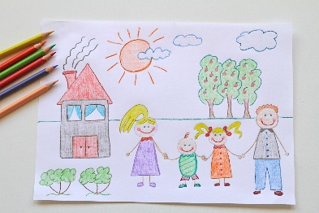
Main Theme- This half terms topic will be ‘There’s no Place like Home’.
As the children prepare to make a transition into their next phase, they will be encouraged to think about change; how they have changed, what they have achieved during their time at nursery and what they might like to change. They will continue to explore their local environment and the ‘homes’ it provides for a whole range of species- including us.

Communication and Language- Children will explore how to talk about the past and their shared experience. They will take a look back at the year and learn how to use the correct tense when talking about the past.

Physical Development- Children will further develop their independent/ self-help skills. They will continue to take part in PE sessions as well as having continued access to the outdoor garden. They will learn how to negotiate obstacles safely and how to work together. The children will also practice for their sports day! This is a relaxed event where the children can enjoy participating in different ‘sporting’ events- more information about the running of the morning will follow shortly.

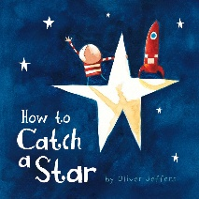
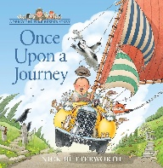
PSED- Through the theme of ‘change’ the children will think about how far they have they come. They will think about their friendships and the importance of team work. We also have a big focus on the transition into Reception, Rainbows and Sunbeams!

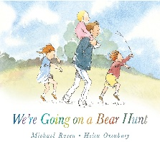
Author of the term- Our authors of the term are as follows – Rainbows – Oliver Jeffers, Sunbeams- Nick Butterworth and Raindrops – Helen Oxenbury. We use the authors of the term in nursery to support our love for reading and focus on a particular author who has written a range of different stories with familiar characters and illustrations styles.

Literacy- The rainbows will continue to work through our RWI. Phonics scheme. They will begin to develop an idea of more formal activities and the notion of putting pencil to paper with meaning- in different forms. Sunbeams and Raindrops will explore different stories and books and become familiar with retelling them.

Maths- Children will explore numbers and how they can be represented in different ways. They will become familiar with using different items to count e.g. pennies, buttons, sweeties, animals etc. We will continue to focus on estimating, composition and subitising.

Understanding the World- Children will learn about a range of community members and how they can help us. They will continue to explore our local area and where ‘we’ live. As we think about the holidays, the children will look beyond the school and gates and different places to Scholar Green e.g. places by the sea, places with mountains etc. We will also be revisiting the topic of caring for nature as we plant seeds and look after the nursery garden.

Expressive Arts and Design- the children will learn how they can use colour to express themselves. They will look at artwork by famous artists and respond to them through creating their own pieces of artwork. Our Artist of the term is Van Gogh and the children are continuing to be inspired by his work this term.

Library Books- The children will continue to choose these regularly. Please send reading books back in with the children each time they attend Nursery. We are now changing them as and when so it’s important your child have the books in their bag. We kindly ask that you note down in the yellow reading record book when you have shared these together and then we know to change them. We thank you for your continued support with this.
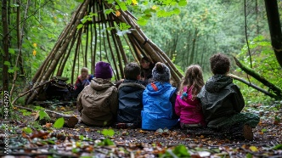
Forest School- We will be visiting forest school once a week this term so we are asking that all children always have a waterproof coat and wellies in school every day (these can be left in school until the Summer).
Equipment- Please ensure children have a sun hat (named) every day and sun cream (named) in school, so that we can make the most of the outdoors. It is crucial during this term to ensure the children are safe in the sunshine, so please ensure they have a named bottle, with water, that they recognise as their own.
Home Learning- Please continue to return your child’s home learning pouch with the completed activity so we can add them to their WOW and mark making books. Please ensure these are in your child’s bags so they can be swapped out accordingly. This is done as and when.
Communication- We have an open-door policy- however, drop off and pick up times can be very busy when greeting the children and ensuring they all arrive and leave safely. Email is a great form of contact and staff will endeavour to get back to you as soon as possible.
Please let both us in nursery and the office know if your child is unable to attend their nursery session at any time. Particularly for illness and holidays, this reduces the Nursery staff workload.
Other- We are still appealing for Secret Readers – parents who surprise their child and read a story, and any parents who want to come in and talk to the class about their job.

Many thanks, Miss Hadfield and the Nursery EYFS team
Miss Hadfield- mhadfield@scholargreen.cheshire.sch.uk
Miss Brock cbrock@scholargreen.cheshire.sch.uk
Miss Aitken eaitken@scholargreen.cheshire.sch.uk
Mrs Copestake acopestake@scholargrgeen.cheshire.sch.uk
Miss Triner striner@scholargreen.cheshire.sch.uk
Scholar Green Admin – for Holidays and Illnesses admin@scholargreen.cheshire.sch.uk

Please see below for Important Dates

Dates for the Dairy
15.06.26 | National School Sports Week
19.06.26 | Main School Sports Day Followed by Family Picnic & Summer Fayre
26.06.26 | Nursery Sports Day
30.06.26 | New Class Transition Day
02.07.26 | New Class Transition Day
03.07.25 | Year 6 Enterprise Day – please send your child in with change in a purse.
10.07.26 | Reports to Parents
14.07.26 | Scholar Green’s Got Talent ‘26’
15.07.26 | PTA Disco
16.07.26 | Leaver’s Assembly for pupils
17.07.26 | Class Parties

