

Spring 1 Newsletter 2026
Year One

Dear Parents/Carers,
I hope you have all managed to have a lovely Christmas! I am really looking forward to hearing all about what you have been up to over the next few days.
This term, the reading target of reading 4 times a week at home will continue, unless your child is put onto Accelerated Reader. They will then be set a points target to achieve. You will be notified when this happens, so until then just continue with 4 times a week. Thank you for your support with reading at home, this has a really positive impact upon the children’s reading progress.
Our class author for this half term will be David McKee, he is most famous for the Elmer the Patchwork Elephant books.
In English, we will be focusing on using capital letters for proper nouns and starting to use some conjunctions and, but, so. We will also be writing our own version of the Elmer story. The children will also start to write their own date during lessons, so a great activity at home would be to practice writing the days of the week with a capital letter.
In Maths, we will be adding and subtracting with numbers up to 20 and will also be looking at measuring length, height, volume and mass.
In Science, we are going to be looking at the properties of materials and investigating the best materials for certain purposes.
Our History, will focus on Sir Stanley Matthews and his importance to our local area. We will also be going on a visit on Tuesday 27th January to the Stoke City Stadium, a letter regarding this has already been sent home and needs to be returned on the 7th January.
In Geography, we will look at the 4 countries that make up the United Kingdom and their surrounding seas. In R.E, we will start to look at the religion of Judaism.
Our PE days will be Tuesday and Thursday. On PE days, children need to come to school dressed in their PE kits and they must be wearing footwear that is suitable for PE e.g. pumps or trainers. Please also make sure that on PE days your child’s hair is tied back if it is long. Earrings should be completely removed and not just covered by plasters. Also, please make sure all items of your child’s clothing, including their shoes are named (initials can be written inside) as the children cannot always identify their own belongings. They will also need warm clothing as PE will be outside wherever possible.
During next half term, Year 1 will be taking part in swimming lessons at some point after Monday 26th January. A letter giving more information on this will be sent out nearer to the time. During that week, there will be no other PE. I advise sending them in PE kit every day when they are swimming, if possible, as this tends to be easier for getting changed.
Each day at lunchtime, Mrs Kirk will be running PE clubs on the playground or field. These will change on a weekly basis and there will be no need to sign up in advance. Children will be able to join in as and when they would like to. To take part children will need their trainers only, but you may prefer to send your child into school in their PE kit on those days.

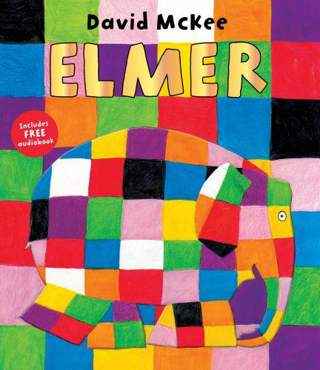
If you have any queries or concerns, please do not hesitate to email me.
Miss Hancock
ehancock@scholargreen.cheshire.sch.uk

