
Autumn 2 Newsletter Year One

Dear Parents/Carers,
I hope you have all had a lovely half term break. The children have settled into Year One really well so far, and I have been so proud of their attitude towards their learning!
This half term, we will continue with the transition period from Reception meaning the room will still have spaces to play, read and create. However, slowly, we will begin to introduce whole class lessons to the children.
In Maths, we will be working on addition and subtraction with a particular focus on number bonds to 10, this will build on the children’s learning from Reception. It is essential that children know their number bonds to 10 confidently so this is something they need to be practising at home regularly.
In English, our author for this half term is Julia Donaldson. I am sure most children will have enjoyed many of her stories at home. We will be focusing on the rhyme within her stories. A reminder also, that all children need to read at least 4 times per week at home (recorded in yellow diaries). This does not include the reading they do they in school. If they do not read 4 times per week, they will not be able to take part in our class reading treat at the end of the term. Reading books will be changed regularly, however, in school we have a focus on reading fluently so this may mean that books need to be re-read more than once at home.
In Geography, we will be comparing Scholar Green, Mow Cop and Congleton as well as spotting signs that the seasons are changing to Winter. Whilst in History, we will be looking at the pottery industry and how that is important to our local area.
In Science will focus on looking at different animals and whether they are herbivores, carnivores or omnivores.
We will continue with our focus on PSHE (personal, social, health and economic education) and will be helping children to become more independent with their learning.
Year 1 PE days will now be on a Wednesday and Thursday. On these days, children need to come to school dressed in their school PE kits and they must be wearing footwear that is suitable for PE e.g. pumps or trainers. Please also make sure that on PE days your child’s hair is tied back if it is long and no jewellery or watches are worn. Also, please make sure all items of your child’s clothing, including their shoes are name (initials can be written inside) as the children cannot always identify their own belongings.
Each day at lunchtime, Mrs Kirk will be running PE clubs on the playground or field. These will change on a weekly basis and there will be no need to sign up in advance. Children will be able to join in as and when they would like to. To take part children will need their trainers only, but you may prefer to send your child into school in their PE kit on those days. KS1 clubs will be on Monday and Wednesday and KS2 will be on Tuesday and Thursday. Friday will always be running club and will be for both KS1 and KS2.
Homework will continue as weekly spellings, 20 minutes minimum of Numbots, and reading at home 4 times a week. Spell check will be every Wednesday – words to be sent out via School Spider.
This term is very exciting as we will also be practicing for our Christmas Production! More information to follow.
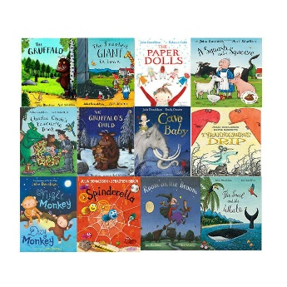
If you have any queries or concerns, please do not hesitate to email me.
I’m so excited to see what this term brings!
Kind regards,
Miss Hancock
ehancock@scholargreen.cheshire.sch.uk

Dates for the diary
