Our Lady of Lourdes Catholic Primary School

HOME / SCHOOL
PARTNERSHIP AGREEMENT
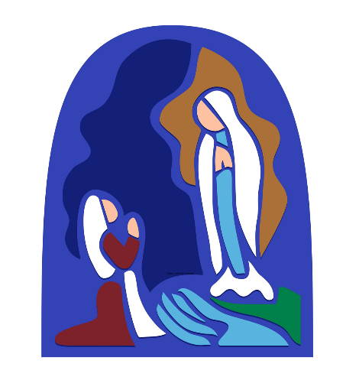

At Our Lady of Lourdes Catholic Primary School we
seek to create a unique and enabling community
whereby children and staff are encouraged
to journey beyond their expectations -
academically, socially and spiritually -
within a culture based on Gospel Values.

LOVE, LIVE AND LEARN AS JESUS TAUGHT US

September 2025 - July 2031

Our Lady of Lourdes Catholic Primary School

HOME/SCHOOL
PARTNERSHIP AGREEMENT

The school will:
- Provide a positive, enriching and caring learning environment in which your child can flourish.

- Embrace the Catholic teachings of the Gospel according to its Values.

- Establish and nurture a home / school learning partnership in the best interests of your child.

- Strive continually to provide the best possible educational opportunities for your child; rooted in our beliefs, our values and our skills.

- Plan, deliver and evaluate work appropriate for the child. Use assessment, target setting, feedback and marking to enable to the child to move on in their learning.

- Identify your child’s ‘starting point’ and provide support and challenge to strive for excellence to achieve their highest unique standard of personal, social, spiritual and intellectual development.

- Always keep your child’s safety and wellbeing as the main priority.

- Communicate regularly with parent partners; sharing successes and improvements in work or behaviour, and raising concerns regarding health, work or behaviour patterns which are affecting the child and his / her performance, as appropriate.

- Inform parents/carers of your child’s progress through in/formal Parent meetings and the school’s Annual Record of Achievement to parents.

- Keep parents informed about school policy and procedure, new initiatives, special events and activities through regular newsletters, workshops and meetings.

Signature: M. Wilson (Mrs Meg Wilson – Head Teacher)
September 2025 - July 2031

Our Lady of Lourdes Catholic Primary School

HOME/SCHOOL
PARTNERSHIP AGREEMENT

As a parent / carer of a pupil at Our Lady of Lourdes Catholic Primary School, I will:

- Ensure my child attends school regularly (national expectation at least 96% attendance annually).

- Actively support the school’s Aims, Christian Values and Code of Behaviour.

- Encourage my child to approach learning with their best efforts.

- Model positive social behaviours and encourage my child to consistently show kindness and consideration to others.

- Teach my child to take responsibility for his / her actions, words and property.

- Actively support my child and seek out regular opportunities for home learning.

- Establish a positive relationship based on regular, honest communication about my child’s wellbeing (health, happiness and achievement) between home and school.

- Attend Parents‘ Consultation Evenings and appropriate information meetings set up to discuss and support my child’s progress.

- Not discuss the business of the school or children attending school in any public forum including social networking sites.

- Contribute towards the culture of safeguarding for all children in the school.

- Have trust in the Home/School partnership.

Signature:……………………………….……….Name:…………………………

September 2025 - July 2031
Our Lady of Lourdes Catholic Primary School

HOME/SCHOOL PARTNERSHIP AGREEMENT

As a pupil at Our Lady of Lourdes Catholic Primary School, I will:

- Attend school regularly and on time.

- Treat everyone - children and adults - always with kindness and respect.

- Behave sensibly so we can be happy and safe as we learn at school.

- Do my best every day to be the best learner I can be.

- Take responsibility for my words and actions.

- Say sorry and seek reconciliation if I hurt another person.

- ‘Stand up Now’ for another person who I see to be hurt.

- Wear my school uniform with pride and bring all the equipment I need every day.

- Take care of the school equipment and furniture.

- Take pride and look after our school environment.

- Actively contribute to making our school community the best it can possibly be for everyone in it.

- Every day, aim to Love, Live and Learn as Jesus Taught us.

Signature……………………………….……….Name…………………………….

September 2025 - July 2031
(please return this signed copy to school office)

