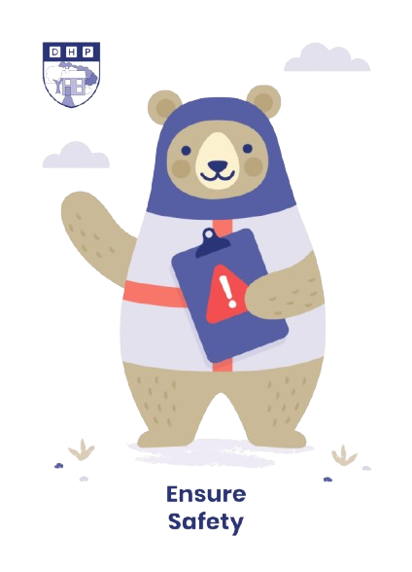
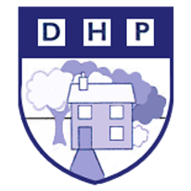


Dene House Primary School

Manor Way, Peterlee, Co. Durham. SR8 5RL. Tel (0191) 586 2937
Email address: office@denehouseprimary.co.uk
Website: www.denehouse-pri.durham.sch.uk

School Uniform Policy

Date of last review: | Sept 2024
Date of next review: | Sept 2025

Aim
Uniform is compulsory at Dene House Primary School. It is our policy that all children should wear clothing that is in keeping with a purposeful learning ethos. We believe that wearing uniform encourages a sense of identification, equality, pride and a belonging to Dene House Primary School. We also believe uniform should be practical, inclusive and affordable.

Uniform
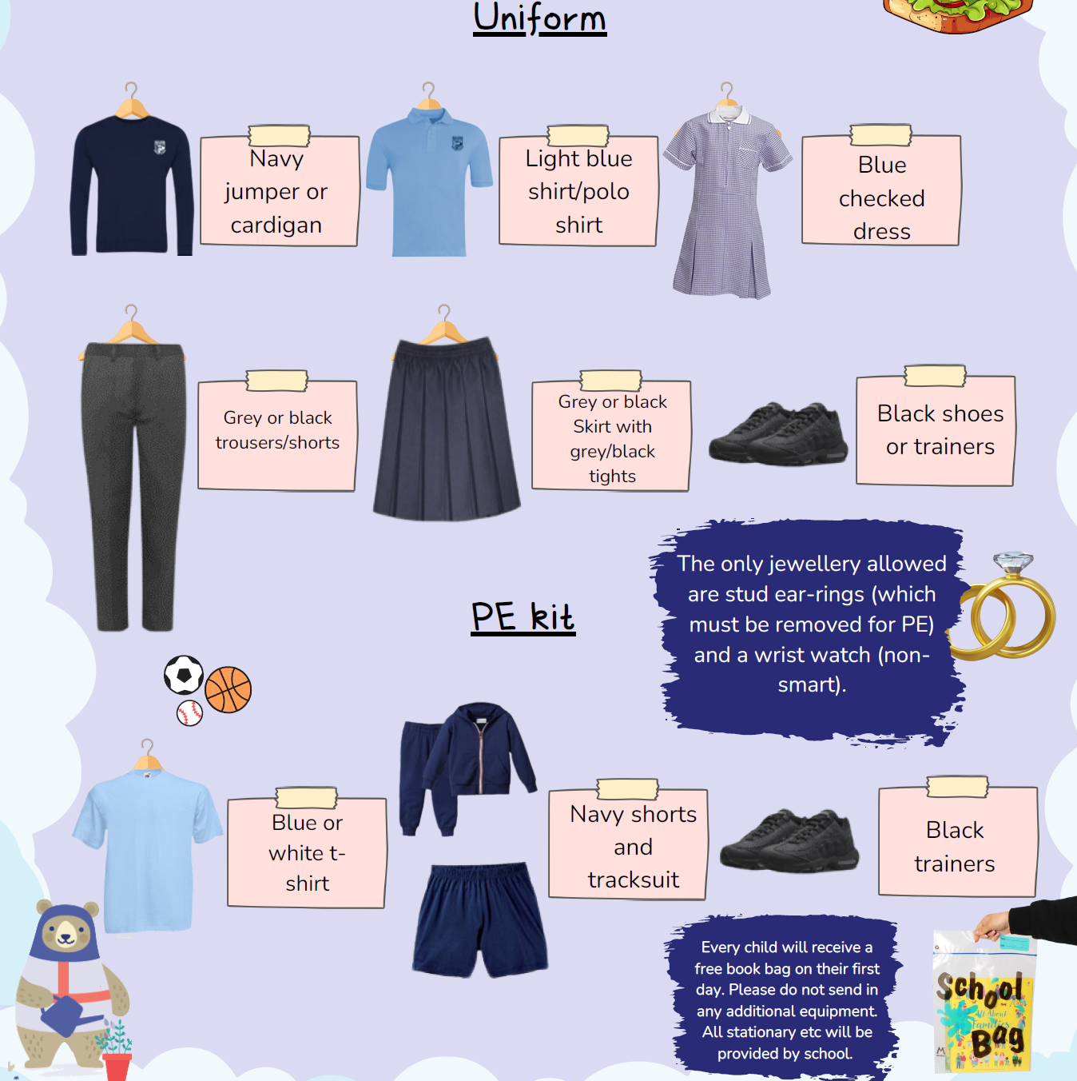
School does not stock trousers/skirts/dresses etc - these can be purchased from the usual outlets. Please ensure your child wears suitable shoes for school.
Blue sweatshirts/cardigans can be bought from any outlet.
If you would like uniform embroidered with the school badge, this can be ordered from the School Outfit online: https://theschooloutfit.co.uk/collections/dene-house-primary-school
Make-up and nail varnish is discouraged.

