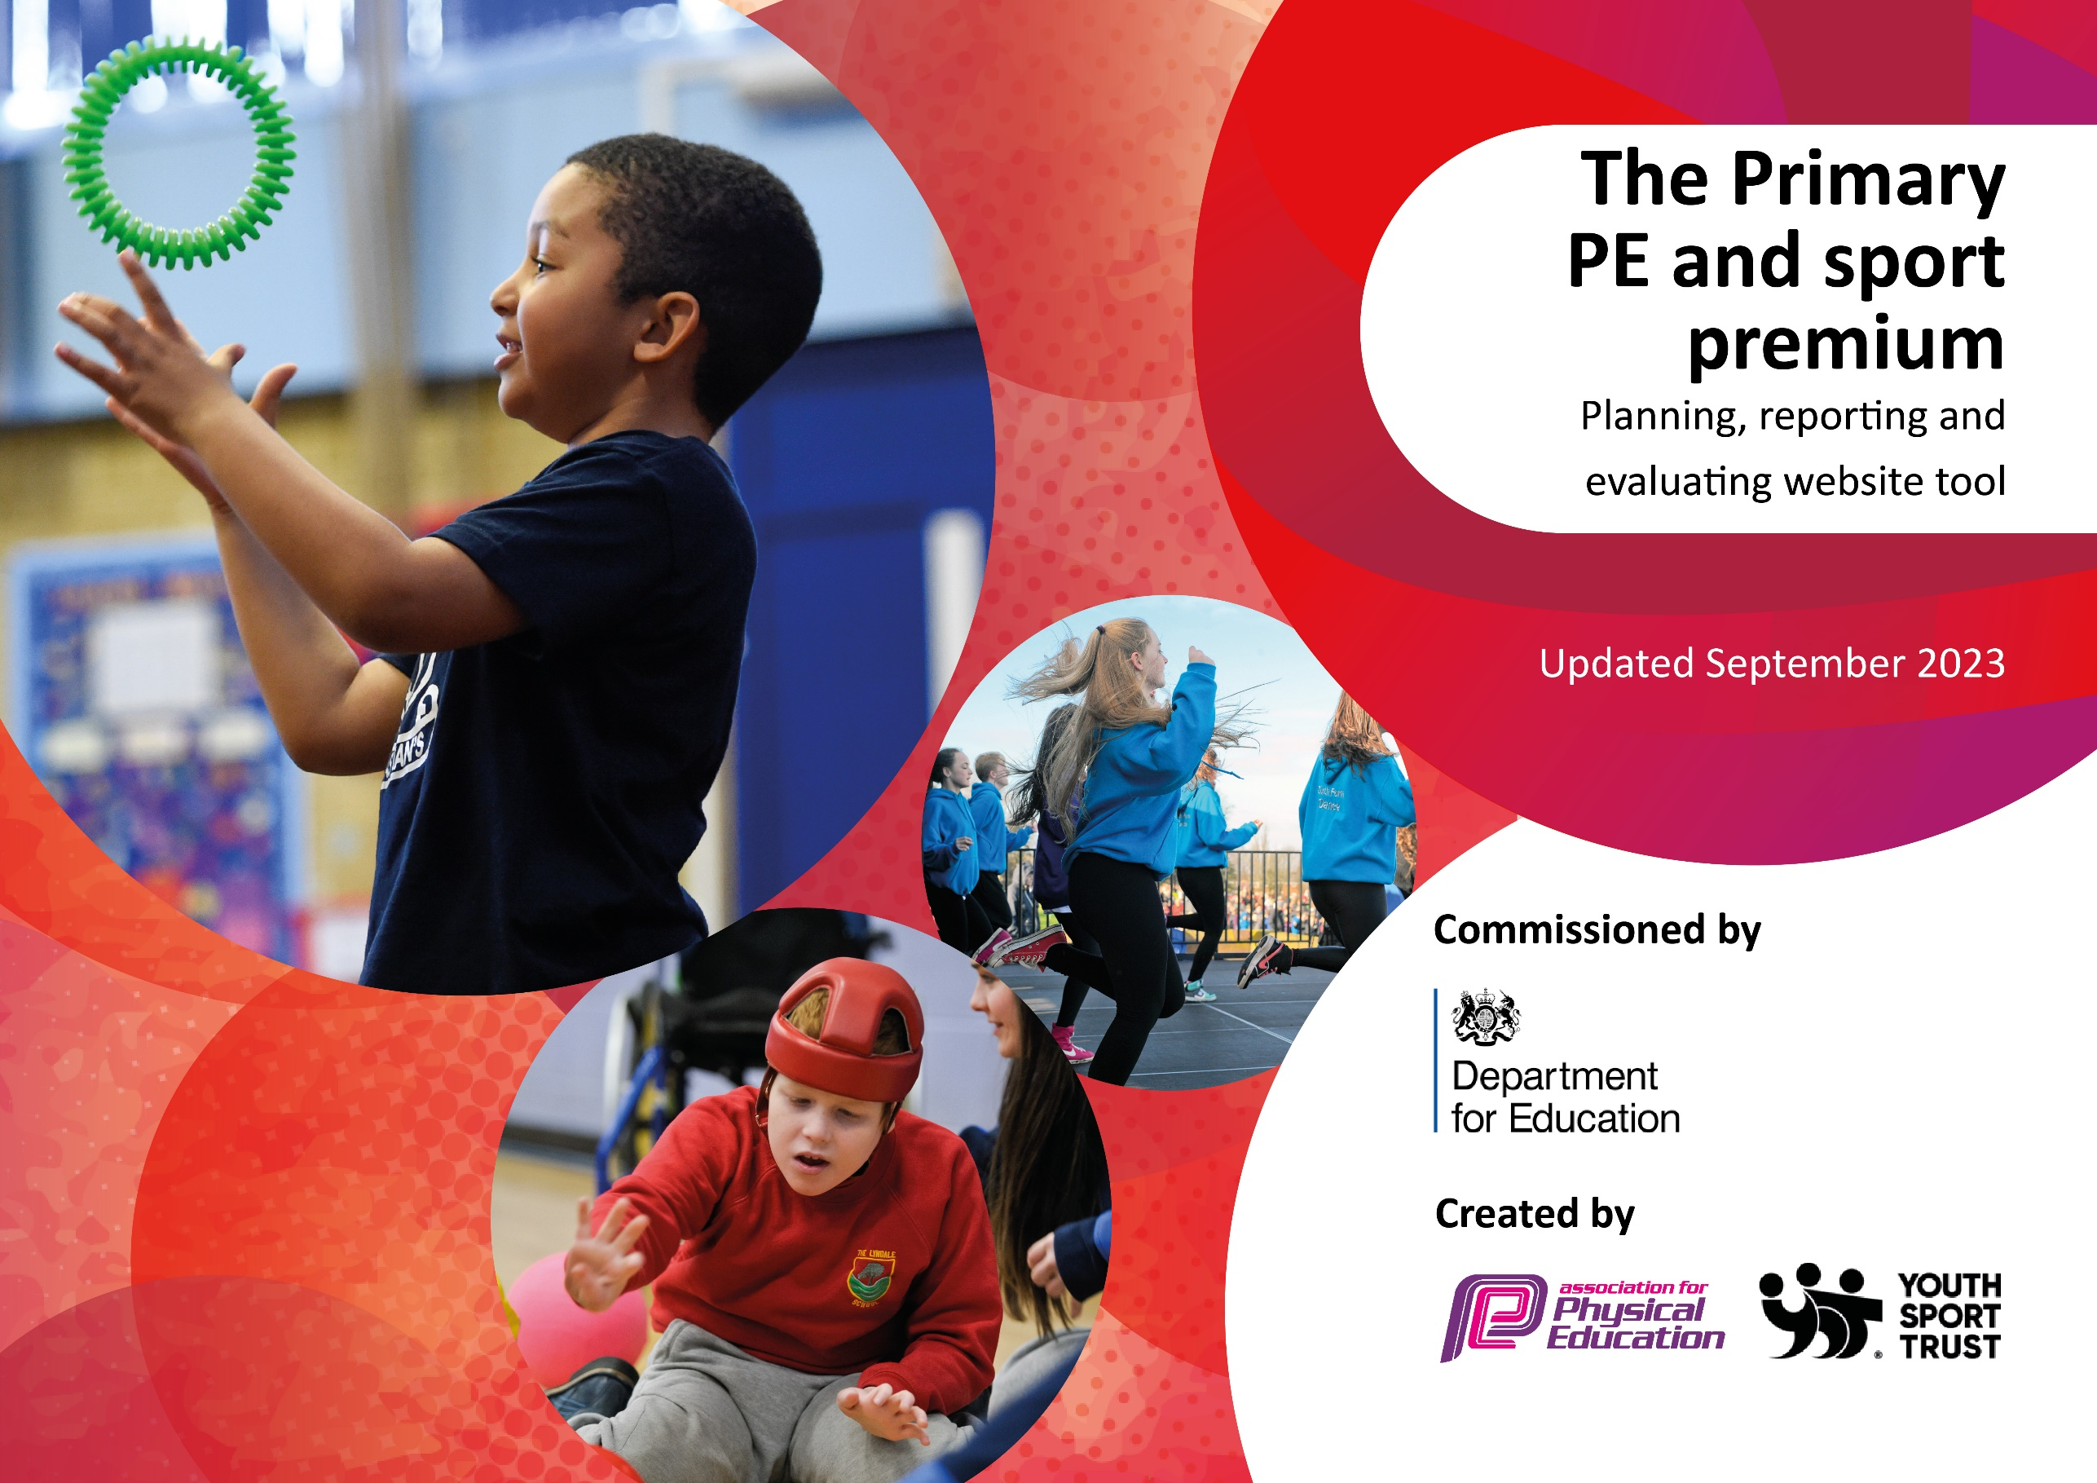

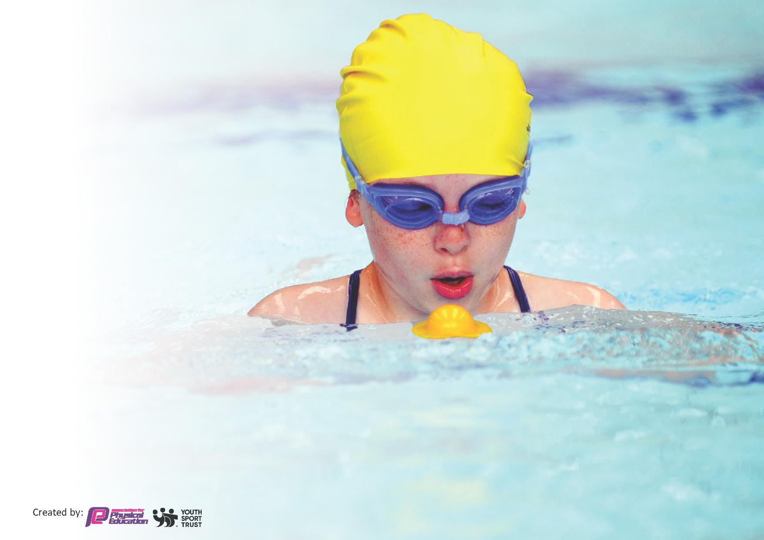
This template can be used for multiple purposes:
by:
- It enables schools to effectively plan their use of the Primary PE and sport premium
- It helps schools to meet the requirements (as set out in guidance) to publish information on their Primary PE and sport premium
- It will be an effective document to support Ofsted inspections enabling schools to evidence progress in Physical Education (PE) and evidence swimming attainment, which forms part of the PE National Curriculum. We would recommend schools consider
the Intent, Implementation and Impact of any spend,
as examined within the Education Inspection Framework.

It is important that your grant is used effectively and based on school need.
Schools must use the funding to make additional and sustainable
improvements to the quality of the PE, School Sport and Physical Activity (PESSPA)
they offer. This means that you should use the Primary PE and sport premium to:

- Build capacity and capability within the school to ensure that improvements made now will benefit Children joining the school in future years
- Develop or add to the PESSPA activities that your school already offers.

The Primary PE and sport premium should not be used to fund capital spend projects; the school’s core budget should fund these. Further detail on capital expenditure can be found in the updated Primary PE and sport premium guidance.

The Primary PE and sport premium guidance, outlines 5 key priorities that funding should be used towards. It is not
necessary that spending has to meet all the key priorities, you should select the priorities that you aim to use any funding towards.

Although completing this template is not a requirement for schools, schools are required to publish details of how they spend this funding. Schools must also outline what the impact this funding has had on Children’ PE and sport participation and attainment and how any spending will be sustainable in the future. All funding must be spent by 31st July 2024.
The Department for Education has worked closely with the Association for Physical Education (afPE) and the Youth Sport Trust (YST) to develop this template and encourages schools to use it. This template is an effective way of meeting the reporting requirements of the Primary PE and sport premium.
Review of last year’s spend and key achievements (2023/2024)

We recommend you start by reflecting on the impact of current provision and reviewing your previous spend.

Activity/Action | Impact | Comments
- Active dinnertimes- increased physical activity, training of all Y4,5 and 6 children as sports leaders. | - All children in year 4 and up were trained,  and some are very effective leaders. | - A variety of staff and year groups are outdoors at lunch time, so this needs relaunch and an update to equipment.  - Year 4 children need training.
- Participation in the Hathershaw sports cluster.  - Sports coach. | - Children of differing abilities were able to attend a variety of competitions, to have an experience many would otherwise not receive. | - Participation to continue.
- Active 60 relaunch. | - Staff aware of its importance and where it fits in to PE and HAL | - Continue to promote and remind staff.

Key priorities and Planning
This planning template will allow schools to accurately plan their spending.

Action – what are you planning to do | Who does this action impact? | Key indicator to meet | Impacts and how sustainability will be achieved? | Cost linked to the action
- Active 30 - All children have opportunity to be active for 30 minutes per day in school.  - Active learning in class, active lunch times  - Promotion by young leaders and sports crew. | - TAs and lunch time supervisors.  - Children – those who will lead (sports leaders) and those who will take part. | Key indicator 1: The engagement of all Children in regular physical activity – Chief Medical Officer guidelines recommend that primary school child/ren undertake at least 30 minutes of physical activity a day in school.  Key indicator 4: Broader experience of a range of sports and activities offered to all children | - More children meeting their daily physical activity goal, more  - Children encouraged to take part in PE and Sport Activities. | Classroom resources  (spinner, stopwatch)  £100
- Use of the travel tracker to monitor active trips to school  - Engagement in seasonal Travel events to encourage pupil activity. | - Teachers – inputting data.  - Children – participants. | Key indicator 1: The engagement of all Children in regular physical activity – Chief Medical Officer guidelines recommend that primary school child/ren undertake at least 30 minutes of physical activity a day in school. | - More children coming to school in an active way.  - Improving Active 60 participation.  - Children more focused and less “off task time” | Funded
- Enhancement of Enrich orienteering  - Develop external outdoor physical activity within school curriculum | - Teachers – planning providing. Opportunity to apply and adapt to own lessons  - Children – participants | Key indicator 1: The engagement of all Children in regular physical activity – Chief Medical Officer guidelines recommend that primary school child/ren undertake at least 30 minutes of physical activity a day in school.  Key indicator 2 - The profile of PE and sport being raised across the school as a tool for whole school improvement. | - More children coming to school in an active way.  - Improving Active 60 participation.  - Children more focused and less “off task time”  - Children engaged and exited about PE engagement | £2595
- Monitor safety of PE equipment | - Sports safe to monitor and repair equipment, site manager, PE lead | Key indicator 4: Broader experience of a range of sports and activities offered to all Children | - Ensure safety of equipment and make sure it is fit for purpose. | £75

- Update PE equipment | - PE leader to audit and order equipment.  - Teachers – to support their planning.  - Children – to broaden sports ability. | Key indicator 1: The engagement of all Children in regular physical activity – Chief Medical Officer guidelines recommend that primary school child/ren undertake at least 30 minutes of physical activity a day in school.  Key indicator 4: Broader experience of a range of sports and activities offered to all Children | - Replacing equipment enabling children to access all areas of the PE curriculum and increase PE knowledge and skills. | £1000
- Relaunch School Sports Organising Crew | - PE leader  - Representatives and Children | Key indicator 2 - The profile of PE and sport being raised across the school as a tool for whole school improvement. | - Organise intra-school sport events increase participation in competitions – child lead. | £1000
- Increased confidence and knowledge of Subject leader (New to the role) | - PE leader  - Staff supported by PE leader | Key indicator 3: Increased confidence, knowledge and skills of all staff in teaching PE and sport | - PE lead able to monitor and coach  - PE lead is clear about expectations and standards in PE | £1000  Cover
- Purchase a new resource (CPD) to support in the effective delivery of PE. | - Teachers  - Children | Key indicator 3: Increased confidence, knowledge and skills of all staff in teaching PE and sport | - Support teachers to deliver effective high quality PE sessions, better resources and skilled. | Get Set4PE  £1000
- Extra-curricular activities | - Staff  - Children | Key indicator 1: The engagement of all Children in regular physical activity – Chief Medical Officer guidelines recommend that primary school child/ren undertake at least 30 minutes of physical activity a day in school.  Key indicator 2 - The profile of PE and sport being raised across the school as a tool for whole school improvement. | - Increase engagement in regular activity and sport. | £2500 per year  Part funded by PP )
- Membership of the Hathershaw school sport partnership  - Participation in Hathershaw cluster | - Staff  - Children | Key indicator 5: Increased participation in competitive sport | - Increase the engagement of a wide range of Children in competitive sport. | £1600 annual fee  £1600 transport  £1000 staff
- Sports coach 1/2day per week | - Staff Y1-6 rota  - Children | Key indicator 2 - The profile of PE and sport being raised across the school as a tool for whole school improvement. | - Increase staff confidence in supporting PE, increasing engagement of Children. | £3900 sports coach
- Balancability | - Year 1 and reception Children | Key indicator 4: Broader experience of a range of sports and activities offered to all Children | - Broaden the skills/ achievement of participating children. | Funded
- Bikeability | - KS2 Children | Key indicator 4: Broader experience of a range of sports and activities offered to all Children | - Broaden the skills/ achievement of participating children. | Funded
- Continuation of sports leaders provision /training. | - Year 4,5 and 6  - Teachers | Key indicator 2 - The profile of PE and sport being raised across the school as a tool for whole school improvement.  Key indicator 4: Broader experience of a range of sports and activities offered to all Children | - Children trained to deliver a leadership role. | £100 resource
Contingency | - Staff, children, parents | Key indicator 2 - The profile of PE and sport being raised across the school as a tool for whole school improvement. | - Attendance at unknown opportunities  - CPD opportunities  - Linking opportunities | £330
 |  |  | Total spent | £17,800
 |  |  | Allocation | £17,800

Key achievements 2024-2025
This template will be completed at the end of the academic year and will showcase the key achievements schools have made with their Primary PE and sport premium spending.

Activity/Action | Impact | Comments
- Active 30 - All children have opportunity to be active for 30 minutes per day in school.  - Active learning in class, active lunch times.  - Promotion by young leaders and sports crew. | The Sports Leaders have held a meeting each term to discuss strategies and plan activities, ensuring their role is purposeful and well-structured. They have taken responsibility for leading physical activities at break and lunchtime, as well as organising and delivering smaller competitions. As a result, pupil engagement in activities has improved, contributing to an overall increase in levels of physical activity. In addition, our teaching assistants have successfully completed the Midday Supervisor Training Course delivered by School Games, further enhancing their skills in facilitating active play and ensuring high-quality provision during unstructured times of the school day. Together, these initiatives contribute to creating a more active, inclusive, and supportive school environment. | - New sports leader will need to be selected and trained.
- Update PE equipment and monitor safety of PE equipment | The PE equipment was audited in September 2025 by the PE lead. | - New equipment such as tennis ball and bean bags will need ordering.  - Equipment will need re auditing.
- Purchase a new resource (CPD) to support in the effective delivery of PE | The Get Set 4 PE scheme is used to deliver the PE curriculum, with the sports coach also making effective use of this resource. The sports coach has focused on inclusion and adaptation to ensure that all pupils are able to participate fully in PE lessons. Pupils are further supported by both the class teacher and teaching assistant, ensuring that individual needs are met and that all children can engage successfully in physical education. | - New sports coach to be shown the Get Set 4 PE scheme.
- Enhancement of Enrich orienteering  - Develop external outdoor physical activity within school curriculum | Enrich Orienteering has enhanced the provision of outdoor physical activity within the school curriculum. It has been incorporated into PE lessons, featured as part of Sports Day, supported SATs practice, and been integrated into other subjects such as Maths and Geography. In the Early Years Foundation Stage, it has also been used to support phonics and outdoor learning activities, providing a creative and active approach to developing key skills.
- Sports coach 1/2day per week | The sports coach is used to support and develop staff knowledge and confidence in delivering high-quality PE. A key focus has been on inclusion and adaptation, ensuring that all pupils are able to participate fully in lessons. Pupils are further supported by both the class teacher and teaching assistant, enabling individual needs to be met and ensuring that every child can engage successfully in physical education. | - New sports coach to be shown the Get Set 4 PE scheme.
- Membership of the Hathershaw school sport partnership  - Participation in Hathershaw cluster  - Extra curriculum activities. | A wide range of children represented the school at Hathershaw, with A, B, and C teams participating. After-school sports clubs and the yoga club were also well attended by pupils. Through careful mapping, a number of SEND pupils were enabled to attend a variety of sporting events during the school day. This experience helped to build their confidence and increase their participation in PE. Surveys conducted before and after the events demonstrated a positive impact on their engagement and overall attitude towards physical activity.

Swimming Data
Meeting National Curriculum requirements for swimming and water safety.
Priority should always be given to ensuring that Children can perform safe self-rescue even if they do not fully meet the first two requirements of the National Curriculum programme of study

Question | Stats: | Further context  Relative to local challenges
What percentage of your current Year 6 cohort can swim competently, confidently and proficiently over a distance of at least 25 metres? | 45 % | Families of children at Holy Rosary do not have access to the income needed to support their child in learning to swimming.  Access to swimming lessons is also not easy as transport to these sessions is a barrier.
What percentage of your current Year 6 cohort can use a range of strokes effectively [for example, front crawl, backstroke, and breaststroke]? | 55.2%

What percentage of your current Year 6 cohort are able to perform safe self-rescue in different water-based situations? | 82.7%% | .
If your schools swimming data is below national expectation, you can choose to use the Primary PE and sport premium to provide additional top-up sessions for those Children that did not meet National Curriculum requirements after the completion of core lessons. Have you done this? | Yes/No | Children at Holy Rosary are given 3 opportunities to attend swimming. If they cannot swim 25 metres – 1 term in Y3, 4 and 5. They may reattend in Year 5 to help them reach the baseline measure.
Have you provided CPD to improve the knowledge and confidence of staff to be able to teach swimming and water safety? | Yes/No | Staff have attended Reach and rescue training. They attend the swimming sessions alongside the children and are guided by pool staff. Member of staff to enter pool where needed.

Signed off by:

Head Teacher: | Tracy Cavanagh
Subject Leader or the individual responsible for the Primary PE and sport premium: | Katy Morrish
Governor: | G.Hegginbottom
Date:

