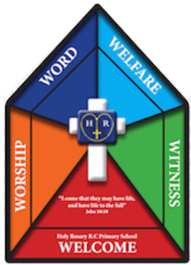

Faith Team Minutes

Date: 8.5.25 Time: 3.15pm-4.15pm Minutes taken by: Mrs Dootson

Meeting attended by: All

Focus of the meeting: Assembly planning – The Good Shephard and the Lost Sheep

Register and opening prayer.

Remind children of the faith team jobs.

Share the Bible story ‘Jesus calls Peter’ with the Faith Team.

Discuss which Catholic Social teaching theme it is.

Discuss the altar – what would be good to have on an altar (The Faith Team decided to set up a focal point in the middle of the hall using the EYFS farm set. They want to have green grass, a farmer and a flock of sheep, and then one sheep on its own.)

Story – children decided to share the story as a video from YouTube.

Children decided on 4 reflective questions to ask.

Children then in pairs wrote 4 bidding prayers and they created the response.

Together, we wrote a final prayer to do with the story.

Resources – Laptop, planning format

Actions for next meeting:

Make sure the Faith Team knows who is doing what in the assembly.