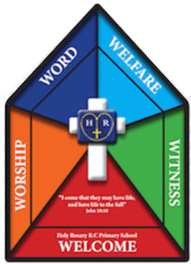

Faith Team Minutes

Date: 19.6.25 Time: 3.15pm-4.15pm Minutes taken by: Mrs Dootson

Meeting attended by: All

Focus of the meeting: Assembly planning – Feeding of the 5000

Register and opening prayer.

Remind children of the faith team jobs.

Share the Bible story ‘Feeding of the 5000’ with the Faith Team.

Discuss which Catholic Social teaching theme it is.

Discuss the altar – what would be good to have on an altar (The Faith Team decided to set up a net with fish caught in the net as the focal point. They also wanted the Bible story visible.)

Story – children decided to share the story orally.

Children decided on 4 reflective questions to ask.

Children then in pairs wrote 4 bidding prayers and they created the response.

Together, we wrote a final prayer to do with the story.

Resources – Laptop, planning format

Actions for next meeting:

Make sure the Faith Team knows who is doing what in the assembly.