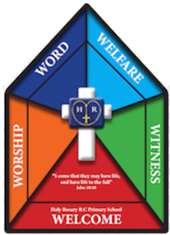

Faith Team Minutes

Date: 26.6.25 Time: 3.15pm-4.15pm Minutes taken by: Mrs Dootson

Meeting attended by: All

Focus of the meeting: Prayer and Reflection

Register and opening prayer.

Remind children of the faith team jobs.

Share this year’s action plan.

What would they add/change for next year?

Prayer and reflection circle – end of year thanksgiving.

* Begin with quiet music and a candle.
* Each child to draw one thing that they are grateful to God for this school year.
* Share aloud (if comfortable) and place into a thanksgiving basket.
* End with short prayer of thanks

(Children to write the short prayer of thanks together.)

Resources – Laptop, planning format

Actions for next meeting: